Hands-On Data Visualization

Interactive Storytelling from Spreadsheets to Code

Jack Dougherty

Ilya Ilyankou

2020-07-09

# Introduction



This open-access **book-in-progress**, by Jack Dougherty and Ilya Ilyankou, is under contract with O’Reilly Media, Inc., and was last updated on: 09 Jul 2020

Tell your story and show it with data, using free and easy-to-learn tools on the web. This introductory book teaches you how to design interactive charts and customized maps for your website, beginning with easy drag-and-drop tools, such as Google Sheets and Tableau Public, then gradually working up to editing open-source Chart.js and Leaflet code templates on GitHub. Follow along with the step-by-step tutorials, real-world examples, and online resources. This book is ideal for students, non-profit organizations, small business owners, local governments, journalists, academics, or anyone who wants to tell their story and show the data. No coding experience is required.

Read for free online at <https://HandsOnDataViz.org> or purchase print/eBook editions, to come from the publisher.

Please send corrections or suggestions for this book-in-progress to [handsondataviz@gmail.com](mailto:handsondataviz@gmail.com), or open an issue or submit a pull request on its [GitHub repository](https://github.com/handsondataviz/book). If you submit a GitHub pull request, in your commit message, please add the sentence “I assign the copyright of this contribution to Jack Dougherty and Ilya Ilyankou,” so that we can maintain the option of publishing this book in other forms.

View open-source code for source text and templates at <https://github.com/handsondataviz>.

Hands-On Data Visualization is copyrighted by Jack Dougherty and Ilya Ilyankou and distributed under a Creative Commons BY-NC-ND 4.0 International License. You may freely share this content for non-commercial purposes, with a source credit to http://HandsOnDataViz.org.

#### Trademarks

Any use of a trademarked name without a trademark symbol is for readability purposes only. We have no intention of infringing on the trademark.

* GitHub and the GitHub logo are registered trademarks of GitHub, Inc.
* Google and the Google logo are registered trademarks of Google Inc.
* WordPress is a registered trademark of the WordPress Foundation

#### Disclaimer

The information is this book is provided without warranty. The lead author, contributors, and publisher have neither liability nor responsibility to any person or entity related to any loss or damages arising from the information contained in this book.

## Authors

|  |  |
| --- | --- |
| Authors | About Us |
|  | [Jack Dougherty](http://jackdougherty.org) is Professor of Educational Studies at Trinity College in Hartford, Connecticut, where he and his students partner with community organizations to help tell their data stories on the web. Follow him on [Twitter](https://twitter.com/doughertyjack) and [on GitHub](https://github/com/jackdougherty). |
|  | [Ilya Ilyankou](https://www.linkedin.com/in/ilya-ilyankou-a64675ab) is a Civic Technologist at Connecticut Data Collaborative. He has completed a double major in Computer Science and Studio Arts in the Class of 2018 at Trinity College. Visit [his website](http://ilyankou.com) or follow him [on GitHub](https://github.com/ilyankou). |

## Acknowledgements

An earlier version of this book was titled *Data Visualization For All* and designed to accompany a [free online edX course](https://www.edx.org/course/data-visualization-for-all) by the same name at Trinity College. Two co-instructors for this edX course contributed valuable ideas and co-created videos: Stacy Lam, Trinity Class of 2019, and David Tatem, Instructional Technologist at Trinity College. Veronica X. Armendariz, Trinity Class of 2016, also made valuable contributions to an earlier version of the book while she was a Teaching Assistant for the DataViz internship seminar.

Videos for the edX course were produced with Trinity College Information Technology staff and friends: Angie Wolf, Sean Donnelly, Ron Perkins, Samuel Oyebefun, Phil Duffy, and Christopher Brown.

Funding for student contributors to an earlier version of this book was generously provided by the [Community Learning Initiative](https://cher.trincoll.edu/community-learning/) and [Information Technology Services](https://www.trincoll.edu/LITC/its/) at [Trinity College in Hartford, Connecticut](http://www.trincoll.edu).

Thanks to many individuals and organizations for generously making time to help us learn many of the skills that we teach in this book: Alvin Chang and Andrew Ba Tran, who tutored and shared their Leaflet map templates while at *The Connecticut Mirror*; Patrick Murray-John, formerly at the Roy Rosenzweig Center for History and New Media, who clued us into being *code-curious*, and many others at The Humanities and Technology Camp (THATCamp) conference series…

## What is Data Visualization?

Data visualization is broadly defined as a method of encoding quantitative, relational, or spatial information into images. Classic examples include [Charles Menard’s figurative map](https://en.wikipedia.org/wiki/Charles_Joseph_Minard) of Napoleon’s defeat and retreat during the Russian campaign of 1812, and [John Snow’s dot map](https://en.wikipedia.org/wiki/John_Snow) of cholera cases during the London epidemic of 1854.



Images: Menard’s figurative map (left) and Snow’s dot map (right), from Wikimedia

This free online introductory book focuses on selected topics in data visualization:

**Charts and maps** Despite the growing variety of visualization types, this book features chapters on creating [charts](chart) and [maps](map), and a wide range of ways to communicate with these classic models.

**Reusable tools and templates:** Unlike infographics created for one-time use, all of the tools and templates in this book are recyclable, and allow you to upload a new dataset to display your story.

**Free and easy-to-learn:** We have selected data visualization tools that are free to use (or work on a freemium model, where advanced features or higher usage requires payment), and searched for those that we believe are easy-to-learn, based on our teaching experience with undergraduate students and non-profit community organizations.

**Interactive on the open web:** Many books assume that you will deliver your data visualizations to in-person audiences on printed paper or presentation slides. But in this book, we show how to [embed interactive charts and maps on your website](embed), to share with the wider public.

**Storytelling:** Data visualization is more than pretty pictures. In this book, the best visualizations are those that [tell your data story](story) – and pull readers’ attention to what really matters – by combining images and text, and offering exploration with explanation.

#### Learn more

* Michael Friendly and Daniel J. Denis, “Milestones in the History of Thematic Cartography, Statistical Graphics, and Data Visualization,” 2001, <http://www.datavis.ca/milestones/>
* Isabel Meirelles, Design for Information: An Introduction to the Histories, Theories, and Best Practices Behind Effective Information Visualizations (Rockport Publishers, 2013), <http://isabelmeirelles.com/book-design-for-information/>
* Edward Tufte, The Visual Display of Quantitative Information (Graphics Press, 1983), and subsequent works at <https://www.edwardtufte.com>

## Why this book?

*Hands-On Data Visualization*, an open-access online textbook, seeks to help you tell your story—and show your data—through the power of the public web.

This open-access book reflects what I’ve learned while teaching data visualization [to undergraduate students at Trinity College](http://commons.trincoll.edu/dataviz), and now [to a global online class on the Trinity edX platform](https://www.edx.org/school/trinityx). Over the past few years, Trinity students and I have built interactive charts and maps in partnership with non-profit organizations in Hartford, Connecticut, to help them share their stories with data on the public web. Also, my students and colleagues have used these tools to create [On The Line: How Schooling, Housing, and Civil Rights Shaped Hartford and its Suburbs](http://ontheline.trincoll.edu), an open-access book-in-progress that features interactive historical maps of urban-suburban change. Students and colleagues who wrote tutorials, designed learning exercises, or developed code templates for *Hands-On Data Visualization* are listed as [authors and contributors](authors).

Although my outstanding colleagues have professional training, do not confuse them with me, the proverbial “Jack of all trades, master of none.” I do not consider myself an expert in data visualization, nor should anyone mistake me for a computer scientist or data scientist. Inspect my higher education transcripts and you’ll see only one computer science class (something called FORTRAN77 back in 1982), and not a single course in statistics, sadly. Instead, my desire to learn data visualization was driven by my need as an historian to tell stories about urban-suburban places and change over time. If you’ve ever watched me teach a class or deliver a presentation on these topics – always talking with my hands in the air – you’ll understand my primal need to create charts and maps. Stories become more persuasive when supported with data, especially well-crafted images that convey data relationships more clearly than words. Furthermore, these data stories become more powerful when we share them online, where they reach broader audiences who can interact with and evaluate our evidence.

In the early 2000s, when I began to dabble in data visualization, our tools were expensive, not easy to learn, and not designed to share our stories on the public web. (One of my well-worn jokes is point to the bald spot on my head, and claim that it was caused while tearing out my hair in frustration while using ArcGIS.) But everything began to change around 2005 when Google Maps publicly released its application programming interface (API) that allowed people with some coding skills to show data points on an interactive web map. Gradually, between 2008-11, I began learning what was possible by working on map projects with talented programmers and geographers, such as Jean-Pierre Haeberly at Trinity, and Michael Howser at the [University of Connecticut Libraries Map and Geographic Information Center](http://magic.lib.uconn.edu/) (MAGIC, my favorite acronym), thanks to a grant from the [National Endowment for the Humanities](http://www.neh.gov). Free and low-cost workshops sponsored by [The Humanities and Technology Camp](http://thatcamp.org) (THATCamp) at the Center for History and New Media at George Mason University, and [Transparency Camp](https://sunlightfoundation.com/transparency-camp/) by the Sunlight Foundation, introduced me to many people (especially Mano Marks and Derek Eder) who demonstrated easier-to-use tools and templates, such as Google Fusion Tables and GitHub. Closer to home, Alvin Chang and other data journalists at the [Connecticut Mirror](http://ctmirror.org) showed me how to tell stories on the web with more flexible open-source tools, such as Leaflet and Highcharts.

All of these data visualization lessons I learned have been so valuable—to me, my students, our community partners, and thousands of readers on the web—that my co-authors and I have agreed to share our knowledge with everyone for free. This open-access book is guided by the principle of democratization of knowledge for the public good, hence the book’s title: *Hands-On Data Visualization*. Not everyone can afford to make this choice, I realize. But the [mission of Trinity College](http://www.trincoll.edu/AboutTrinity/mission/Pages/default.aspx) is to engage, connect, and transform, with both our local city of Hartford and the world at large. Since Trinity already pays my salary as a tenured professor, the right thing to do with the knowledge my students and I have gained is to pay it forward. That’s why we created *Hands-On Data Visualization.*

If this free book is valuable for your education, then join us by sharing and supporting it for future readers:

* Tell your friends about the book and share the link via social media, text, or email
* Improve the book by adding comments or suggesting new chapters on our GitBook platform

Try out the tutorials, explore the online examples, share what you’ve learned with others, and dream about better ways to tell your data stories.

Warning: To follow the steps in this book, we recommend either a desktop or laptop computer, running either the Mac or Windows or Linux operating system, with an internet connection and a modern web browser such as Chrome, Firefox, Safari, or Edge. Another good option is a Chromebook laptop, which enables you to complete *most* of the steps in this book, and we’ll point out any limitations in specific chapters. While it’s possible to use a tablet or smartphone device, we do not recommend it because you cannot follow all of the steps, and you’ll also get frustrated with the small screen and perhaps throw your device (or this book) across the room, and possibly hit someone else in the head. Ouch! We are not responsible for injuries caused by flying objects.

Tip: If you’re working on a laptop, consider buying or borrowing an external mouse that can plug into your machine. We’ve met several people who found it much easier to click, hover, and scroll with a mouse rather than a laptop’s built-in trackpad.

Tip: If you’re new to working with computers—or teaching new users with this book—consider starting with [mouse exercises](http://www.pbclibrary.org/mousing/mousercise.htm). All of the tools in this book assume that users already know how to click tiny buttons, hover over links, and scroll web pages, but rarely are these skills taught, and everyone needs to learn them at some point in our lives.

## How to Read

This open-access book-in-progress is free to read online at <http://HandsOnDataViz.org> to fully experience the interactive charts, maps, and video clips. Any modern web browser will display the book, but readers may prefer larger screens (desktop, laptop, tablet) over smaller screens (such as smartphones). In your web browser, try these toolbar features near the top of the page:

* Menu
* Search
* Font to adjust text size and display
* View source code on GitHub
* Shortcuts (arrow keys to navigate; s to toggle sidebar; f to toggle search)
* Social Media
* Share



Screenshot: How to read

#### Open links in new tabs

Keep your place when reading online and moving between pages.

* Two-finger trackpad click
* or Control + click (Mac)
* or Alt + click (Chromebook)
* or right-click (Windows and others)



Screenshot: Open link in new tab (on Mac)

#### Use a second monitor

If you have a small screen, consider connecting a second monitor, or work next to a second computer or tablet. This allows you to view tutorials in one screen and build visualizations in the other screen.



Image: Laptop with second monitor, and with tablet

#### Refresh browser

To view the most up-to-date content in your web browser, do a “hard refresh” to [bypass any saved content in your browser cache](https://en.wikipedia.org/wiki/Wikipedia:Bypass_your_cache).

* Ctrl + F5 (most Windows-Linux browsers)
* Command + Shift + R (Chrome or Firefox for Mac)
* Shift + Reload button toolbar (Safari for Mac)

# Choose Tools to Tell Your Data Story

TODO: Reorganize and rewrite chapter

Do you feel overwhelmed by the enormous range of data visualization tools? There’s been so many different tools released in recent years that anyone would have a hard time deciding which ones to use. Even if you limit your choices to the dozen or so tools specifically mentioned in this book, how do you make wise decisions?

* [Draw and Write Your Data Story](draw.html) reminds us to start with the most important item in your toolkit: ***your story***. Begin by drawing pictures and writing questions or sentences to capture your ideas on paper, and then choose the most appropriate tools to create your vision.
* [Ask Questions When Choosing Tools](ask.html) lists several criteria to consider when making software decisions. Many of us look for free or affordable tools in the perfect sweet spot—easy-to-learn, yet powerful—and that’s the focus of this book.
* [Rate Three Simple Map Tools](rate.html) invites readers to create a basic interactive point map using three different online tools, and to evaluate each one using selected criteria from the chapter above.

TODO: add password manager tutorial to keep track of your accounts for the online tools you’ll use in this book. The free and open-source BitWarden.com tool nicely integrates with most browsers and even smartphones.

Enroll in our free online course **TO DO add link**, which introduces these topics in the brief video below, and offers more exercises and opportunities to interact with instructors and other learners.

#### Watch the YouTube Video

## Draw and Write Your Data Story

Before you dive deeply into software, think about the most important item in your toolkit: **your story**. The primary reason we’re designing visualizations is to improve how we communicate our data story to other people, so let’s begin there.

Push away the computer and pick up some old-school tools:

* colored markers or pencils
* lots of blank paper
* your imagination

First, at the top of the page, write down your data story.

* Is it in the form of a question? If so, figure out how to pose the question.
* Or maybe it’s in the form of an answer to that question? If so, spell out your clearest statement.
* If you’re lucky, perhaps you already can envision a full story, with a beginning, middle, and end.
* Whatever form it takes in your head, write out the words that come to mind.

Further down the page (or on a separate sheet), draw quick pictures of the visualizations that comes to your mind, even if you don’t yet have any data. No artistic skills are required. Just use your imagination. - Do you envision some type of chart? Sketch a picture. - Or do you imagine some type of map? Show what it might look like. - Will your visualization be interactive? Insert arrows, buttons, whatever.

Finally, share your data story with someone else and talk through your preliminary ideas. Does your sketch and sentences help to convey the broader idea that you’re trying to communicate? If so, this is one good sign that your data story is worth pursuing, with the visualization tools, templates, and techniques in other chapters of this book.

## Ask Questions When Choosing Tools

When each of us decides which digital tools best fit our needs, we often face trade-offs. On one hand, many of us prefer easy-to-learn tools, especially those with a drag-and-drop interface, but they often force us to settle for limited options. On the other hand, we also favor powerful tools that allow us to control and customize our work, yet most of these require higher-level coding skills. The goal of this book is to find the best of both worlds: that “sweet spot” where tools are both friendly and flexible.



Diagram: the ‘sweet spot’ for easy-to-learn and powerful tools

Before testing out new tools, try listing the criteria that guide your decision-making process. What are the most important factors that influence whether or not you add another item to your digital toolkit? Here’s the list that came to our minds:

1. Price: Is the tool free, or is there a “freemium” model to pay for more features or higher usage?
2. Easy-to-learn: Is the tool relatively simple for new users without coding skills?
3. Power: Does the tool support large amounts of data, and various types of visualizations?
4. Customization: Can I modify details about how my work appears?
5. Data Migration: Can I easily move my data in and out, in case I switch to a different tool? Hint for historians: Future-proof your digital history projects! Choose tools that allow you to easily export and migrate data to other platforms. Design projects to keep your data separate from its digital presentation.
6. Hosting: Can I decide exactly where my data and visualizations will be stored online?
7. Support: Is the tool actively maintained by its creators, and do they answer questions?
8. Open Source: Is the tool’s software visible, can it be modified, and redistributed?
9. Security: Is the tool and my data protected from malicious hackers and malware?
10. Collaborative: Does the tool allow several people to work together on one shared product?
11. Privacy: Under the terms of service, is my data and work private or public?
12. Error-friendly: When something fails, does the tool point out possible problems and solutions?
13. Cross-platform: Does this tool work across different computer operating systems?
14. Mobile-friendly: Will it correctly display my work on various mobile devices and browsers?

That’s a long list! It’s even longer than the number of tools we’ll mention in this book. But don’t let it overwhelm you. The diagram at the top of the page illustrates the two most important criteria for the many free tools that are currently available: easy-to-learn and powerful features.

TODO: expand on privacy to review sample “terms of service” to use free tools such as Google Drive - <https://support.google.com/drive/answer/2450387?hl=en#>:~:text=As%20our%20Terms%20of%20Service,store%20in%20your%20Drive%20account. - See alimSpyingStudentsSchool2017 - Many of the free web-based tools in this book require that your publicly share your data. Check each tool and decide whether it is appropriate for your data, which may have some privacy restrictions.

#### Learn more about choosing tools

Carl V. Lewis, Dataviz.tools: A curated guide to the best tools, resources and technologies for data visualization, <http://dataviz.tools>

Lincoln Mullen, “How to Make Prudent Choices About Your Tools,” ProfHacker blog, Chronicle of Higher Education, August 14, 2013, <http://www.chronicle.com/blogs/profhacker/how-to-make-prudent-choices-about-your-tools>

Lisa Charlotte Rost, “What I Learned Recreating One Chart Using 24 Tools,” Source, December 8, 2016, <https://source.opennews.org/en-US/articles/what-i-learned-recreating-one-chart-using-24-tools/>

Lisa Spiro and colleagues, DiRT: Digital Research Tools Directory (formerly Bamboo), <http://dirtdirectory.org>

Audrey Watters, “‘The Audrey Test’: Or, What Should Every Techie Know About Education?,” Hack Education, March 17, 2012, <http://hackeducation.com/2012/03/17/what-every-techie-should-know-about-education>

## Rate Three Simple Map Tools

Let’s explore criteria from the previous chapter by comparing three different tools, and reflecting on which factors you feel are most important when making decisions about your toolkit. We’ll test three drag-and-drop tools to transform sample address data into a simple interactive point map.

Each tool can **geocode** address data by looking up a location (such as 500 Main Street, Hartford CT) in a large database, deciding on the best match, and converting this data into latitude and longitude coordinates (such as 41.762, -72.674).

For our sample data, we’ll use this table of 9 locations in North America, with 3 intentional mistakes to test for geocoding errors.



Image: Sample address data screenshot

First, click this link and Save to download the sample file to your computer: [sample-address-data in CSV format](data/sample-address-data.csv). CSV means comma-separated-values, a generic spreadsheet format that many tools can easily open. If you need help with downloading, see this [short video tutorial](https://www.youtube.com/watch?v=-04PQldP9HQ).

Next, build a point map with the sample data, by following the tutorials for the three tools below.

|  |  |
| --- | --- |
| Tool | Step-by-step tutorial in this book |
| [Google My Maps](https://www.google.com/maps/d/) | [My Maps tutorial](mymaps) |
| [Carto Builder](http://carto.com) | [Carto tutorial](carto) |

Finally, rate your experience using each tool with these selected criteria:

* Easy-to-learn: Which tool was the simplest for creating a basic point map?
* Price: Which of these free tools provided the most services at no cost?
* Customization: Which tool enabled you to modify the most details about your map?
* Data Migration: Which tool most easily allowed you to import and export your data?
* Error-friendly: Which tool geocoded most accurately or signaled possible errors?

Recommended: Enroll in our free online course **LINK TO DO** to compare your ratings to other students.

# Improve Your Spreadsheet Skills

Before we begin to design data visualizations, let’s bring our spreadsheet skills up to speed. While teaching this topic, we’ve heard many people describe how they “never really learned” how to use spreadsheet tools as part of their official schooling or workplace training. But spreadsheet skills are vital to learn, not only as incredible time-savers for tedious tasks, but more importantly, to help us discover the stories buried inside our data.

To fill this gap, we added this chapter to introduce or refresh your spreadsheet skills. The interactive charts and maps that we’ll construct later this book are built on data tables, which we typically open with spreadsheet tools to reveal rows and columns of numbers and text, where each box in the grid is called a “cell.” In this chapter, we’ll start by reviewing basic steps, such as [sharing data](share.html), [sorting and filtering](sort.html), and [calculating with formulas and functions](calculate.html). Then we’ll step up to the next level of skills, such as [regrouping data with pivot tables](pivot.html), [matching columns with lookup tables](vlookup.html), [connecting sheets with a relational database](database.html), and [collecting data with online forms](forms.html). All of the methods we illustrate are intended for introductory users, and do not require any background in statistics.

If you can add up numbers—or better said, if you want your computer to add up numbers and do even more work for you—then this chapter is right for you. Even if you *think* you know something about using spreadsheets, skim these sections and you might learn a trick or two that will help you to design charts and maps more efficiently in later chapters.

About spreadsheet tools:

* Free online [Google Sheets](https://www.google.com/sheets/about/) offers an easy-to-learn yet powerful spreadsheet tool that works in any modern web browser. Since it’s designed for collaboration and exports data into multiple open formats, we feature it in several examples in this book. You can sign up for a free personal [Google Drive](https://drive.google.com) account with the same username as your Google Mail account, or create a separate account to reduce Google’s invasion into your personal life. Another option is to pay for a [Google Suite](https://gsuite.google.com/) business account, with nearly identical tools, but designed for larger teams and organizations.
* Free downloadable [LibreOffice and its Calc spreadsheet](https://www.libreoffice.org/) is a powerful and increasingly popular open-source alternative to Microsoft Office, available for Mac, Windows, and Linux desktop and laptop computers. When downloading, a donation is requested to continue support for open-source software development.
* Free online [Microsoft Excel for OneDrive](https://onedrive.live.com) and the paid online [Microsoft Excel for Office 365](https://www.microsoft.com/en-us/microsoft-365/microsoft-office) offer limited Office tools in your web browser. For example, these online versions of Excel do *not* allow you to easily save or download files into the Comma Separated Values (.csv) generic data format, a very important feature required by other data visualization tools in later chapters of this book. Exporting to CSV format requires the downloadable version of Excel below. TODO: Further fact-checking needed because I investigated for 15 minutes and cannot find an easy way to export to CSV in the online Excel using the free OneDrive or paid Office 365 account, contrary to this Microsoft Support page: <https://support.microsoft.com/en-us/office/import-or-export-text-txt-or-csv-files-5250ac4c-663c-47ce-937b-339e391393ba>
* Paid downloadable [Microsoft Excel](https://www.microsoft.com/) is available for Windows and Mac desktops and laptops, and other devices. When people simply say “Excel” they usually mean this powerful yet pricey version. It offers the most complete set of spreadsheet tools (including the simple task of exporting to CSV that its online cousins lack), but was not originally designed for online collaboration.

Which spreadsheet tool should you use? As we describe in more detail in [Chapter 1: Choose Tools to Tell Your Data Story](choose.html), that answer depends on multiple factors. Is your data public or private? If private, consider using downloadable spreadsheet tool that runs on your personal computer, to reduce the risk of an accidental data breach with an online spreadsheet tool. Also, will you be working solo or with other people? For collaborative projects, consider using an online spreadsheet tool that’s designed to allow other team members to simultaneously view or edit data. In this book, we emphasize public, shared datasets, so our examples feature Google Sheets. But most of the spreadsheet methods we teach are common across other spreadsheet tools, and we point out exceptions where relevant.

About data formats:

Spreadsheet tools organize data in different formats. When you download spreadsheet data to your personal computer, you typically see its filename, followed by a period and a 3- or 4-character abbreviated extension, which represents the data format, as shown in Figure 1. The most common data formats we use in this chapter are:

* .csv means Comma Separated Values, a generic format for a single sheet of simple data, with no formulas or styling.
* .ods means OpenDocument Spreadsheet, a standardized open format that supports multi-tabbed data sheets, formulas, styling, etc.
* .xlsx or the older .xls means Microsoft Excel, a proprietary format that supports multi-tabbed sheets, formulas, styling, etc.



Figure 1: Three common data formats—csv, ods, and xlsx—displayed as icons in the Mac Finder. TODO: Expand screenshot to show data formats as displayed in Chromebook for comparison?

Warning: Several tools in this book may not work properly on a Mac computer that does not display the filename extensions, meaning the abbreviated file format after the period, such as data.csv or map.geojson. The Mac operating system hides these by default, so you need to turn them on by going to Finder > Preferences > Advanced, and check the box to *Show all filename extensions*, as shown in Figure 2.



Figure 2: On a Mac, go to Finder > Preferences > Advanced and check the box to *Show all filename extensions*.

## Make Your Own Copy of a Google Sheet

In several chapters of this book, we share sample data with links to Google Sheets, using settings that allow you to view—but not edit—the original file. We want everyone to have access to the data, but do not want anyone to accidentally modify the contents. Follow these simple steps to make your own copy of a Google Sheet that you can edit, without changing our version.

1. Right-click on this [sample-students Google Sheets file](https://docs.google.com/spreadsheets/d/1FYTiLHfOI2caT2lkI4i8fGbhA-oKT_MSOP1vQWWC9MA) to open in a new tab. We set it to “View only” so that anyone on the internet can see the contents, but not edit them.
2. Sign in to your Google account by clicking the blue button in the upper-right corner.
3. Go to *File > Make a Copy* to create a duplicate of this Google Sheet in your Google Drive, as shown in Figure 3. You can rename the file to remove “Copy of…”.



Figure 3: Go to *File > Make a Copy* to create your own version of this Google Sheet.

1. To keep your Google Drive files organized, click the *My Drive* button and the *New folder* button to create a folder for your data, before clicking *OK*, as shown in Figure 4. If you make a habit of saving every file in a folder, you’ll save a lot of time later when searching for the correct file.



Figure 4: Click the *My Drive* and *New folder* buttons to save your work in a folder.

Your copy of the Google Sheet will be private to you only, by default. In the next section we’ll learn about different options for sharing your Google Sheet data with others.

## Share Your Google Sheets

If you’re working on a collaborative project with other people, Google Sheets offers several ways to share your data online, even with people who do not own a Google account. When you create a new Sheet, its default setting is private, meaning only you can view or edit its contents. In this section, you’ll learn how to expand those options using the *Share* button.

1. Log into your [Google Drive account](http://drive.google.com), click the *New* button, select *Google Sheets*, and create a blank spreadsheet. By default, a new Sheet will be private to you. You will need to name your file to proceed with next steps.
2. Click the *Share* button in the upper-right corner, and your options will appear on the *Share with people and groups* screen, as shown in Figure 5.
3. In the top half of the screen, you can share access with specific individuals by typing their Google usernames into the *Add people and groups* field. For each person or group you add, on the next screen select the drop-down menu to choose if they can *View*, *Comment* on, or *Edit* the file. Decide if you wish to notify them with a link to the file and optional message.
4. In the lower half of the screen, you can share access more widely by clicking on *Change to anyone with the link*. On the next screen, the default option is to allow anyone who has the link to *View* the file, but you can change this to allow anyone to *Comment* on or *Edit* it. Also, you can click *Copy link* to paste the web address to your data in an email or public website.



Figure 5: Click the *Share* button to grant access to individuals (top half) or anyone with the link (bottom half).

Tip: If you don’t want to send people a really long and ugly Google Sheet web address such as https://docs.google.com/spreadsheets/d/1FYTiLHfOI2caT2lkI4i8fGbhA-oKT_MSOP1vQWWC9MA, use a free link-shortening service. For example, by using our free [Bitly.com](http://bitly.com) account and its handy [Chrome browser extension](https://chrome.google.com/webstore/detail/bitly-unleash-the-power-o/iabeihobmhlgpkcgjiloemdbofjbdcic) or [Firefox browser extension](https://addons.mozilla.org/en-US/firefox/user/13352154/), we can paste in a long URL and customize the back-end to something shorter, such as [bit.ly/sample-students](https://bit.ly/sample-students), as shown in Figure 6. If someone else has already claimed your preferred custom name, you’ll need to think up a different one. Beware that bit.ly links are case-sensitive, so we prefer to customize the back-end in all lower-case to match the front-end.

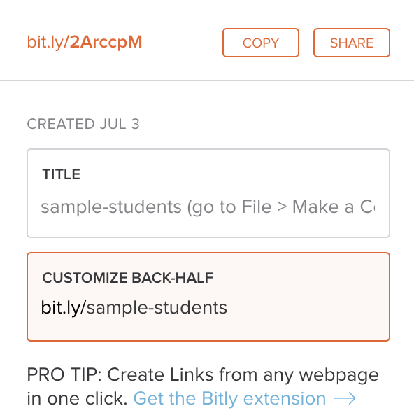

Figure 6: Use a free link-shortening service, such as Bitly.com, and customize its back-end.

Now that you have different options for sharing a Google Sheet, let’s learn how to upload and convert data from different formats.

## Upload and Convert Data to Google Sheets

A common mistake to avoid when using Google Drive is failing to check the hidden *Convert uploads* box. Checking this box automatically transforms files such as Microsoft Excel sheets or Word documents into Google Sheets or Google Docs format, which allows easier editing. Google turns off this option by default on new accounts, and hides it inside its Settings screen. But if you’re reading this page, you’ll learn how to turn it on, and the benefits of doing so. Share this tip with your family, friends, and co-workers—they’ll thank you!

1. Find an Excel file you can use on your personal computer. If you don’t have one, click this [sample Excel data file](https://handsondataviz.org/data/data.xlsx) and save to download to your computer.
2. Log into your [Google Drive](https://drive.google.com) account, and click the *Gear* symbol in the upper-right corner to open the Settings screen. Note that this global *Gear symbol > Settings* appears at Google Drive level, *not* inside each Google Sheet.
3. Check the box to *Convert uploaded files to Google Docs editor format*, as shown in Figure 7, and click *Done*. This turns on the conversion setting globally, meaning it will convert all possible files that you upload in the future—including Microsoft Excel, Word, PowerPoint, and more—unless you turn it off.



Figure 7: Inside your Google Drive settings (the gear symbol), check the box to convert uploads.

1. Upload a sample Excel file from your computer to your Google Drive. Either drag-and-drop it to the desired folder, as shown in Figure 8, or use the *New* button and select *File upload*.



Figure 8: Drag-and-drop your sample Excel file into your Google Drive to upload it.

If you forget to check the *Convert uploads* box, Google Drive will keep uploaded files in their original format, and display their icons and file name extensions such as .xlsx or .csv, as shown in Figure 9.



Figure 9: If you forget to convert uploads, Google Drive will keep files in their original format with these icons.

Tip: Google Drive now allows you to edit Microsoft Office file formats, but not all features are guaranteed to work across platforms. Also, Google Drive now allows you to convert an uploaded Excel file into its Google format by using the *File > Save as Google Sheets* menu.

Tip: To convert individual files to your Google Drive, while keeping the global conversion setting off, from inside any Google Sheet you can select *File > Import > Upload*. But we recommend that most people turn on the global conversion setting as described above, except in cases where you intentionally use Google Drive to edit an Excel-formatted file, and understand that some features may not work.

## Download and Export to CSV or ODS formats

In [Chapter 1: Choose Tools to Tell Your Data Story](choose.html), we learned the advantages of selecting software tools that support data migration, so that you can export your work to other platforms. Digital technology always changes. Never upload important data into a tool if you can’t easily get it out! In addition, better tools allow you to export your work in open-data or generic file formats, not just proprietary formats created primarily for a specific company’s software platform.

When choosing a spreadsheet tool, test if and how it exports into these two open data formats:

* Comma Separated Values (.csv) export only one sheet of data, with no formulas or formatting, into a wide range of spreadsheet and visualization tools, including several featured in later chapters of this book.
* OpenDocument Spreadsheet (.ods) exports a spreadsheet with multiple tabs of data, including basic formulas and formatting, into multiple spreadsheet tools, including Google Sheets, Microsoft Excel, and LibreOffice

In Google Sheets, go to *File > Download As* to export in CSV format (for only the current sheet) or ODS format (for a multi-tabbed spreadsheet with most formulas and formatting), or other formats, as shown in Figure 10.

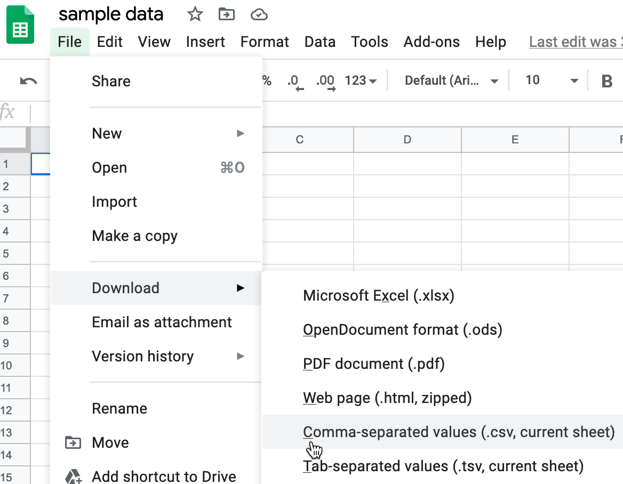

Figure 10: In Google Sheets, go to *File > Download As* to export data to other common formats.

In the downloadable LibreOffice and its Calc spreadsheet tool, select *File > Save As* to save in its native ODS format, or export in CSV, XLSX, and other formats.

In the online Excel for free OneDrive or paid Office 365, the *File > Save As* menu allows you to save a file in its native XLSX format, or export in ODS format, as shown in Figure 11. But online Excel lacks an easy way to export data in CSV format.

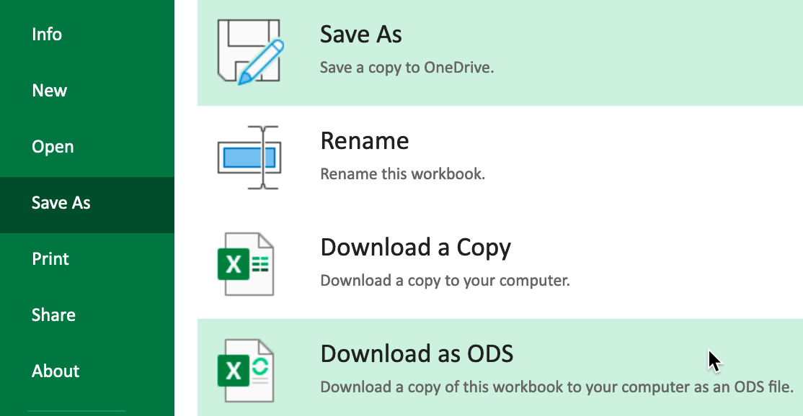

Figure 11: Online versions of Excel export into ODS format, but not CSV.

In the downloadable Excel for Windows and Mac, the *File > Save As* menu allows you to save a file in its native XLSX format, or export in CSV, ODS, or other formats. But saving from Excel into CSV format requires thinking through a few steps that sometimes confuse people.

1. Remember that if you have an Excel workbook with multiple sheets and formulas, the CSV export will only save the *active* sheet (meaning the one you’re currently viewing), and only the *data* in that sheet (meaning none of the formulas you may have used for calculations). If you need to create a CSV version for other data visualization tools in this book, we advise that you first save a full-version of your Excel file, and then save a CSV file, using parallel file names:

* data.csv
* data.xlsx

1. In the downloadable version of Excel, click on *File > Save As* and select *CSV* format. If you see multiple CSV options, choose *CSV UTF-8*, which should work best across different computer platforms.
2. If your Excel workbook contains multiple sheets, you may see a warning that it cannot be saved in CSV format, which only saves data contained in the active sheet. If you understand this, click *OK* to continue. On the next screen, Excel may warn you about “Possible data loss” when saving an Excel file in CSV format, which is true. That’s why we recommended that you first save the full-version of your Excel file before saving a CSV file.

TODO: I can add screenshots of any of the downloadable Excel steps above, but I don’t think it’s necessary. Thoughts?

Once you’ve learned how to export your spreadsheet data into an open format, you’re ready to migrate it into other data visualization tools or platforms that we’ll introduce in later chapters of this book. Data portability is key for ensuring that your charts and maps will last well into the future.

## Sort and Filter Data

Spreadsheet tools help you delve into your data and lift its stories to the surface. One of the most basic steps in organizing your data is to *sort* the contents of an entire table by one column, such as alphabetical order in a column of text, or highest-to-lowest order in a column of numbers. A related method is to *filter* an entire table to display only rows that contain certain values, such as a specific text or numerical value among all of the other entries. While you could manually sort or filter small datasets, spreadsheets become more powerful when you work with hundreds or thousands of rows of data.

Let’s use a large sample file to learn how to sort and filter data.

1. Open this [Google Sheet of New York City restaurant health inspection data](https://docs.google.com/spreadsheets/d/1WvEa46w8en5uWiMX7Jq6o02Q--wMHN2jGFOjD4sr73A/). It contains over 13,000 rows of data for inspections conducted in January 2020, where each row is a health violation. This is just a fraction of the full dataset available from the original source, [NYC Open Data](https://nycopendata.socrata.com/Health/DOHMH-New-York-City-Restaurant-Inspection-Results/43nn-pn8j).
2. Login to your Google Sheets account, and go to *File > Make a Copy* to create your own version that you can edit.
3. Before sorting, click the upper-left corner of the sheet to select all cells, as shown in Figure 12. The entire sheet should become light blue to show you’ve selected all cells.

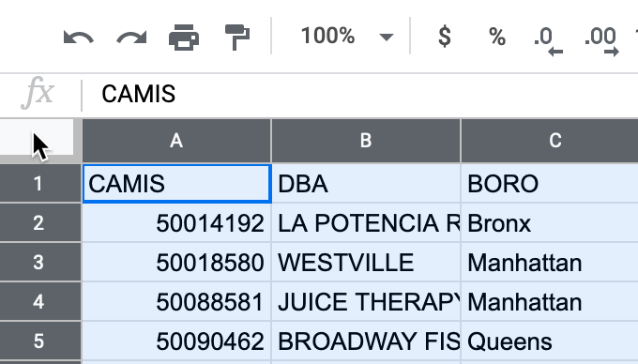

Figure 12: Click the upper-left corner to select all cells before sorting.

Warning: If you forget to select all cells, you might accidentally sort one column independently of the others, which would scramble your entire dataset and make it meaningless. Always select all cells before sorting!

1. Go to *Data > Sort Range* to review all of your sort options. In the next screen, check the *Data has header row* box to view the column headers in your data. Let’s sort the *SCORE* column in ascending order (from A-Z), as shown in Figure 13, to display the lowest-scoring restaurants at the top of the sheet.

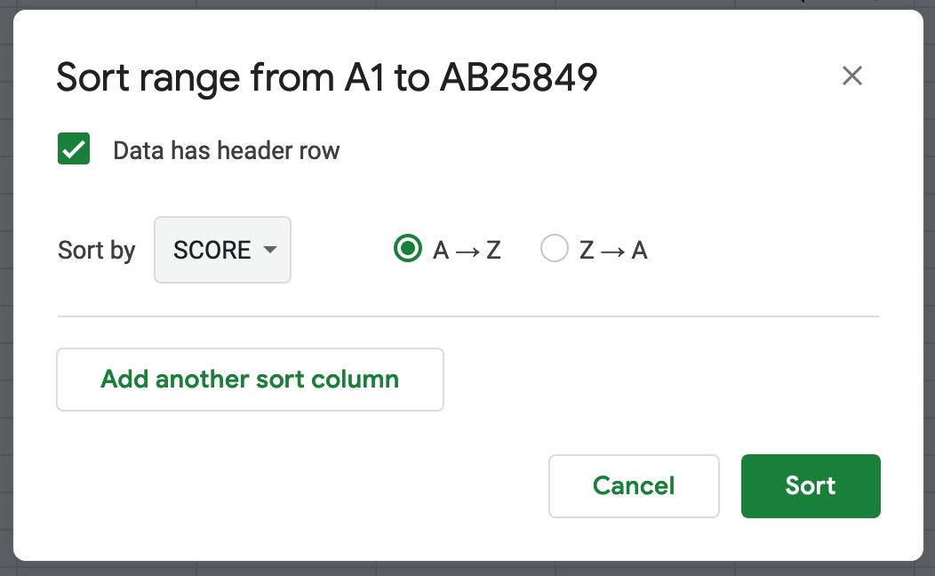

Figure 13: Go to *Data > Sort Range*, check the header row box, and sort by *SCORE* in ascending order.

1. Now let’s try filtering your sheet. Go to *Data > Create a Filter*, which inserts downward arrows in each column header. Click on the downward arrow in the *BORO* column, and see options to display or hide rows of data. For example, click only the *Manhattan* boro, and unclick all of the other options, to display only rows with that name, as shown in Figure 14.

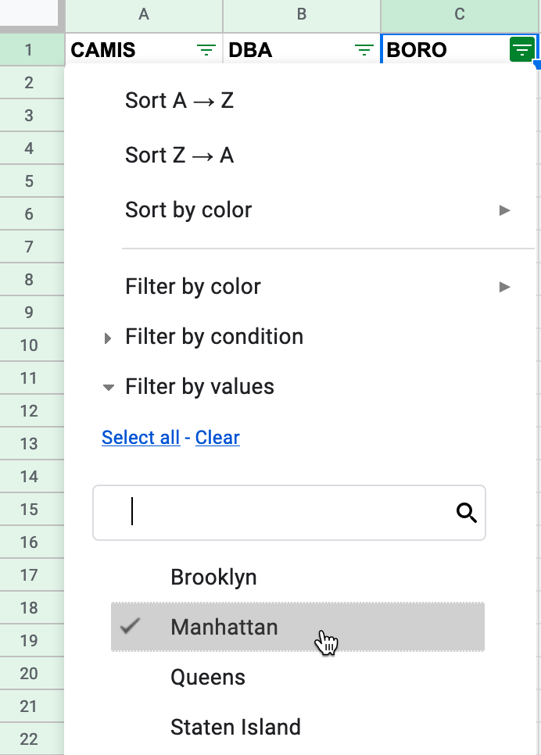

Figure 14: Go to *Data > Create a Filter*, and in the *BORO* column, select only *Manhattan*.

By sorting and filtering large spreadsheets, you can begin to focus on key details in your data. Where should we *not* go out for lunch?

## Calculate with Formulas and Functions

Spreadsheet tools can save you lots of time when you insert simple formulas and functions to automatically perform calculations across entire rows and columns of data. In this section you’ll learn how to write a simple formula that adds up a column of numbers, then you’ll insert built-in functions to show the sum and average.

1. Open this Google Sheet of [Measles cases in three nations 2010-18](https://docs.google.com/spreadsheets/d/15Q16jcgoIcoQ-UkAJ3nfQpU-4d_Hk6tJqEYoobmnxY0/), a subset of [data from the World Health Organization](https://www.who.int/data/gho/data/indicators/indicator-details/GHO/measles---number-of-reported-cases). Log into your Google Drive account, and go to *File > Make a Copy* to edit your own version.
2. Let’s calculate the total number of reported cases in 2010 by inserting a simple formula that adds up the cells for Canada, Mexico, and the US that year. Spreadsheet formulas begin with an = equal sign, and refer to specific cells and operations. Click on cell B5 and type in = B2 + B3 + B4 then press *Return* or *Enter*. A total of 162 cases in 2010 will appear in the cell where you entered the formula.
3. Now let’s speed up our work using the built-in SUM function to total up numbers for us. Click on column C5 and type in =SUM(C2:C4), which calculates the sum of all of the cells between C2 and C4. then press *Return*. A total of 1,026 cases in 2011 will appear.
4. Now let’s speed up our work even more by using the built-in click-and-drag tool to extend the SUM calculation across the row for each remaining year. Click in cell C5, and float your cursor over the dot in the bottom-right corner, which transforms your cursor into a crosshair symbol. Then click-and-drag your crosshair cursor from cell C5 to J5, which automatically copies and pastes the formula in each cell, and let go, as shown in Figure 15.

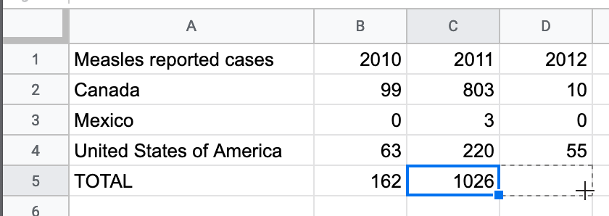

Figure 15: Click on the bottom-right dot to transform your cursor into a crosshair, then drag to paste the formula, as shown in this [animated GIF](https://handsondataviz.org/images/02-spreadsheet/drag-calculation.gif).

1. We can use another built-in function to calculate the average number of reported cases for each nation over time. Click in cell K2 and type in =AVERAGE(B2:J2) or select it if the tool suggests it. Then click the right-corner dot in cell K2 and drag downward to extend the calculation for the other rows.

Tip: Spreadsheet tools ignore empty cells when performing calculations. In this example, the World Health Organization did not list any data for the US in 2018.

Warning: When you save a spreadsheet in CSV format, your calculated results will remain, but any formulas that created those results will disappear from the CSV sheet. Keep the original in a spreadsheet format as a reminder about how you constructed the formulas.

Spreadsheet tools contain many more functions to perform numerical calculations and also to modify text. See more examples in the “Split data into two or more columns” and “Combine columns into one” sections in [Chapter 4: Clean Up Messy Data](clean.html). In the next section, you’ll learn a more advanced spreadsheet method to regroup data with a pivot table.

## Regroup Data with Pivot Tables

Pivot tables are another powerful feature built into spreadsheet tools to help you regroup or rearrange your data, hence the name “pivot.” In this section we’ll start with a sheet that contains an anonymous partial class roster for an online data visualization class we previously taught. Each row represents an individual student, including their birth year, gender, and country of origin. You’ll learn how to “pivot” this individual-level data into a new sheet that cross-tabulates the number of students by birth year and gender.

1. Open this [Google Sheet of Sample Students](https://docs.google.com/spreadsheets/d/1FYTiLHfOI2caT2lkI4i8fGbhA-oKT_MSOP1vQWWC9MA), log into your Google Drive, and go to *File > Make a Copy* to edit your own version.
2. Go to *Data > Pivot Table*, and on the next screen, select *Create* in a new sheet, as shown in Figure 16.

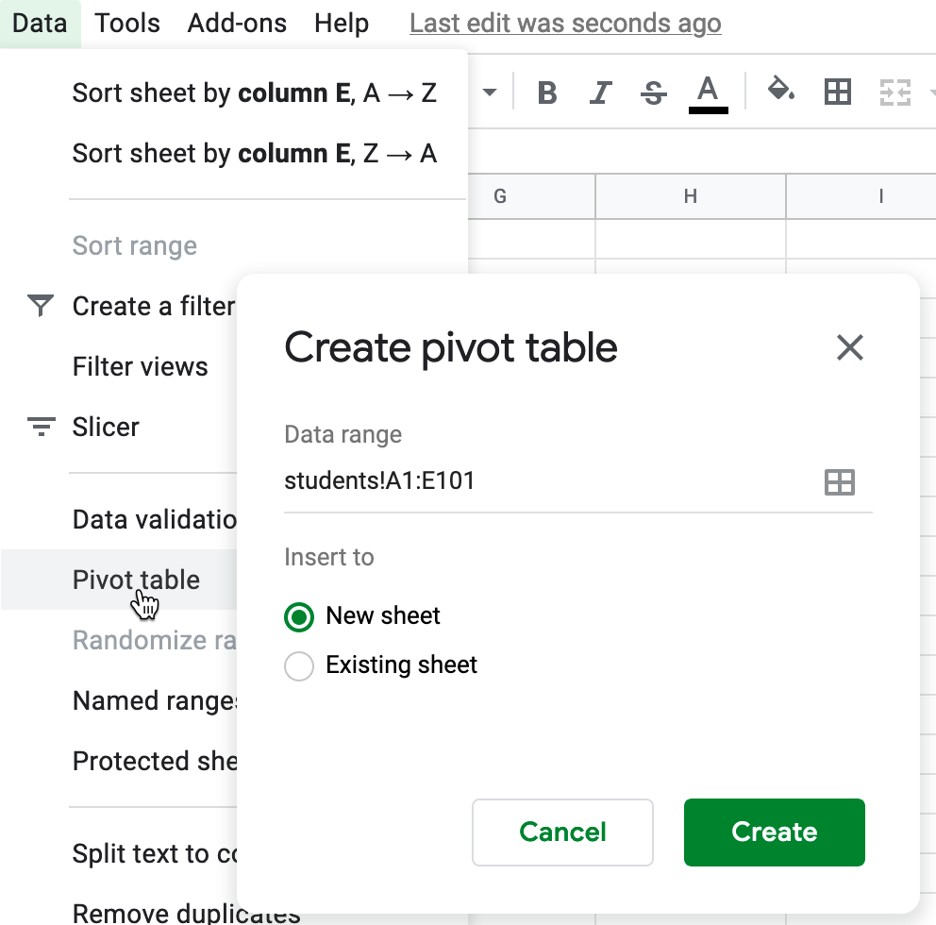

Figure 16: Go to *Data > Pivot Table*, and create in a new sheet.

1. In the *Pivot table editor* screen, you can regroup data from the first sheet by adding rows, columns, and values. First, click the Rows *Add* button and select *year*, which shows each of the unique entries for birth year in column A.
2. Next, to count the number of students for each birth year, click the Values *Add* button and select *year* again. Initially, the pivot table will summarize by adding up the total of all birth years, but you don’t want that. Instead, change the *Summarize by* drop-down menu to *COUNT*, which shows the frequency for each row, as shown in Figure 17.

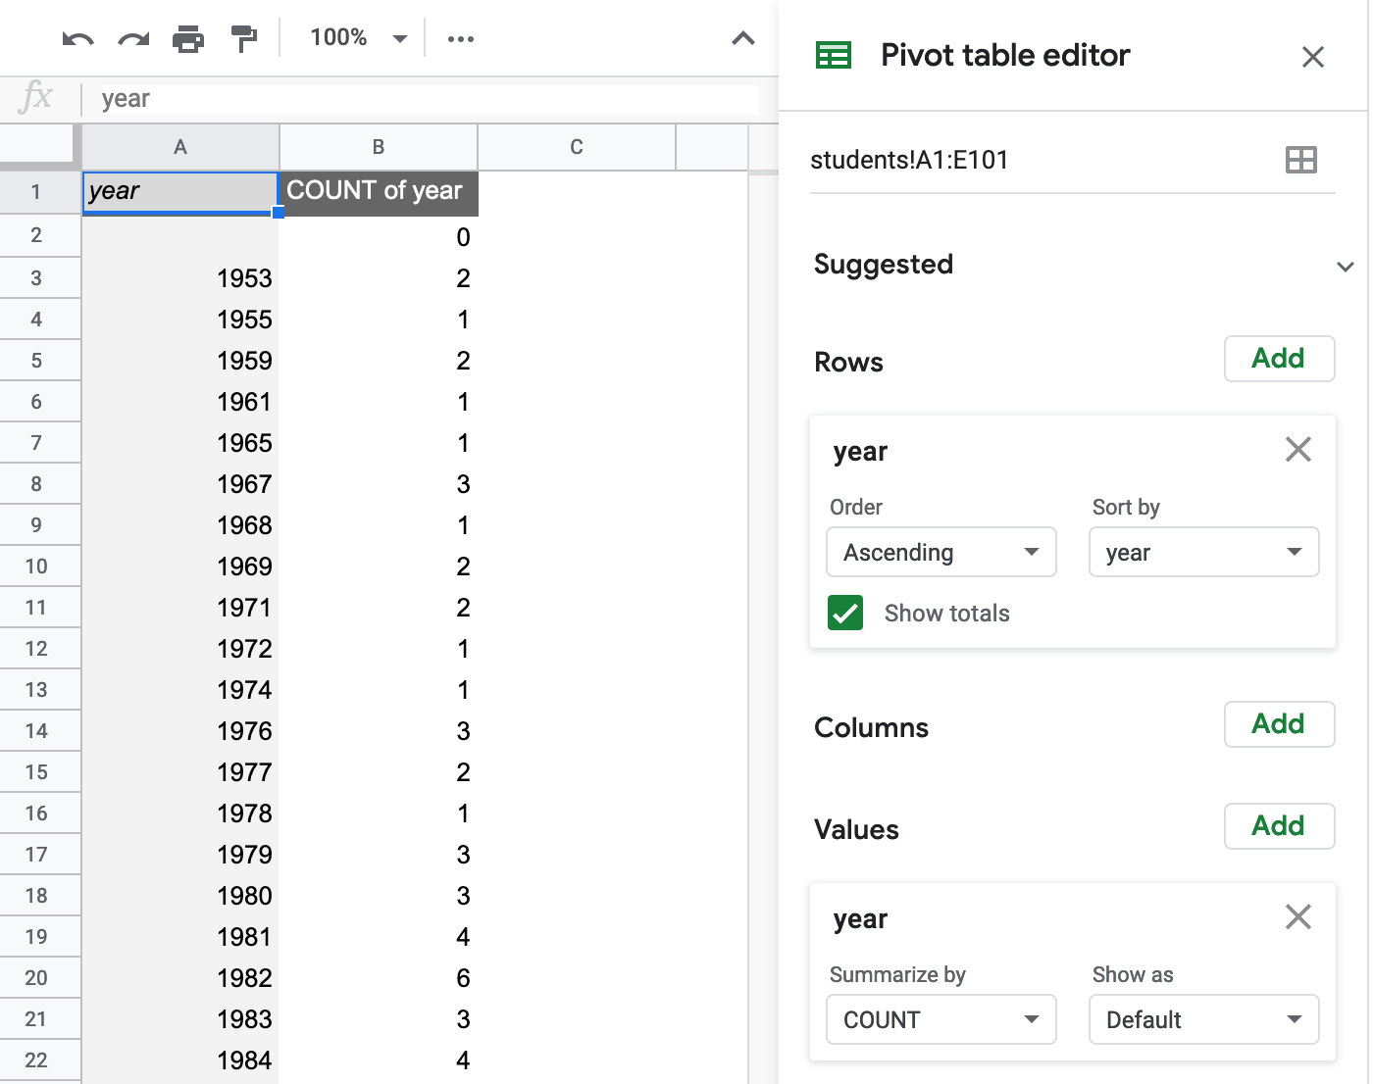

Figure 17: In the Google Sheets pivot editor, add *year* as a Row, and add *year* again as a Value, but change *Summarize by* to *Count*, as shown in this [animated GIF](https://handsondataviz.org/images/02-spreadsheet/sheets-pivot-editor.gif).

Tip: *COUNT* summarizes numerical values, and *COUNTA* summarizes text values.

1. You can create more advanced pivot tables by adding a *Column* header, such as *gender*, to display a cross-tabulation of students by birth year and gender. Furthermore, you can also *Filter* the data, for example, to show only students who listed *US* as their country of origin.

While pivot tables may look a bit different across other spreadsheet tools, the concept is similar. Learn more about how pivot tables work in the [support pages for LibreOffice](https://help.libreoffice.org/Calc/Creating_Pivot_Tables) and [Microsoft Excel](https://support.microsoft.com/en-us/office/create-a-pivottable-to-analyze-worksheet-data-a9a84538-bfe9-40a9-a8e9-f99134456576). Click to download and save this [sample student data in CSV format](https://handsondataviz.org/data/sample-students.csv) to your computer to upload into either tool.

Now that you’ve learned how to regroup data with pivot tables, let’s move on to another common task of matching data columns from different sheets.

## Match Columns with VLOOKUP

Spreadsheet tools also allow you to “look up” matching data from one sheet and automatically paste it into another sheet, using the “VLOOKUP” function. The “V” stands for “vertical” lookup, which means making matches across columns, the most typical way to lookup data. In this section you’ll learn how to write a function in one sheet that looks for matching data in a second sheet, and pastes it into a new column in the first sheet.

Here’s a common problem where “VLOOKUP” can save you lots of time. Imagine two spreadsheets. The first sheet, which we saw in the previous section, contains a list of students enrolled in a class, where each row includes a two-letter code for their country of origin. But some abbreviations may not be familiar to everyone. A second sheet contains a list of all of the two-letter abbreviated codes, plus the full name of each country, as shown in Figure 18. Your goal is to “lookup” each student’s two-letter code in the second sheet, and paste the full name of each country for each row in the first sheet. Doing this manually would require lots of your time, but learning how to use the VLOOKUP function will do the work for you automatically.

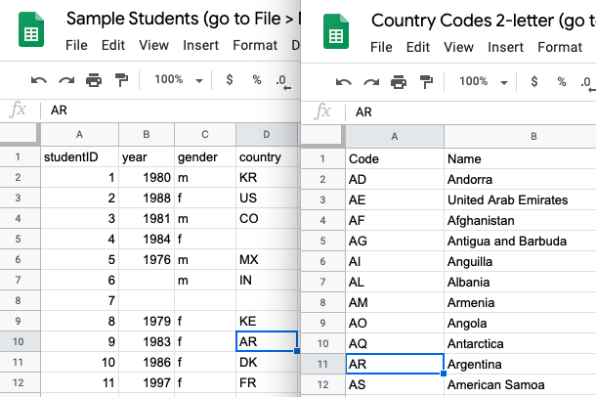

Figure 18: The problem: match each two-letter code in the left sheet with the full country name in the right sheet.

1. In one browser tab, open this [Google Sheet of Sample Students](https://docs.google.com/spreadsheets/d/1FYTiLHfOI2caT2lkI4i8fGbhA-oKT_MSOP1vQWWC9MA). In another tab, open this [Google Sheet of Country Codes 2-letter](https://docs.google.com/spreadsheets/d/1iuImHkn2Aotf-0g6pcKv6e65QLWICjVHNUrcGfPxQNE). Log into your Google Drive, and go to *File > Make a Copy* to create your own version of both sheets, so that you can edit them.
2. Let’s simplify this two-file problem by copying all of the data into one Google Sheet. Go to the Country Codes sheet, select the *countries* tab, and go to *Copy to > Existing spreadsheet*, and select *Sample Students,* as shown in Figure 19. Go back to the *Sample Students* sheet and you’ll see a new tab named *Copy of countries*.

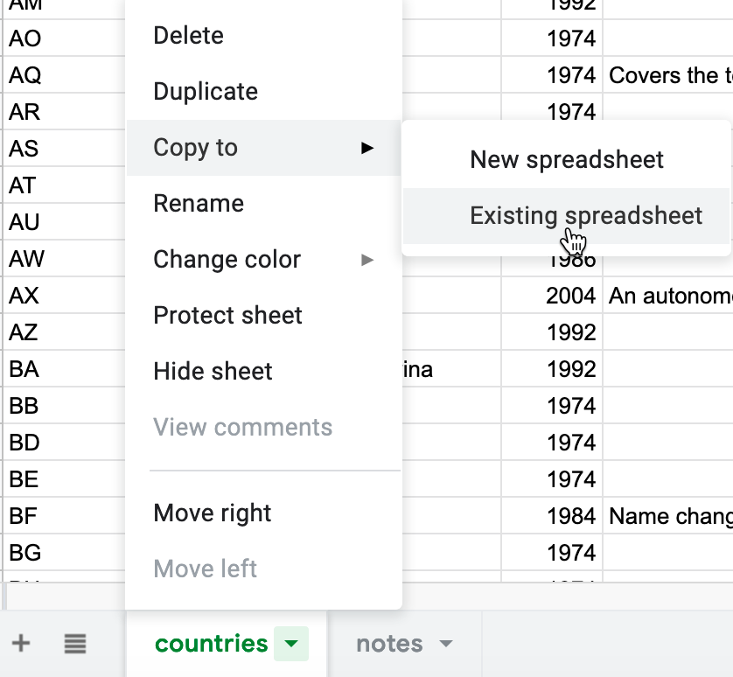

Figure 19: Copy the *countries* data into the existing *Sample Students* sheet.

1. In the Sample Students sheet, in the *students* tab, click in cell E1 and type country name. This creates a new column header where lookup results will be automatically pasted.
2. Click in cell E2 and type =VLOOKUP and Google Sheets will suggest that you complete the full formula in this format:

VLOOKUP(search_key, range, index, [is_sorted])

Here’s what each part means:

* search_key = The cell in Sheet 1 you wish to match.
* range = At least two columns in Sheet 2 to search for your match and desired result.
* index = The column in the Sheet 2 range that contains your desired result, where 1 = first column, 2 = second column, etc.
* [is_sorted] = Enter false to find exact matches only, which makes sense in this case. Otherwise, enter true if the first column of the Sheet 2 range is sorted and you will accept the closest match, even if not an exact one.

1. Type in the full VLOOKUP formula or click on the relevant cells and columns to automatically enter it. Your formula should look similar to =VLOOKUP(D2,'Copy of countries'!A:B,2,false), as shown in Figure 20, but may differ if you have different tab names.

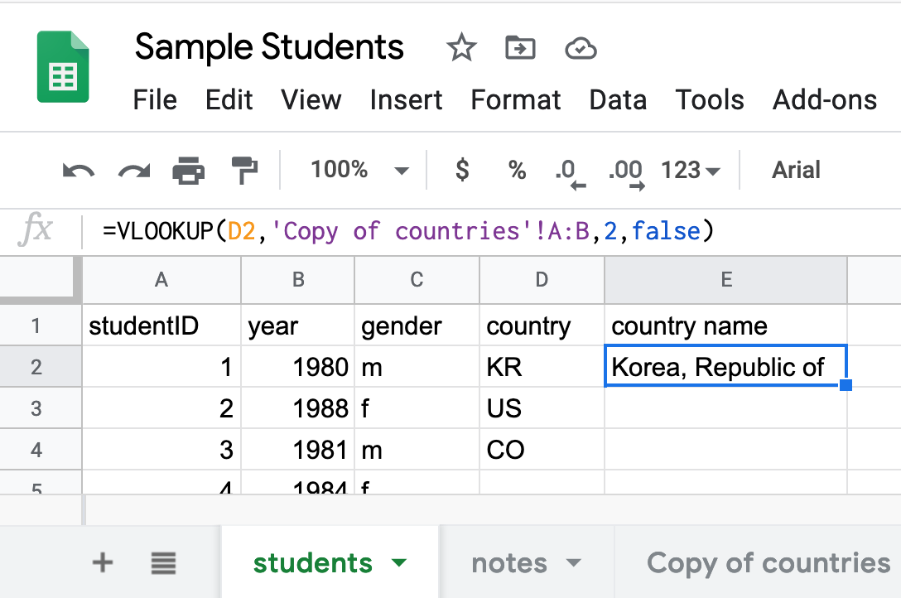

Figure 20: Your VLOOKUP formula should look similar to this, depending on your tab names.

Let’s break down each part of that formula, separated by commas:

* D2 = The search_key, the cell you want to match in the *students* tab.
* *‘Copy of countries’!A:B* = The range, meaning you are searching for matches and results in all of columns A and B in the *Copy of countries* tab.
* 2 = The index, meaning your desired result appears in the 2nd column of the range above.
* *false* = Display exact matches only.

1. After you enter the full VLOOKUP formula, press *Enter* on your keyboard, and the result should display an exact match, if found. In this example, the student with country code KR should also display its full country name, Korea, Republic of. Float your cursor over the dot in the bottom-right corner of that cell to drag down the results.

While we used Google Sheets to demonstrate how to “lookup” matching data in another spreadsheet column, the

Now that you understand how to use the VLOOKUP function to match columns data columns across spreadsheets, the next section will introduce you to the concept of a relational database, and when you might want to use one.

## Connect Sheets with Relational Database

In the previous section, you learned how the VLOOKUP function can search for matching data in columns across spreadsheets and automatically paste results. Building on that concept, let’s distinguish between a spreadsheet and a relational database, and in what cases you might want to use the latter.

A spreadsheet is sometimes called a “flat-file database” because all of the records are stored in rows and columns in a single table. For example, if your company kept track of all of your orders and customers in a spreadsheet, the entries would appear like this:

Order Customer Location  
1 Janice New York  
2 Jean Seattle  
3 Jim Dallas  
4 Joe Los Angeles  
5 Julius Chicago  
6 Janice New York  
7 Julius Chicago

In a spreadsheet, every time a customer placed an order, their location would need to be entered separately, which would mean lots of duplicated information. Also, updates would requiring changing the same information in multiple places in your spreadsheet.

By contrast, if your company used a relational database, you would maintain two tables—one for orders and one for customers—with links between them, like this:

Order Customer  
1 Janice   
2 Jean  
3 Jim  
4 Joe   
5 Julius  
6 Janice  
7 Julius  
  
  
Customer Location  
Janice New York  
Jean Seattle  
Jim Dallas  
Joe Los Angeles  
Julius Chicago

When someone’s address changed, in a relational database it would only need to be updated in one place—the customer table—and only one time. Also, by separating data into different tables, it would be easier to add up your total customers without counting duplicates.

If you’re responsible for managing data tables with relationships between them, especially one-to-many relationships (such as where Janice and Julius each place multiple orders), consider the pros and cons of working with a relational database. Years ago, relational databases required complex software that was not easy to set up. But a newer generation of tools such as [AirTable](http://airtable.com) enable you to create relational databases in your web browser with up to 1,200 free records (and more with the paid version), using existing templates (or design your own), and collaborative editing with your co-workers. Furthermore, Airtable supports data migration by allowing you to export all of your records in CSV format.

While the details of setting up a relational database are beyond the scope of this chapter, it’s important to understand the conceptual difference between a “flat-file” spreadsheet and a collection of data tables with linked relationships. In the next section, we’ll describe how to collect data using online forms, a feature found in Google Sheets, Airtable, and several other tools.

## Collect Data with Online Forms

No doubt, everyone with an email address has been asked to fill out at least one online form. We promise *not* to send you another! But if you need to collect simple data from people who communicate digitally with you, sometimes the easiest solution is to send them an online form that compiles their responses in a data table, which can be much faster than re-entering information from paper forms.

If you already have a Google Drive account, one tool that many people overlook is Google Forms, which is partially hidden under *New > More > Google Forms*, as shown in Figure 21.

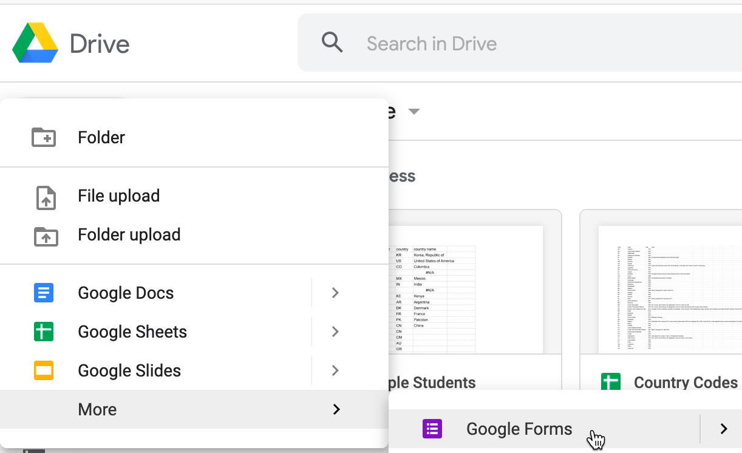

Figure 21: The Google Forms tool is partially hidden in the Google Drive *New > More* menu.

The Google Forms *Questions* tab allows you to request different types of responses: short- and paragraph-length answers, multiple choice, checkboxes, file uploads, etc., as shown in Figure 22. Click the *Preview* (eyeball) button to see how your form will appear to users, then click the *Send* button to distribute via email, a link, or an iframe. You can learn more about how to use the latter in [Chapter 7: Embed On Your Web](embed.html).

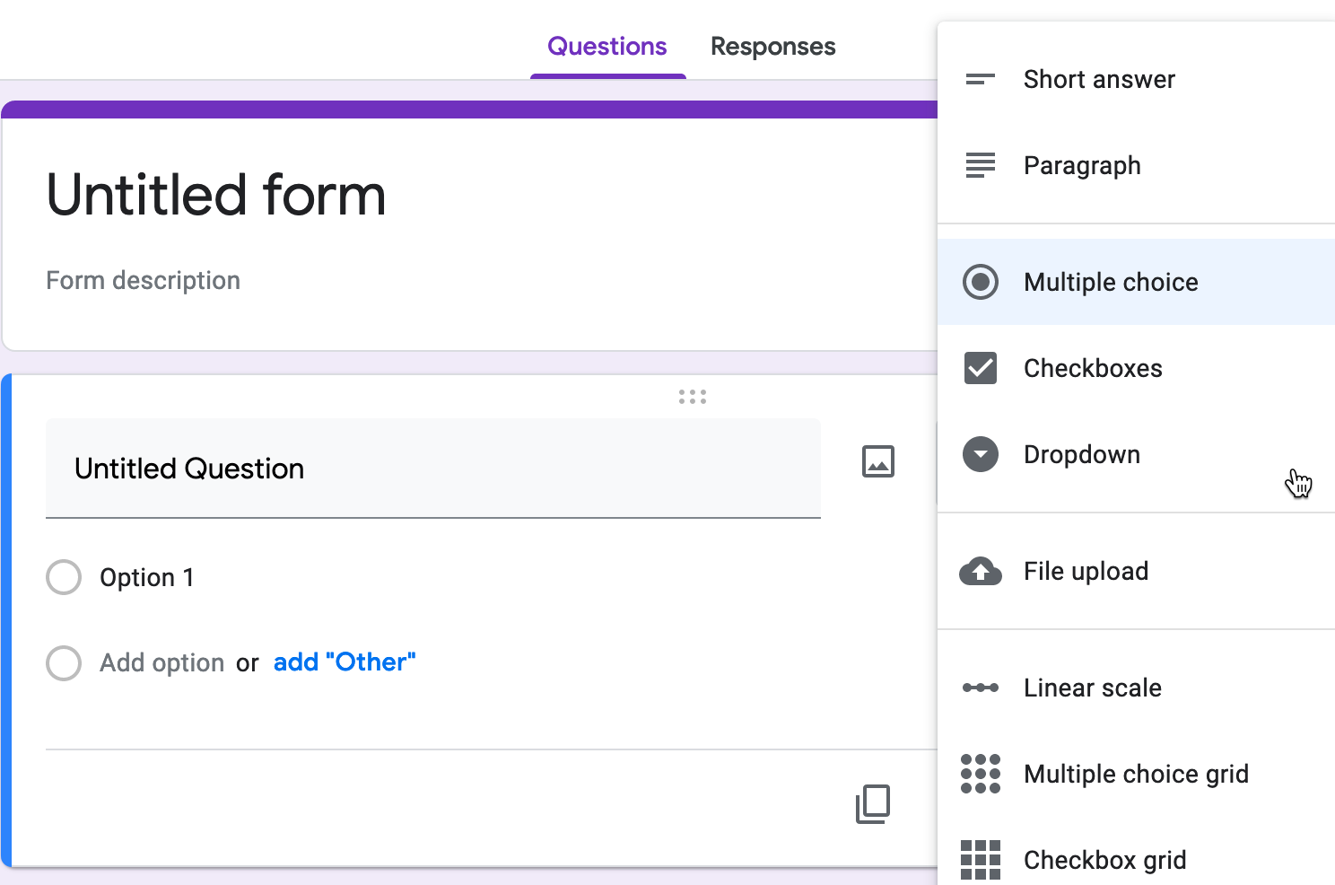

Figure 22: The Google Forms *Questions* tab allows you to request different types of responses.

The Google Forms *Responses* tab includes a button to open answers you receive in a linked Google Sheet, as shown in Figure 23. As you’ve learned in this chapter, data becomes more powerful when you can share, organize, and analyze it using spreadsheet tools to help reveal and tell its underlying stories.



Figure 23: The Google Forms *Responses* tab includes a button to open answers in a linked Google Sheet.

**Summary** If you’re one of the many people who “never really learned” about spreadsheets in school or on the job, or if you’ve taught yourself bits and pieces along the way, we hope that this chapter has successfully introduced or refreshed your skills. All of the subsequent chapters in this book, especially those on designing interactive charts and maps, require a basic level of familiarity with spreadsheets. In addition to serving as incredible time-savers when it comes to tedious data tasks, the spreadsheet tools and methods featured above are designed to help you share, sort, calculate, as well as more advanced skills in pivoting tables and matching with lookup tables, with the broader goal of telling your data stories.

The next chapter describes strategies for finding data, particularly on open data sites operated by governmental and non-profit organizations, where you’ll also need spreadsheet skills to download information in an organized way. See additional spreadsheet skills in later chapters of the book. [Chapter 4: Clean Up Messy Data](clean.html) demonstrates how to find and replace, split data into columns, and combine columns of data (such as when you need the street address, city, and postal code all in one line). [Chapter 11: Transform Your Map Data](transform.html) also features more advanced spreadsheet skills and tools, such as how to geocode addresses, pivot address points into polygons, and how to normalize data to create more meaningful polygon maps.

# Find and Know Your Data

In the early stages of a visualization project, you will likely ask two important and related questions: *Where can I find data?* and when I do, *How do I know what it really means?* If you skip over these questions and leap too quickly into constructing charts and maps, you run the risk of creating meaningless, or perhaps worse, misleading visualizations. This chapter breaks down both of these broad questions in greater detail, and provides concrete strategies to [recognize bad data](bad.html), [source your data](source.html), navigate [public versus private data](public.html), and search a growing number of [open data repositories](opendata.html).

When searching for data, your newest best friend may be a librarian. Sometimes a data-smart librarian happens to know exactly where to locate a dataset that you’ve been seeking for day. But their more valuable skill is guiding us on *how to search* by reflecting on the types of questions librarians commonly ask:

1. What types of organizations may have collected or published the data you seek? If a governmental organization may have been involved, then at what level (national, state/provincial, regional, or municipal), and which branch or agency? Or might data have been compiled by a non-governmental organization, such as academic institutions, journalists, for-profit corporations, or non-profit groups? Figuring out which organizations might have collected the data can help point you to the digital or print materials they typically publish, and most appropriate tools to focus your search in that particular area.
2. Have any prior publications drawn on similar datasets, and if so, how can we trace their sources? Some of our best data visualization ideas began while reading textual evidence or noticing a table in a print publication or outdated web page, which convinced us that the data existed *somewhere*. With these valuable leads, librarians can help you track down source notes on where the data originated, or sometimes find more up-to-date versions of the data.
3. What level(s) of data are available? Is information disaggregated by individual cases or aggregated into larger groups? Librarians can help us to decipher how and why different organizations publish data in different formats. For example, US Census seeks to collect data every ten years about each person residing in the nation, but under the law, this individual-level data is confidential and not released to the public for 72 years. You can look up individual census data for 1940 and earlier decades at the [US National Archives](https://www.archives.gov/research/genealogy/census/about) and other websites. But the US Census publishes current data for larger areas, such as neighborhood-level block groups, census tracts, cities, and states, by aggregating individual records into data tables, and suppressing small-numbered cells to protect people’s privacy. Librarians can help us understand organization’s guidelines on when and how they make data available at different levels.

If your search has produced some results, the next step is to get to know your data. Closely examine your files and ask questions about their origin, meaning, and limitations:

1. Who collected and published this data, and for what purpose? Since individuals and organizations require time and resources to do this work, seek to clarify their motivations and assumptions, both explicit and implicit ones. Who was the intended audience of the work? Whose perspectives does the data privilege? Whose stories remain untold? As practitioners of data visualization, we strongly favor evidence-based reasoning over its less-informed alternatives. But we also caution against embracing so-called data objectivity. Numbers are *not* neutral, and we always need to consider the broader contexts in which people created them.
2. What do the data labels *really* mean? Most spreadsheets contain abbreviated column headers, particularly due to software character limits, but some questions of data interpretation run much deeper. For example, socially-constructed labels such as “race” or “gender” may not clarify how the creators defined their terms, or what role respondents played in the collection process. Even seemingly objective labels such as “income” or “population” or “elevation” may not adequately describe exactly what was counted, how it was measured, and the margins of error. Better-quality datasets include detailed definitions of the collection process to help you to understand the decisions made by its creators. If not, then your next best option may be to go out into the field, if feasible, and directly observe how the data is measured and collected.

To be clear, you may never *truly know* your data if it was collected by someone else, particularly a different person in a distant place or time. But don’t let that philosophical obstacles stop you from asking good questions about the origins and limitations of your data. Only by clarifying what we know—and what we don’t know—can we create meaningful data visualizations that bring their inner-stories to life.

## Recognize Bad Data

A vital skill needed by all data visualization creators is the ability to recognize bad data. If you fail to catch a problem in your data at an early stage, someone else may discover it later, which could diminish the credibility of all of your work. Fortunately, members of the data visualization community have shared multiple examples of issues we’ve encountered in our work, and newer members will benefit from our embarrassing mistakes. One popular crowd-sourced compilation by data journalists was [The Quartz Guide to Bad Data](https://github.com/Quartz/bad-data-guide), last updated in 2018, which includes several of these helpful warning signs:

Watch out for spreadsheets with “bad data”:

* Missing values: If you see blank or “null” entries, does that mean data was not collected? Or maybe a respondent did not answer? If you’re unsure, find out from the data creator. Also beware when humans enter a 0 or -1 to represent a missing value, without thinking about the consequences of running calculations.
* Missing leading zeros: The US Census Bureau lists every place using a FIPS code, and some spreadsheet users may accidentally convert text to numbers and strip out the leading zeroes. For example, the FIPS code for Los Angeles County is 037, but someone might accidentally strip out the leading zero and convert it to 37, which represents North Carolina.
* 65536 rows or 255 columns: These are the maximum number of rows supported by older-style Excel spreadsheets, or columns supported by Apple Numbers spreadsheet, respectively. If your spreadsheet stops exactly at either of these limits, you probably have only partial data.
* Inconsistent date formats: For example, November 3rd, 2020 is commonly entered in spreadsheets by Americans as 11/3/2020 (month-date-year), while many others around the globe type 3/11/2020 (date-month-year). Check your source.
* Dates such as January 1st 1900, 1904, or 1970: These are default timestamps in Excel spreadsheets and Unix operating systems, which may indicate the actual date was blank or overwritten.
* Dates similar to 43891: When you type March 1 during the year 2020 into Microsoft Excel, it automatically displays as 1-Mar, but is saved using Excel’s internal date system as 43891. If someone converts this column from date to text format, you’ll see Excel’s 5-digit number, not the dates you’re expecting. According to a [2016 report in the Washington Post](https://www.washingtonpost.com/news/wonk/wp/2016/08/26/an-alarming-number-of-scientific-papers-contain-excel-errors/), a team of geneticists detected a surprisingly high number of related Excel errors in papers published in leading scientific journals.

## Source Your Data

Another way to reduce “bad data” issues is to clarify the source every time you download or create a new spreadsheet file. Add details about where the data came from, so that someone other than you, several years in the future, has sufficient information to understand its origin and limitations.

The first step is to label every data file that you download or create. All of us have experienced bad file names like these:

* data.csv
* download.xls
* data2020.xlsx

Write a short but meaningful file name. While there’s no perfect system, a good strategy is to abbreviate the source (such as census or worldbank or eurostat), with topic keywords, and a date or range. If you or co-workers will be working on different versions of a downloaded file, include the current date in YYYY-MM-DD (year-month-date) format. Replace blank spaces with dashes (-) or underscores (_). Better file names look like this:

* town-demographics-2019-12-02.xls
* census2010_population_by_county.csv
* eurostat-1999-2019-CO2-emissions.xlsx

The second step is to save more detailed source notes about the data on a separate tab inside the spreadsheet (which works for multi-tab spreadsheet tools such as Google Sheets, LibreOffice, and Excel). Add a new tab named *notes* that describes the origins of the data, a longer description for any abbreviated labels, and when it was last updated, as shown in Figure 24. Add your own name and give credit to collaborators who worked with you. For CSV files, which do not support multi-tabs sheets, create a text file using a parallel file name.

 A third step is to make a backup of the original data before cleaning or editing it. For a simple one-sheet file in a multi-tab spreadsheet tool, right-click on the tab containing the data to make a duplicate copy in another tab, also shown in the preceding figure. Clearly label the new tab as a backup and leave it alone! For CSV files or more complex spreadsheets, create a separate backup file.

Make a habit of using these three sourcing strategies—filenames, notes, and backups—to reduce your chances of making “bad data” errors and to increase the credibility of your data visualizations. In the next section, we’ll address a related set of questions you should ask yourself regarding public versus private data.

## Public versus Private Data

In addition to asking questions about the origins and limitations of your data, it’s also important for you to be aware of important distinctions between public versus private data, and their implications for designing your visualizations. This section offers some general observations about data privacy based on our context in the United States. Since we are not lawyers (thank goodness!), please consult with legal experts for advice about your specific case.

Here’s what’s most important—and confusing—about access to data in the US. Individual-level data is often considered private, except in certain areas where our governmental process has determined that broader interests are served by making it public. First, here are two examples where individual-level data generally remains private:

* Patient-level health data is generally protected under the [Privacy Rule of the Health Insurance Portability and Accountability Act](https://en.wikipedia.org/wiki/Health_Insurance_Portability_and_Accountability_Act#Privacy_Rule), commonly known as HIPAA. But public health officials regularly aggregate individual patient records into larger anonymized public datasets to track progress about various illnesses.
* Student-level education data is generally protected under the [Family Educational Rights and Privacy Act](https://en.wikipedia.org/wiki/Family_Educational_Rights_and_Privacy_Act), commonly known as FERPA. But education officials regularly aggregate individual student records into larger anonymized public datasets to track the progress of schools, districts, and states.

But here are other examples where our government has determined that a broader interest is served by making individual-level data available to the public:

* Individual contributions to political candidates are public. You can search donors by name and address in this [US Federal Election Commission public database](https://www.fec.gov/data/receipts/individual-contributions/), as well as other state-level sites.
* Individual salaries for officers of tax-exempt organizations are public. You can search by name across a digitized database of Internal Revenue Service (IRS) 990 forms that tax-exempt organizations are required to submit on several platforms, such as ProPublica’s [Nonprofit Explorer](https://projects.propublica.org/nonprofits).
* Individual property ownership records are public, and increasingly online in many locations. For example, one company provides a [US public records directory](https://publicrecords.netronline.com/) with links to local government property records, where available. Follow the links to search the value of the home owned by the first author in West Hartford, Connecticut, how much he and his spouse paid for it, the number of bathrooms, and so forth.
* Individual police officer reports regarding “use of force” are public by New Jersey state law. But no one could easily search these local police department records until a team of journalists from NJ Advance Media created a public database, [The Force Report](https://force.nj.com/), where anyone can look up individual officers and investigate patterns of violence.

Also, the US federal government is subject to the [Freedom of Information Act](https://en.wikipedia.org/wiki/Freedom_of_Information_Act), which enables people to submit a “FOIA” request to obtain certain types of public records to improve government transparency. Many states and their municipalities are subject to related FOIA laws, which are listed by non-profit organizations such as the [National Freedom of Information Coalition](https://www.nfoic.org/). While some government agencies routinely delay or reject FOIA requests, others have learned that fighting against public information can be expensive, and have begun to pro-actively share more information on open data repositories.

## Open Data Repositories

Over the past decade, an increasing number of governmental and non-governmental organizations have begun to publicly share data through open data repositories. While some of these datasets were previously available as individual files on isolated websites, these growing networks have made open data easier to find, enabled more frequent updates, and sometimes have allowed live interaction. Open data repositories often include these features:

* View and Export: At minimum, open data repositories allow users to view and export data in common spreadsheet formats, such as CSV, ODS, and XLSX. Some repositories also provide geographical boundary files for creating maps.
* Built-in Visualization Tools: Several repositories offer built-in tools for users to create interactive charts or maps on the platform site. Some also provide code snippets for users to embed these built-in visualizations into their own websites, which you’ll learn more about in [Chapter 7: Embed on Your Web](embed.html).
* Application Programming Interface (APIs): Some repositories provide endpoints with code instructions that allow users to pull data directly from the platform into an external site or online visualization. When repositories continuously update data and publish an API endpoint, it can be an ideal way to display “nearly live” data in your visualization, which you’ll learn more about in [Chapter 10: Leaflet Map Templates](leaflet.html).

Due to the recent growth of open data repositories, especially in governmental policy and scientific research, there is no single website that lists all of them. Instead, we briefly mention just a few of the sites we turn to when hunting for types of data that may interest our readers, while acknowledging that we could have added many others:

TODO: Decide which links to include, remove, or others to add below….

United States open data:

* [Data.gov](https://www.data.gov/), the official repository for US federal government agencies.
* [Data.census.gov](https://data.census.gov), the main platform to access US Census Bureau data. The Decennial Census is a full count of the population every ten years, while the American Community Survey (ACS) is an annual sample count that produces one-year, three-year, or five-year estimates for different census geographies, with margins of error.
* [Open Data Network](https://www.opendatanetwork.com/) directory of primarily US state and municipal open data platforms by Socrata

International open data:

* [Eurostat](https://ec.europa.eu/eurostat), the statistical office of the European Union
* [Global Open Data Index](https://index.okfn.org/dataset/) by the Open Knowledge Foundation
* [Google Public Data](https://www.google.com/publicdata/directory)
* [openAfrica](https://africaopendata.org/) by Code for Africa
* [Open Data Inception](https://opendatainception.io/) a map-oriented global directory
* [World Bank Open Data](https://data.worldbank.org/)

In addition, students, staff, and faculty at better-resourced institutions of higher education also may have access to a paid library subscription to “closed” data repositories:

* [Social Explorer](https://www.socialexplorer.com/) includes decades of demographic, economic, health, education, religion, and crime data for local and national geographies, primarily for the US, Canada, and Europe. Previously, some access was public, but now requires paid subscription or 14-day free trial.
* IPUMS NHGIS?
* more?

**Summary**

This chapter reviewed two broad questions that everyone should ask during the early stages of their visualization project: *Where can I find data?* and *How do I know what it really means?* We broke down both questions into more specific parts to develop your knowledge and skills in recognizing bad data, sourcing the origins of your data, distinguishing between public versus private data, and navigating the growing number of open data repositories. As you leap into the next few chapters on cleaning data and creating interactive charts and maps, remember these lessons as you strive to create meaningful visualizations.

# Clean Up Messy Data

More often than not, datasets will be messy and hard to visualize right away. They will have missing values, various spelling of the same categories, dates in different formats, text in numeric-only columns, multiple things in the same columns, and other unexpected things (see Figure 25 for inspiration). Don’t be surprised if you find yourself spending longer cleaning up data than actually analyzing and visualizing it—it is often the case for data analysts.



Figure 25: More often than not, raw data looks like this.

It is important to learn several tools in order to know which one to use to clean your data efficiently. We will start by looking at fairly basic data cleanup using Google Sheets. Keep in mind that the same principles (and in most cases even the same formulas) can be use in Microsoft Excel, LibreOffice Calc, Mac’s Numbers, or other spreadsheet packages.

We will then show you how to extract table data from PDF documents using a free tool called Tabula. Tabula is used by data journalists and researchers worldwide to analyze government spendings, procurement records and all sorts of other datasets that get trapped in PDFs.

At the end, we will introduce OpenRefine, an extremely powerful and versatile tool to clean up the messiest spreadsheets, such as those containing dozens of misspelled versions of universities or town names.

## Clean Data with Spreadsheets

Let’s take a look at some techniques to clean up data directly in your favorite spreadsheet tool. We will use Google Sheets as an example, but the same principles will apply to most other software packages, such as Excel, Calc, or Numbers.

#### Find and Replace with a blank

A common problem with census data is that geographic names contain unnecessary words. For example, your data can look something like that:

Hartford town  
New Haven town  
Stamford town

But you want a clean list of towns, either to display in a chart, or to merge with a different dataset:

Hartford  
New Haven  
Stamford

Here’s one quick solution: In any spreadsheet tool, use the Find and Replace command to remove unwanted characters. You can download our [sample file](data/find-replace-town-geonames.csv), which contains 169 Connecticut towns and their population, for the exercise.

1. Select the column you want to modify by clicking on the column header. If you don’t, you will be searching and replacing in the entire spreadsheet.
2. From *Edit* menu, choose *Find and replace* item. You will see the window like is shown in Figure 26.
3. In the *Find* field, type town, without quotation marks and leaving a space before the word. If you don’t leave the space, you will accidentally remove *town* from *Newtown*, and you will end up with trailing spaces which can cause troubles in the future.
4. Leave the *Replace with* field blank.
5. *Search* field should be set to the range you selected in step 1, or *All sheets* if you didn’t select anything.
6. You have the option to *match case*. If checked, town and Town and tOwN will be treated differently. For our purpose, you can leave *match case* unchecked.
7. Press the *Replace all* button. Since this sample file contains 169 towns, the window will state that 169 instances of “town” have been replaced.

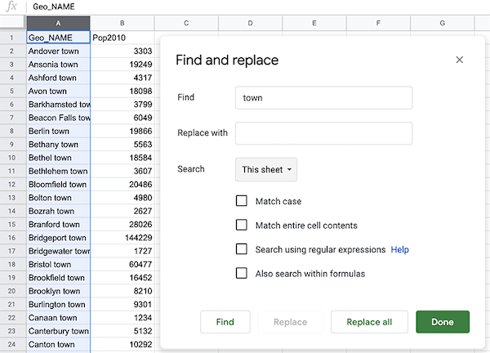

Figure 26: Find and Replace window in Google Sheets.

#### Split data into two or more columns

Sometimes multiple pieces of data appear in a single cell, such as names (John Doe), coordinate pairs (40.12,-72.12), or addresses (300 Summit St, Hartford, CT, 06106). For your analysis, you might want to split them into separate entities, so that your *FullName* column (with John Doe in it) becomes *FirstName* (John) and *LastName* (Doe) columns, coordinates become *Latitude* and *Longitude* columns, and your *FullAddress* column becomes 4 columns, *Street*, *City*, *State*, and *Zip* (postcode).

##### Example 1

Let’s begin with a simple example of coordinate pairs. You can use our [sample file](data/split-coordinate-pairs.csv), which is a collection of latitude-longitude pairs separated by a comma, with each pair on a new line.

1. Select the data you wish to split, either the full column or just several rows. Note that you can only split data from one column at a time.
2. Make sure there is no data in the column to the right of the one you’re splitting, because all data there will be written over.
3. Go to *Data* and select *Split text to columns*, as in Figure 27.
4. Google Sheets will try to guess your separator automatically. You will see that your coordinates are now split with the comma, and the Separator is set to *Detect automatically* in the dropdown. You can manually change it to a comma (,), a semicolon (;), a period (.), a space character, or any other custom character (or even a sequence of characters — more about that in Example 2 of this section).
5. You can rename columns into *Longitude* (first number) and *Latitude* (second number).

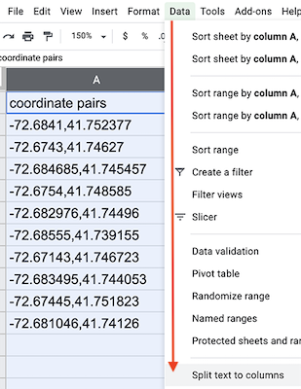

Figure 27: Select Data > Split text to columns to automatically separate data.

##### Example 2

Now, let’s look at a slightly more complicated example. Imagine your dataset is structured as follows:

| Location |  
| 300 Summit St, Hartford CT--06106 |  
| 1012 Broad St, Hartford CT--06106 |  
| 37 Alden St, Hartford CT--06114 |

Each cell contains a full address, but you want to split it into four cells: street address (300 Summit St), city (Hartford), state (CT), and zipcode (06106). Notice that the separator between the street and the rest of the address is a comma, a separator between the city and state is a space, and there are two dash lines between state and zipcode.

1. Start splitting left to right. So your first separator will be a comma. Select your column (or one or more cells within that column), and go to *Data* > *Split text to columns*.
2. Google Sheets should automatically split your cell into two parts, 300 Summit St and Hartford CT--06106, using comma as a separator. (If it didn’t, just select *Comma* from the dropdown menu that appeared).
3. Now, select only the second column and perform *Split text to columns*. You will see that the city is now separate from the state and zipcode, and Google Sheets chose space as a separator (if it didn’t, choose *Space* from the dropdown menu).
4. Next, select only the third column and perform *Split text to columns* again. Google Sheets won’t recognize -- as a separator, so you will have to manually select *Custom*, type -- in the text field, and hit Enter. You should now have four columns.

Tip: Google Sheets will treat zipcodes as numbers and will delete leading zeros (so 06106 will become 6106). To fix that, select the column, and go to *Format > Number > Plain text*. Now you can manually re-add zeros. If your dataset is large, consider concatenating 0s using the formula introduced in Combine separate columns into one.

#### Combine separate columns into one

Now, let’s see how to perform the reverse action. Imagine you receive address data in separate columns, formatted like this:

| Street | City | State | Zip |  
| 300 Summit St | Hartford | CT | 06106 |

The data comes is four columns: street address, city, state, and zipcode. Let’s say your mapping tool requires you to combine all of this terms into one location column, like that:

| Location |  
| 300 Summit St, Hartford, CT 06106 |

You can write a simple formula to combine (or concatenate) terms using ampersands (&) as cells values connectors, and quoted spaces (" "), or spaces with commas (", "), or a dash with spaces on both sides (" - "), or anything else as term separators.

For example, imagine that a spreadsheet contains an address that is separated into four columns—*Address, City, State,* and *Zip*—as shown in columns A-D in Figure 28. In column E, you can add new header named *Location* and insert a formula in this format, to combine the items using ampersands (&) and separating them with quoted spaces (" "), like this: =A2&" "&B2&" "&C2&" "&D2



Figure 28: Use ampersands to combine items and separate them with spaces.

You are now able to split data to columns using custom separators, and concatenate values from different cells into one. But what if your table is trapped inside a PDF? In the next section, we will introduce Tabula and show you how to convert tables from PDF documents into tables that you can analyze in Google Sheets, Microsoft Excel, or similar packages.

## Extract Tables from PDFs with Tabula

It sometimes happens that the dataset you are interested in is only available as a PDF document. Don’t despair, you can *likely* use Tabula to extract tables and save them as CSV files.

Tabula is a free tool that runs on Java, and is available for Mac, Windows, and Linux computers. It runs on your local machine and does not send your data to the cloud, so you can also use it for sensitive documents.

Note: Keep in mind that PDFs generally come in two flavors, image-based and text-based. You know your PDF is text-based if you can use cursor to select and copy-paste text. These are great for Tabula. Image-based PDFs are those that were created from scanning documents. Before they can be processed with Tabula, you will need to use an optical character recognition (OCR) software, such as Adobe Acrobat, to create a text-based PDF.

### Set Up Tabula

[Download the newest version of Tabula](https://tabula.technology/). You can use download buttons on the left-hand side, or scroll down to the *Download & Install Tabula* section to download a copy for your platform.

Unlike most other programs, Tabula does not require installation. Just unzip the downloaded archive, and double-click the icon. If prompted with a security message (such as “Tabula is an app downloaded from the internet. Are you sure you want to open it?”), follow the instruction to proceed (on a Mac, click *Open*; you might have to go to System Preferences > Security & Privacy, and resolve the issue there).

Your default system browser should open, like shown in Figure 29. The URL will be something like http://127.0.0.1:8080/, meaning Tabula is running on your local machine. 127.0.0.1, also known as localhost, is the hostname for your machine. 8080 is called port (it’s okay if you see a different port—most likely because 8080 was taken by some other program running on your computer). If for any reason you decide to use a different browser, just copy-paste the URL.



Figure 29: Tabula welcome page.

### Load a PDF and Autodetect Tables

Since the beginning of the Covid-19 pandemic, the Department of Public Health in Connecticut has been issuing daily PDFs with case and death count by town. For the demonstration, we will use [one of those PDFs](data/ct-dph-covid-2020-05-31.pdf) from May 31, 2020.

1. Select the PDF you want to extract data from by clicking the blue *Browse…* button.
2. Click *Import*. Tabula will begin analyzing the file.
3. As soon as Tabula finishes loading the PDF, you will see a PDF viewer with individual pages. The interface is fairly clean, with only four buttons in the header.
4. The easiest first step is to let Tabula autodetect tables. Click the relevant button in the header. You will see that each table is highlighted in red, like shown in Figure 30.



Figure 30: Selected tables are highlighted in red.

### Manually Adjust Selections and Export

1. Click *Preview & Export Extracted Data* green button to see how Tabula thinks the data should be exported.
2. If the preview tables don’t contain the data you want, try switching between *Stream* and *Lattice* extraction methods in the left-hand-side bar.
3. If the tables still don’t look right, or you with to remove some tables that Tabula auto-detected, hit *Revise selection* button. That will bring you back to the PDF viewer.
4. Now you can *Clear All Selections* and manually select tables of interest. Use drag-and-drop movements to select tables of interest (or parts of tables).
5. If you want to “copy” selection to some or all pages, you can use *Repeat this Selection* dropdown, which appears in the lower-right corner of your selections, to propagate changes. This is extremely useful if your PDF consists of many similarly-formatted pages.
6. Once you are happy with the result, you can export it. If you have only one table, we recommend using CSV as export format. If you have more than one table, consider switching export format to *zip of CSVs*. This way each table will be saved as an individual file, rather than all tables inside one CSV file.

Once you exported your data, you can find it in a Downloads folder on your computer (or wherever you chose to save it). It is ready to be opened in Google Sheets or Microsoft Excel, analyzed, and visualized! In the following section, we are going to look how to clean up messy datasets with OpenRefine.

## Clean Data with OpenRefine

Consider a dataset that looks like the one in Figure 31. Can you spot any problems with it?



Figure 31: First 20 rows of the sample dataset. Can you spot any problems with it?

Notice how the funding amounts (last column) are not standardized. Some amounts have commas as thousands separators, some have spaces, and some start with a dollar character. Notice also how the Country column includes various spellings of North and South Korea. Datasets like this can be an absolute nightmare to analyze. Luckily, OpenRefine provides powerful tools to clean up and standardize such data.

Note: This data exerpt is from [US Overseas Loans and Grants (Greenbook) dataset](https://catalog.data.gov/dataset/u-s-overseas-loans-and-grants-greenbook), which shows US economic and military assistance to various countries. We chose to only include assistance to South Korea and North Korea for the years between 2000 and 2018. We added deliberate misspellings and formatting issues for demonstration purposes (although we did not alter values).

Download this [sample dataset](data/us-foreignaid-greenbook-koreas.csv) or use your own file with messy data. Inspect the file in any spreadsheet software. You can see that the dataset has four columns: year (between 2000 and 2018, inclusive), country (North or South Korea), a US funding agency, and funding amount (in 2018 US dollars). Let’s now use OpenRefine to clean it up.

### Set up OpenRefine

You can download a copy of OpenRefine for Linux, Mac, or Windows from the [official download page](https://openrefine.org/download.html). Just like Tabula, it runs in your browser and no data leaves your local machine, which is great for confidentiality.

If you work on a **Mac**, the downloaded file will be a .dmg file. You will likely encounter a security message that will prevent OpenRefine from launching. Go to System Preferences -> Security and Privacy, and hit *Open Anyway* button in the lower half of the window. If prompted with another window, click *Open*.

If you use **Windows**, unzip the downloaded file. Double-click the .exe file, and OpenRefine should open in your default browser.

Once launched, you should see OpenRefine in your browser with 127.0.0.1:3333 address (localhost, port 3333), like shown in Figure 32.



Figure 32: OpenRefine starting page.

### Load Data and Start a New Project

To begin cleaning up your messy dataset, you should load it into a new project. OpenRefine lets you upload a dataset from your local machine, or a remote URL on the web (including a Google Spreadsheet), or copy/paste data into a text field. OpenRefine is able to extract data directly from SQL databases, but this is beyond the scope of this book. We assume that you downloaded the sample dataset we provided (or you are using your own file), so let’s load it from your computer.

1. Under *Get data from: This computer*, click *Browse…* and select the file. Click Next.
2. Before you can start cleaning up data, OpenRefine allows you to make sure data is **parsed** properly. In our case, parsing means the way the data is split into columns. Make sure OpenRefine assigned values to the right columns, or change setting in *Parse data as* block at the bottom of the page until it starts looking meaningful, like shown in Figure 33.
3. Hit *Create Project* in the upper-right corner.



Figure 33: OpenRefine parsing options.

Now when you’ve successfully read the data into a new project, let’s start the fun part: converting text into numbers, removing unnecessary characters, and fixing the spellings for North and South Koreas.

### Convert Dollar Amounts from Text to Numbers

Once your project is created, you will see the first 10 rows of the dataset. You can change it to 5, 10, 25, or 50 by clicking the appropriate number in the header

Each column header has its own menu (callable by clicking the arrow-down button). Left-aligned numbers in a column are likely represented as text (as is the case with FundingAmount column in our example), and they need to be transformed into numeric format.

1. To transform text into numbers, open the column menu, and go to *Edit cells* > *Common transforms* > *To number*.
2. You will see that some numbers became green and right-aligned (success!), but most did not change. That is because dollar sign ($) and commas (,) confuse OpenRefine and prevent values to be converted into numbers.
3. Let’s remove $ and , from the FundingAmount column. In the column menu, choose *Edit cells* > *Transform*. In the Expression window, type value.replace(',', '') and notice how commas disappear in the preview window. When you confirm your formula works, click *OK*.
4. Now, repeat the previous step, but instead of a comma, remove the $ character. (Your expression will become value.replace('$', '')).
5. Perform Step 1 again. You will see that all but three cells turned green. That is because we have spaces and an a character at the end of one number. Fix those manually by hovering over cells, and clicking the edit button (in the new popup window, make sure to change *Data type* to *number*, and hit *Apply*, like in Figure 34).



Figure 34: Manually remove spaces and extra characters, and change data type to number.

At this point, all funding amounts should be clean numbers, right-aligned and colored in green. We’re ready to move on to the Country column and fix different spellings of Koreas.

### Cluster Similar Spellings

When you combine different data sources, or process survey data where respondents wrote down their answers as opposed to selecting them from a dropdown menu, you might end up with multiple spellings of the same word (town name, education level – you name it!). One of the most powerful features of OpenRefine is the ability to cluster similar responses.

If you use our original sample file, take a look at the *Country* column and all variations of North and South Korea spellings. From *Country* column’s dropdown menu, go to *Facet* > *Text facet*. This will open up a window in the left-hand side with all spellings (and counts) of column values. 26 choices for a column that should have just two distinct values, North Korea and South Korea!

1. To begin standardizing spellings, click on the arrow-down button of Country column header, and choose *Edit cells* > *Cluster and edit*. You will see a window like the one shown in Figure 35.
2. You will have a choice of two clustering methods, *key collision* or *nearest neighbor*. Both methods can be powered by different functions, but let’s leave the default *key collision* with *fingerprint* function.
3. OpenRefine will calculate a list of clusters. *Values in Cluster* column contains grouped spellings that OpenRefine considers the same. If you agree with a grouping, check the *Merge?* box, and assign the “true” value to the *New Cell Value* input box. In our example, this would be either North Korea or South Korea.
4. You can go through all groupings, **or** stop after one or two and click **Merge Selected & Re-Cluster** button. The clusters you chose to merge will be merged, and grouping will be re-calculated (don’t worry, the window won’t go anywhere). Keep regrouping until you are happy with the result.

Spend some time playing with *Keying function* parameters, and notice how they produce clusters of different sizes and accuracy.



Figure 35: Cluster similar text values.

### Export

Once you are done cleaning up and clustering data, save the clean dataset by clicking *Export* button in the upper-right corner of OpenRefine window. You can choose your format (we recommend CSV, or comma-separated value). Now you have a clean dataset that is ready to be processed and visualized.

**Summary**

In this chapter, we looked at cleaning up tables in Google Sheets, liberating tabular data trapped in PDFs using Tabula, and using OpenRefine to clean up very messy datasets. You will often find yourself using several of these tools on the same dataset before it becomes good enough for your analysis. We encourage you to learn more formulas in Google Sheets, and explore extra functionality of OpenRefine in your spare time.

You now know how to clean up your data, so let’s proceed to visualizing it. In the following chapter, we will introduce you to a range of free data visualization tools that you can use to build interactive charts and embed them in your website.

# Chart Your Data

Charts pull readers deeper into your story. Even if your data contains geographical information, sometimes a chart tells your story better than a map. But designing meaningful, interactive charts requires careful thought about how to communicate your data story with your audience.

In this chapter, we will look at main [principles of chart design](chart-design.html), and learn to identify good charts from bad ones. You will learn important rules that apply to all charts, and also some aesthetic guidelines to follow when customizing your own designs. In addition to static chart images, this book focuses on interactive charts that display more data when you float your cursor over them in your web browser. Later you’ll learn how to [embed interactive charts on your web](embed.html) in chapter 7.

To begin, this grid of basic chart types will help you decide which type you wish to create. Your decision will be based on the format of your data, and story you wish to tell, such as the type of data comparison you wish to draw to your reader’s attention. Once you choose your chart type, follow our tool recommendations to create it. This chapter features easy-to-learn drag-and-drop tools, such as the [Google Sheets chart tool](chart-google-sheets.html), and for more advanced charts, [Tableau Public](tableau-public.html), the free version of the powerful software used by many data analysts and visualization practitioners. The grid also refers to more powerful chart tools, such as [Chart.js code templates](chartjs.html) in chapter 9, which give you ever more control over how your design and display your data, but also require learning how to [edit and host code templates with GitHub](github.html) in chapter 8.

|  |  |
| --- | --- |
| Basic chart types | Best use and tutorial chapters |
| Grouped column or bar | Best to compare categories side-by-side. Vertical columns, or horizontal bars for long labels. Easy tool: [Google Sheets bar and column tutorial](column-bar-google.html)Power tool: [Chart.js templates](chartjs.html) |
| Separated column or bar | Best to compare categories in separate clusters. Vertical columns, or horizontal bars for long labels.Easy tool: [Google Sheets bar and column tutorial](column-bar-google.html)Power tool: [Chart.js templates](chartjs.html) |
| Stacked column or bar | Best to compare sub-categories, or parts of a whole. Vertical columns, or horizontal bars for long labels.Easy tool: [Google Sheets bar and column tutorial](column-bar-google.html)Power tool: [Chart.js templates](chartjs.html) |
| Histogram | Best to show distribution of raw data, with number of values in each bucket.Easy tool: [Google Sheets bar and column tutorial](column-bar-google.html)Power tool: [Chart.js templates](chartjs.html) |
| Pie chart | Best to show parts of a whole, but hard to estimate size of slices.Easy tool: [Google Sheets pie chart tutorial](pie-line-area-google.html)Power tool: [Chart.js templates](chartjs.html) |
| Line chart | Best to show continuous data, such as change over time.Easy tool: [Google Sheets line chart tutorial](pie-line-area-google.html)Power tool: [Chart.js templates](chartjs.html) |
| Filtered line chart | Best to show multiple lines of continuous data, with on-off toggle buttons. Easy tool: [Tableau Public filtered line chart tutorial](filtered-line-chart-tableau.html) |
| Stacked area chart | Best to show parts of a whole, with change over time. Easy tool: [Google Sheets stacked area tutorial](pie-line-area-google.html)Power tool: [Chart.js templates](chartjs.html) |
| XY Scatter chart | Best to show relationship between two sets of data. Easy tool: [Google Sheets scatter chart tutorial](scatter-bubble-google.html) or [Tableau Public scatter chart tutorial](scatter-chart-tableau.html)Power tool: [Chart.js templates](chartjs.html) |
| Bubble chart | Best to show relationship between three or four sets of data, using bubble size and color.Easy tool: [Google Sheets bubble chart tutorial](scatter-bubble-google.html)Power tool: [Chart.js templates](chartjs.html) |

## Chart Design Principles

Although not a science, data visualization comes with a set of rules, principles, and best practices that create a basis for clear and eloquent charts. Some of those rules are less rigid than others, but prior to “breaking” them, it is important to establish why they are important.

Before you begin, ask yourself: Do I really need a chart to tell this data story? Or would a table or text alone do a better job? Making a good chart takes time and effort, so make sure it enhances your story.

### Deconstructing a Chart

Let’s take a look at Figure 36. It shows basic chart components that are shared among most chart types.



Figure 36: Common chart components.

A *title* is perhaps the most important element of any chart. A good title is short, clear, and tells a story on its own. For example, “Black and Asian Population More Likely to Die of Covid-19”, or “Millions of Tons of Plastic Enter the Ocean Every Year” are both clear titles.

Sometimes a more “dry” and “technical” title is preferred. Our two titles can then be changed to “Covid-19 Deaths by Race in New York City, March 2020” and “Tons of Plastic Entering the Ocean, 1950–2020”, respectively.

Often these two styles are combined into a title (“story”) and a subtitle (“technical”), like that:

Black and Asian Population More Likely to Die of Covid-19  
Covid-19 Deaths by Race in New York City, March 2020

Make sure your subtitle is less prominent than the title. You can achieve this by decreasing font size, or changing font color (or both).

Horizontal (x) and vertical (y) *axes* define the scale and units of measure.

A *data series* is a collection of observations, which is usually a row or a column of numbers, or *data points*, in your dataset.

*Labels* and *annotations* are often used across the chart to give more context. For example, a line chart showing US unemployment levels between 1900 and 2020 can have a “Great Depression” annotation around 1930s, and “Covid-19 Impact” annotation for 2020, both representing spikes in unemployment. You might also choose to label items directly instead of relying on axes, which is common with bar charts. In that case, a relevant axis can be hidden and the chart will look less cluttered.

A *legend* shows symbology, such as colors and shapes used in the chart, and their meaning (usually values that they represent).

You should add any *Notes*, *Data Sources*, and *Credits* underneath the chart to give more context about where the data came from, how it was processed and analyzed, and who created the visualization. Remember that being open about these things helps build credibility and accountability.

In interactive charts, a *tooltip* is often used to provide more data or context once a user clicks or hovers over a data point or a data series. Tooltips are great for complex visualizations with multiple layers of data, because they de-clutter the chart. But because tooltips are harder to interact with on smaller screens, such as phones and tablets, and are invisible when the chart is printed, only rely on them to convey additional, nice-to-have information. Make sure all essential information is visible without any user interaction.

### Some Rules are More Important than Others

Although the vast majority of rules in data visualization are open to interpretation, there are some that are hard to bend.

#### Bar chars must start at zero

Unlike line charts, bar or column charts need to have their value axis start at zero. This is to ensure that a bar twice the length of another bar represents twice its value. The Figure 37 shows a good and a bad example.



Figure 37: Start your bar chart at zero.

Starting y-axis at anything other than zero is a common trick used by some media and politicians to exaggerate differences in surveys and election results. Learn more about how to [detect bias in data stories](detect.html) in chapter 12.

#### Pie Charts Represent 100%

Pie charts is one of the most contentious issues in data visualization. Most dataviz practitioners will recommend avoiding them entirely, saying that people are bad at accurately estimating sizes of different slices. We take a less dramatic stance, as long as you adhere to the recommendations we give in the next section.

But the one and only thing in data visualization that every single professional will agree on is that *pie charts represent 100% of the quantity*. If slices sum up to anything other than 100%, it is a crime. If you design a survey titled *Are you a cat or a dog person?* and include *I am both* as the third option, forget about putting the results into a pie chart.

### Chart Aesthetics

Remember that you create a chart to help the reader understand the story, not to confuse them. Decide if you want to show absolute numbers, percentages, or percent changes, and do the math for your readers.

#### Avoid chart junk

Start with a white background and add elements as you see appropriate. You should be able to justify each element you add. To do so, ask yourself: Does this element improve the chart, or can I drop it without decreasing readability? This way you won’t end up with so-called “chart junk” as shown in Figure 38, which includes 3D perspectives, shadows, and unnecessary elements. They might have looked cool in early versions of Microsoft Office, but let’s stay away from them today.



Figure 38: Avoid chart junk.

Do not use shadows or thick outlines with bar charts, because the reader might think that decorative elements are part of the chart, and thus misread the values that bars represent.

The only justification for using three dimensions is to plot three-dimensional data, which has x, y, and z values. And don’t let anyone tell you otherwise.

#### Beware of pie charts

Remember that pie charts only show part-to-whole relationship, so all slices need to add up to 100%. Generally, the fewer slices—the better. Arrange slices from largest to smallest, clockwise, and put the largest slice at 12 o’clock. Figure 39 illustrates that.



Figure 39: Sort slices in pie charts from largest to smallest, and start at 12 o’clock.

If your pie chart has more than five slices, consider showing your data in a bar chart, either stacked or separated, like Figure 40 shows.



Figure 40: Consider using bar charts instead of pies.

#### Don’t make people turn their heads to read labels

When your column chart has long x-axis labels that have to be rotated (often 90 degrees) to fit, consider turning the chart 90 degrees so that it becomes a horizontal bar chart. Take a look at Figure 41 to see how much easier it is to read horizontally-oriented labels.



Figure 41: For long labels, use horizontal bar charts.

#### Arrange elements logically

If your bar chart shows different categories, consider ordering them, like is shown in Figure 42. You might want to sort them alphabetically, which can be useful if you want the reader to be able to quickly look up an item, such as their town. Ordering categories by value is another common technique that makes comparisons possible. If your columns represent a value of something at a particular time, they have to be ordered sequentially, of course.



Figure 42: For long labels, use horizontal bar charts.

#### Do not overload your chart

When labelling axes, choose natural increments that space equally, such as [0, 20, 40, 60, 80, 100], or [1, 10, 100, 1000] for a logarithmic scale. Do not overload your scales. Keep your typography simple, use (but do not overuse) **bolding** to highlight major insights. Consider using commas as thousands separators for readability (1,000,000 is much easier to read than 1000000).

#### Be careful with the colors

The use of color is a complex topic, and there are plenty of books and research devoted to it. But some principles are fairly universal. First, do not use colors just for the sake of it, most charts are fine being monochromatic. Second, remember that colors come with some meaning attached, which can vary among cultures. In the world of business, red is conventionally used to represent loss, and it would be unwise to use this color to show profit. Make sure you avoid random colors.

Whatever colors you end up choosing, they need to be distinguishable (otherwise what is the point?). Do not use colors that are too similar in hue (for example, various shades of green––leave them for choropleth maps). Certain color combinations are hard to interpret for color-blind people, like green/red or yellow/blue, so be very careful with those. Figure 43 shows some good and bad examples of color use.



Figure 43: Don’t use colors just for the sake of it.

If you follow the advice, you should end up with a de-cluttered chart as shown in Figure 44. Notice how your eyes are drawn to the bars and their corresponding values, not bright colors or secondary components like the axes lines.



Figure 44: Make sure important things catch the eye first.

## Google Sheets Charts

[Google Sheets](https://sheets.google.com) is a well-known spreadsheet program that allows you to create basic charts using its intuitive drag-and-drop interface. Most people who create charts with Google Sheets export them as static *png* images. But in fact these interactive charts can be easily [embedded on your website](embed.html), as you’ll learn in chapter 7.

In this section, we will look at creating column and bar charts that are separated, grouped, and stacked. We will also look at making pie, line, area, and scatter charts, and learn to visualize three-dimensional data using bubble charts.

As most easy-to-use tools, Google Sheets has its shortcomings. You won’t be able to control tooltips of scatterplot tooltips, or cite or link to source data inside charts. You won’t be able to annotate or highlight items. But you *will* be able to *quickly* make good-looking interactive charts *quickly*.

Tip: Visit [Types of charts & graphs in Google Sheets](https://support.google.com/docs/answer/190718) for an overview of the various chart types supported by this tool.

## Column and Bar Charts with Google Sheets

Column and bar charts are some of the most common types of charts in data visualization (column charts are just vertical bar charts). They are used to compare values across categories.

In this tutorial, we will use three small datasets to build interactive separated, grouped, and stacked bar charts in Google Sheets:

* Obesity in the US (by US CDC and StateOfObesity.org project)
* High-Calorie Fast-Food Items
* Global Database on Body Mass Index by World Health Organization

Before you begin, you will need to create a free [Google Drive account](https://www.google.com/drive/). If you already Google Mail, you can use the same username for your Google Drive account.

### Grouped Column and Bar Charts

Figure 45 shows differences in obesity between men and women, grouped together in three age brackets to allow for easier gender comparisons across the same ages. In the interactive web version, hover over columns and see tooltips with data.

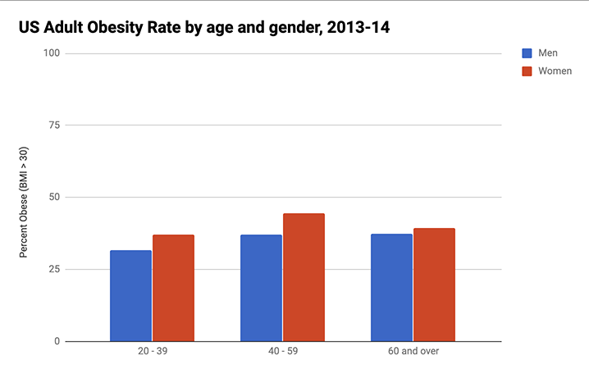

Figure 45: Grouped column chart with data from [StateOfObesity.org](http://stateofobesity.org/files/stateofobesity2016.pdf). Explore the [full-screen interactive version](https://docs.google.com/spreadsheets/d/e/2PACX-1vSkvNNrgYCpNtsaCRxn7g5o4UR8OJXSxBWvUK531t5vYubt39gecV9yLIfic89DCeJnGNvpRttFfKzn/pubchart?oid=787918829&format=interactive).

The following steps will help you recreate an interactive grouped column (or horizontal bar) chart.

1. Right-click to open link in new tab: [Google Sheet Column chart with grouped data template](https://docs.google.com/spreadsheets/d/1ltA9siijVSDkTE3fzB3UaWHO7dotBIrGH4R9wI_Qyqw/)
2. Sign in to continue to Google Sheets (which is part of Google Drive). If you don’t already have a Google account, you can create one.
3. Select File > Make a Copy to save your own version to your Google Drive, as shown in Figure 46.

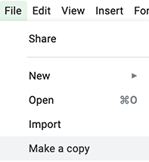

Figure 46: Make your own copy of the Google Sheet template.

1. To remove the current chart from your copy of the spreadsheet, float your cursor to the top-right corner of the chart to make the 3-dot menu appear, and select Delete, as shown in Figure 47.

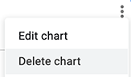

Figure 47: Float cursor in top-right corner of the chart to make the 3-dot menu appear, and select Delete.

1. Format your data to make each column a data series, as shown in Figure 48, which means it will display as a separate color in the chart.

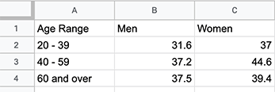

Figure 48: Format data in columns to make colored grouped columns in your chart.

1. Use your cursor to select only the data you wish to chart, then go to the Insert menu and select Chart, as shown in Figure 49.

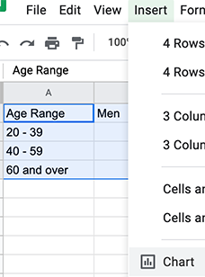

Figure 49: Select your data and then Insert > Chart.

1. In the Chart Editor, change the default selection to Column chart, with Stacking none, to display Grouped Columns, as shown in Figure 50. Or select horizontal Bar chart if you have longer labels.

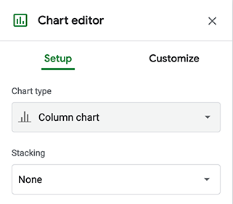

Figure 50: Change the default to Column chart, with Stacking none.

1. To customize title, labels, and more, in the Chart Editor select Customize, as shown in Figure 51.

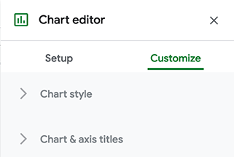

Figure 51: Select Customize to edit title, labels, and more.

1. To make your data public, go to the upper-right corner of your sheet to click the Share button, and in the next screen, click the words “Change to anyone with the link,” as shown in Figure 52. This means your sheet is no longer Restricted to only you, but can be viewed by anyone with the link. See additional options.

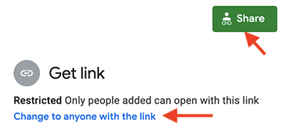

Figure 52: Click the Share button and then click “Change to anyone with the link.” to make your data public.

1. To embed an interactive version of your chart in another web page, click the 3-dot menu in the upper-right corner of your chart, and select Publish Chart, as shown in Figure 53. In the next screen, select Embed and press the Publish button. See [Chapter 7 Embed on the Web](embed.html) to learn what to do with the iframe code.

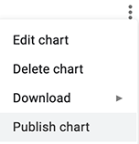

Figure 53: Select Publish Chart to embed an interactive chart on another web page, as described in Chapter 7.

Note: Currently, there is no easy way to cite or link to your source data inside a Google Sheets chart. Instead, cite and link to your source data in the text of the web page. Remember that citing your sources adds credibility to your work.

### Separated Column and Bar Charts

When you visualize independent categories of data, and you don’t want them to appear grouped together, then create a chart with separated columns (or horizontal bars, if you have long data labels). For example, Figure 54 is a separated bar chart of calorie counts of fast food items for two restaurant chains, Starbucks and McDonald’s. Unlike the grouped column chart in Figure 45, here the bars are separated from each other, because we do not need to make comparisons between sub-groups.

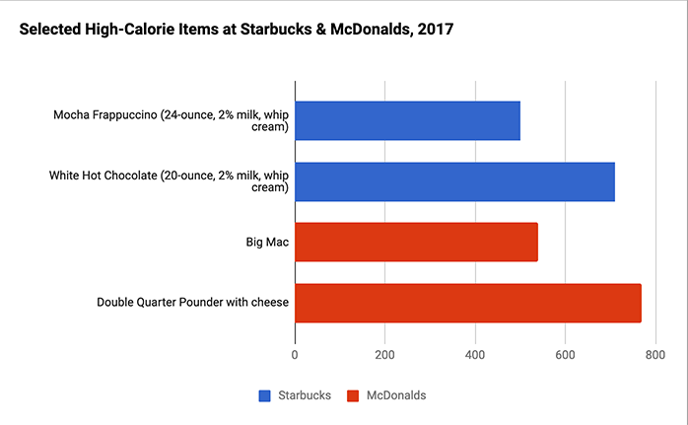

Figure 54: Separated bar chart with data from [Starbucks and McDonalds](https://docs.google.com/spreadsheets/d/1LGUYaVLoRcOiB8KcXb3Rn7LRj0exnUQYOy58LrkGPAk/edit#gid=956322126). Explore the [full-screen interactive version](https://docs.google.com/spreadsheets/d/e/2PACX-1vSkvNNrgYCpNtsaCRxn7g5o4UR8OJXSxBWvUK531t5vYubt39gecV9yLIfic89DCeJnGNvpRttFfKzn/pubchart?oid=787918829&format=interactive).

The only difference between making a grouped versus a separated chart is how you structure your data. To make Google Sheets separate columns or bars, you need to leave some cells blank, as shown in Figure 55. The rest of the steps remain the same as above.

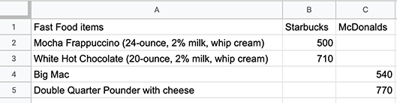

Figure 55: Create a separated column or bar chart by leaving some cells blank.

To create your own separated column or bar chart using the fast-food example, right-click to open this link in a new tab: [Google Sheet Separated Bar Chart template](https://docs.google.com/spreadsheets/d/1LGUYaVLoRcOiB8KcXb3Rn7LRj0exnUQYOy58LrkGPAk/).

### Stacked Column and Bar Charts

Stacked column and bar charts can be used to compare subcategories. They can also be used to represents parts of a whole instead of pie charts. For example, the stacked column chart in Figure 56 compares the percentage of overweight residents across nations, where colors allow for easy comparisons of weight-group subcategories across nations.

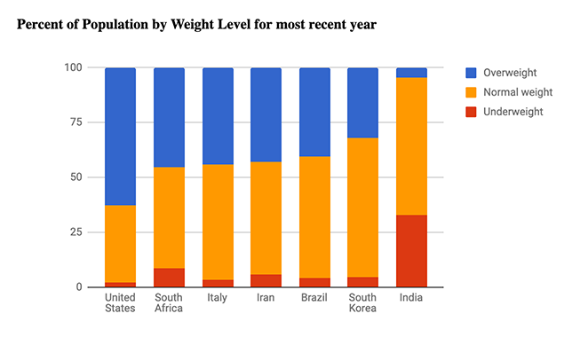

Figure 56: Stacked column chart with data from [WHO and CDC](https://docs.google.com/spreadsheets/d/1WS11EK33JCmvCRzSDh9UpP6R7Z2sHglF7ve5iJL6eZk/edit#gid=735710691). Explore the [full-screen interactive version](https://docs.google.com/spreadsheets/d/e/2PACX-1vSZrCP99EDqmpYc3VxFF5-Fpryh7KOU3GZ39Gl33OmDw4ecWKXxjrfzHDeQKfandKiUwvDkyF6kwK6L/pubchart?oid=307057605&format=interactive).

To create a stacked column or bar chart, structure your data so that each column will become a new series with its own color, as shown in Figure 57. Then in the Chart Editor window, choose Chart Type > Stacked column chart (or Stacked bar chart). The rest of the steps are similar to the ones above.

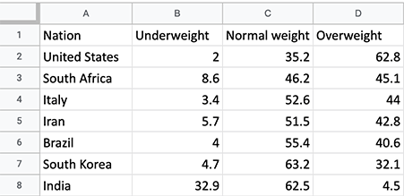

Figure 57: Create a stacked column or bar chart by structuring your data as shown.

To create your own stacked column or bar chart using the international weight level example, right-click to open this link in a new tab: [Google Sheets Stacked Column Chart template](https://docs.google.com/spreadsheets/d/1WS11EK33JCmvCRzSDh9UpP6R7Z2sHglF7ve5iJL6eZk/).

### Histograms

Histogram is a type of bar chart that represents distribution of items, whether numerical or categorical. To bulid a histogram, you need to assign each data point to one of the non-overlapping *buckets* (or *bins*).

Let’s say you want to know what time of day are you more likely to get an email. One approach would be to download metadata about all emails you received in 2020, and assign them to a bucket between 0 and 23 according to the email hour. Hours will become your bins, and email counts will be your frequency data. Then your final dataset would look something like this:

Hour Emails  
0 12  
1 11  
2 7  
...  
21 24  
22 34  
23 22

You can now make a histogram. The good news is, Google Sheets considers histograms to be regular column charts, so you should be able to use a previous tutorial to make one.

Select two columns with the data you want to visualize, and go to Insert > Chart. In the Chart editor window, in the Setup tab, select Chart type > Column chart. See the result in Figure 58

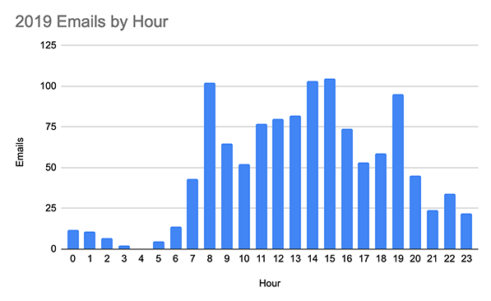

Figure 58: Histogram chart with [fictitious source data](https://docs.google.com/spreadsheets/d/1V-r1bOWpvyCRhmJa0gRZ1TEchXvrr7UTZ97rKOU1WRo/edit#gid=0). Explore the [full-screen interactive version](https://docs.google.com/spreadsheets/d/e/2PACX-1vRyg09UZgGWVHPk3oOKAZ-zlqtDF_RpvOLdAsM-k-ZW5NavcxAyHbErgr-7dt7U_AFSVZONSTZ9sVII/pubchart?oid=509234663&format=interactive).

To create your own histogram chart using our fictional email dataset, right-click to open this link in a new tab: [Histogram Chart template](https://docs.google.com/spreadsheets/d/1V-r1bOWpvyCRhmJa0gRZ1TEchXvrr7UTZ97rKOU1WRo/edit?usp=sharing).

Bins in a histogram should span (in other words, “cover”) the entire range of values of your dataset. This way you don’t leave out any data. We recommend you use bins of the same size (like 24 1-hour bins, or four 6-hour bins) to ensure readers can compare across bars. For example, if you want to create a less detailed histogram, you can combine hours into larger bins, such as *Morning*, *Afternoon*, *Evening*, and *Night* to cover the hours of 6–11, 12–17, 18–23, and 0–5, respectively. Then your dataset will look like:

Time of Day,Emails  
Morning,353  
Afternoon,497  
Evening,279  
Night,37

## Pie, Line, and Area Charts with Google Sheets

#### Pie Chart

As we mentioned in the [Chart Aesthetics section](chart-design.html), you need to be careful when using pie charts. First, remember to not have too many slices (ideally you should limit slices to 5). They should be arranged from largest to smallest and start at 12 o’clock. To separate slices, you can use different slice colors, or lines.

Make sure your data adds up to 100%. For example, if you want to show a pie chart with the number of fruit your store had sold in a day—–21 apples, 5 oranges, and 32 bananas—–the sum of all fruit, 58, is your 100%. Then a reader can figure out that of all fruits sold, approximately 55% were bananas. This example is illustrated in Figure 59. If you decided to include *some*, but *not all* other items that your store has sold (for example, you include pizzas but exclude ice cream), your pie chart would not make sense.



Figure 59: Pie chart with [fictitious source data](https://docs.google.com/spreadsheets/d/11cn0eysXqXIwhcTKmGuzMDw_RmpDpYLKZN3TeevT-Vg/edit?usp=sharing). Explore the [full-screen interactive version](https://docs.google.com/spreadsheets/d/e/2PACX-1vQai8YWkqMOHsiwWXpe1jyhBKy5wW6zcMaEIklkF-598h1QaVBrRR0F9JVrsX2Zo5ihXWP-HlnY-KlE/pubchart?oid=760990456&format=interactive).

To make a pie chart with Google Sheets, arrange your data in two columns, *Label* and *Value*. Values can be expressed as either percentages or counts. For example,

| Apple | 21 |  
| Orange | 5 |  
| Banana | 32 |

Select all cells and go to *Insert > Chart*. Google Sheets is good at guessing chart types, so it is possible the chart you will see right away will be a pie. If not, in Chart editor in tab Setup, select *Pie chart* from the Chart type dropdown list.

Notice that slices are ordered the same way they appear in the spreadsheet. We highly recommend you sort values from largest to smallest: right-click the header of your values column, and click Sort sheet Z-A. You will see that the chart updates automatically.

Right-click on the chart, and choose *Chart & axis titles > Chart title* to add a meaningful title. In *Customize* tab of the Chart editor, you can also change colors and add borders to slices.

#### Line Chart

The most common use of line charts is to represent values at different points in time, in other words to show change over time. The line chart in Figure 60 shows per-capita meat availability in the US for the past 110 years. You can see that the level of chicken (shown in orange) rises steadily and surpasses beef (red) and pork (blue).



Figure 60: Line chart showing meat availability per capita in the US, according to the [US Department of Agriculture](https://docs.google.com/spreadsheets/d/1wkWxxZ2-N5hqkcp7in8bxwdEcT1-XMnt1A8qUXxUSjw/edit?usp=sharing). Explore the [full-screen interactive version](https://docs.google.com/spreadsheets/d/e/2PACX-1vS38EC_34L8gKK9NStS8S322BzvBRbnRNpu9KXQ4oHHpaDmVMBAhEu4SXtCC6CD2yv_V6brX8s386Nf/pubchart?oid=2073830845&format=interactive).

The simplest way to organize your data is to use the first column as x-axis labels, and each additional column as a new series (which will become its own line). For example, the meat data from the line chart is structured as shown in Figure 61.

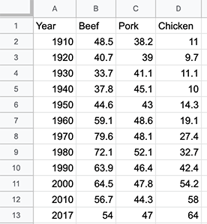

Figure 61: Data for the line chart shown in Figure 60.

The data is available in the [Google Sheet Line chart template](https://docs.google.com/spreadsheets/d/1wkWxxZ2-N5hqkcp7in8bxwdEcT1-XMnt1A8qUXxUSjw/). If you wish to use it, just make a copy to your own Google Drive from the File menu.

Select the data, and choose *Insert > Chart*. It is possible Google Sheets will create a line chart right away. If not, in Chart editor in tab Setup, select *Line chart* from the Chart type dropdown list.

#### Stacked Area Chart

The line chart in the previous example made it possible to see how individual meat availability changed over time. It was hard, however, to estimate if the overall meat availability went up or down. (That is, of course, if we assume that beef, pork, and chicken are the only meats we eat).

We can see how availability of individual meat types, *and* the total meat availability over time using a stacked area chart, like shown in Figure 62. Here, we can still see that chicken has been on the rise since 1970s. We can also see that the total availability was on the rise between 1910 and 1970 with a small dip around 1930s, and it didn’t change much between 1970 and 2017.



Figure 62: In addition to individual meat availability, stacked area charts show the overall availability. See data by [US Department of Agriculture](https://docs.google.com/spreadsheets/d/16QR4prVUoztW6bFVyj_q0n8GjNWqkcW6sgAkIyHQIJc/edit?usp=sharing). Explore the [full-screen interactive version](https://docs.google.com/spreadsheets/d/e/2PACX-1vSotrM_zZDo0MT--JgXwA3nBQudzIwmt8TGwmZxvUxNUzPrfBgqso5glLn05ObJxdTTmKoT_fQWQMx-/pubchart?oid=1976471326&format=interactive).

The data for the stacked area chart is available from the [Google Sheet Stacked area chart template](https://docs.google.com/spreadsheets/d/16QR4prVUoztW6bFVyj_q0n8GjNWqkcW6sgAkIyHQIJc/), which you copy to your own Drive.

Set up the data exactly as you would with a line chart (first column is labels for the x-axis, second and following columns are series, or lines). Select it, and choose *Insert > Chart*. In the Chart editor, in tab Setup, select *Stacked area chart* from the Chart type dropdown list.

## XY Scatter and Bubble Charts with Google Sheets

Consider using XY scatter charts, also known as scatterplots, to display data coordinates to show the relationship between two variables. The first example below compares the relationships between life expectancy (shown on the X axis) and fertility (shown on the Y axis), which each nation is represented as a dot (an X-Y coordinate). Bubble charts are basically scatter charts on steroids, meaning that they can display the relationship of up to five variables. Further below you’ll build a bubble chart based on the same XY life expectancy-fertility dataset, with added variables for population (displayed as circle size) and region of the world (displayed as circle color). Fancier bubble charts animate the circles to represent one more variable: change over time.

#### XY Scatter chart

The scatter chart in Figure 63 uses World Bank data to reveal a downward slope: nations with lower fertility (births per woman) tend to have higher life expectancy. You can also phrase is the other way, nations with higher life expectancy at birth have lower fertility. Remember that correlation does not mean causation, so you cannot use this chart to argue that fewer births result in longer lives, or that longer-living females give birth to fewer children.



Figure 63: This scatter chart shows that nations with lower fertility tend to have higher life expectancy. [See data](https://docs.google.com/spreadsheets/d/1LJCj3RaVgaQsAZriV_JDQhBrIBSvnH_N1LBCkZK1bqs/) by World Bank. Explore the [full-screen interactive version](https://docs.google.com/spreadsheets/d/e/2PACX-1vSyKSe_dy3FURPuTllvmGBvI1b-J5_7Q3hR_6bdP20olDFA79OqoGOKEqtxfhv796NMXJO5vzhs_d0f/pubchart?oid=386475448&format=interactive).

The data used in Figure 63 is available from our [Google Sheets Scatter chart template](https://docs.google.com/spreadsheets/d/1LJCj3RaVgaQsAZriV_JDQhBrIBSvnH_N1LBCkZK1bqs/edit?usp=sharing). You can copy it to your own Google Drive so that you’re able to edit it (go to *File > Make a copy*).

Figure 64 shows the first few rows of the dataset. Notice that the data is structured in three columns. The first column, *Life Expectancy*, is plotted on the x-axis (horizontal). The second column, *Fertility*, is plotted on the y-axis (vertical). The third column contains *Country* labels.



Figure 64: Data for a scatterplot is usually represented in 3 columns: x-values, y-values, and labels.

To build a scatter chart, select the **two** columns that contain your numeric data, and go to *Insert > Chart*. Google Sheets will likely to guess the chart type and you will see a scatterplot, but if not, you can always manually pick Scatter chart from the *Chart type* dropdown. Make sure your x-axis is set to Life Expectancy, and your Series shows Fertility. Note that both Life Expectancy and Fertility have 123 icon, meaning they are numeric.

You will see a lot of scatter charts out there that do not label data points, and that’s okay. Some scatter plots are designed to show whether or not there is a correlation, and knowing which points are which is not important. But sometimes labels are important for your storytelling.

In Chart editor, click on the 3-dot menu for your Series dataset (Fertility), and then *Add labels* (see Figure 65). The labels added by default will be the x-values of points. To make Google Sheets read labels from the third column (*Country*), click the name of your label dataset (Life Expectancy), then *Select a data range* button in the upper-right corner of the dropdown, and choose cells in the relevant columns. Make sure to include the header (first row) if all other data ranges include it.



Figure 65: In the chart’s Setup window, choose *Add labels* to the Series.

Tip: You may notice that some data points are too close to edges, and their labels are cut off. To fix this, go to Customize tab of the Chart editor. There, you can set minimum and maximum values for both horizontal and vertical axes. Unlike in bar charts, axes in scatter plots do not have to start at zero. You can set your minimum and maximum values to be a few units below and above the extreme points of your data range.

Note: Another name for the 3-dot menu symbol is the “kebab menu” because it resembles Middle Eastern food cooked on a skewer, in contrast to the three-line “burger menu” on many mobile devices. TODO: Add picture of each icon?

#### Bubble chart with 3 columns

In this tutorial, we will show you a little trick that you can use if you want a scatter chart with both data values displayed in a tooltip. We will use the same World Bank dataset as we did for the scatter plot.

The bubble chart (more about the *proper* use of bubble charts in the next section) in Figure 66 shows the same data as our scatterplot on life expectancy vs fertility.

In the interactive version of the chart, hover your cursor over each bubble (dot) to reveal a tooltip with the country name and the two data points.



Figure 66: This bubble chart is essentially a scatter chart, because no other dimensions (colors, sizes) are used. [See data](https://docs.google.com/spreadsheets/d/1CL7joH_3wvMYo9HIiSuFP0Ykv_Nl5DK6DYYcd3_gFnU/edit?usp=sharing) by World Bank. Explore the [full-screen interactive version](https://docs.google.com/spreadsheets/u/3/d/e/2PACX-1vQtMosshgyX6YoPpHo9QhSPk-ckOw1_yRryTF_vYJooBeWF13RaPv2IrGffcpaiqHPwfKFJAWY0HwA3/pubchart?oid=2105121864&format=interactive).

The data for this example is available in [Google Sheets Bubble chart with 3 columns template](https://docs.google.com/spreadsheets/d/1CL7joH_3wvMYo9HIiSuFP0Ykv_Nl5DK6DYYcd3_gFnU/).

Notice that we moved the labels column (*Country*) to be the first one in the dataset, but the order shouldn’t matter in this case. So our first column is the label for each bubble, the second column is the data to be plotted on horizontal x-axis, and the third column (fertility) will be place on the y-axis.

Select all three columns, and go to *Insert > Chart*. Google Sheets will likely create a stacked column chart by default, so choose *Bubble* from the Chart type dropdown window.

If you want to remove labels from the bubbles, remove the **ID** series (click on the kebab menu > Remove).

Unfortunately, there is no easy way to reduce all bubbles to a uniformly smaller size. In the following section, we will introduce you to the proper way of using bubble charts.

#### Bubble chart with 5 columns

Bubble charts are a good alternative to scatter charts if you need to include one or two extra series in addition to your x- and y-coordinates. One of those can be expressed through bubble size (bigger bubbles represent larger values). Another one can make use of color (best for categorical data).

The bubble chart in Figure 67 shows fertility and life expectancy for a subset of the nations, with population (shown by bubble size) and region (shown by bubble color). Float your cursor over bubbles to view data details in the interactive version of the chart.

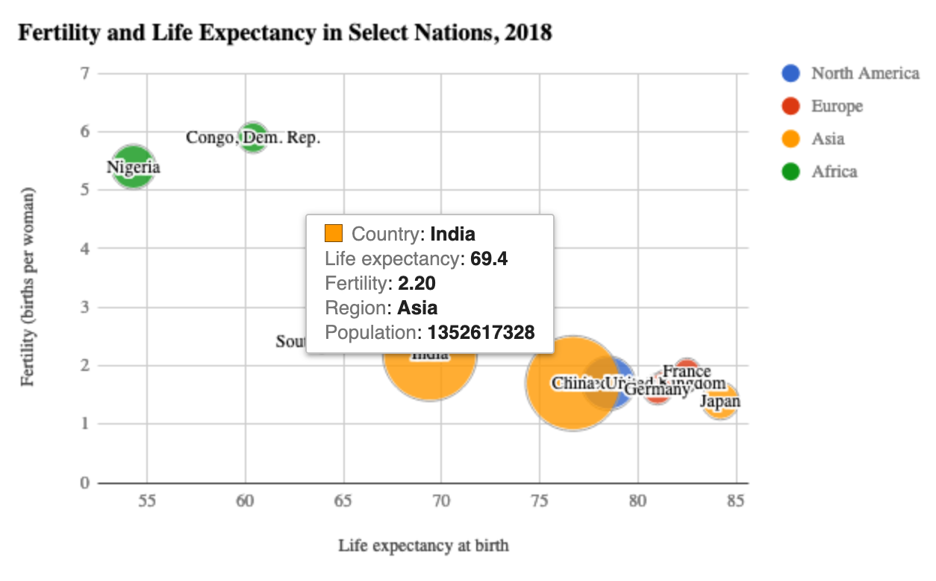

Figure 67: This bubble chart shows fertility and life expectancy for several countries, including their population (shown by bubble size) and region (shown by bubble color). [See data](https://docs.google.com/spreadsheets/d/1YgBWYm9nTGlCuyqSwU3SDb7xk-SMSPgjfYq5iLqL0nQ/) by World Bank. Explore the [full-screen interactive version](https://docs.google.com/spreadsheets/d/e/2PACX-1vQV0lrK1Lomxg-2IJJAYrB8Dvb9uc9mu5bKM2S8sWHzY9-E6ajoZwU4fRSghe2kXIHcmK4SfZO2NG4B/pubchart?oid=200651442&format=interactive).

The five-column dataset is available in this [Google Sheets Bubble chart with 5 columns template](https://docs.google.com/spreadsheets/d/1YgBWYm9nTGlCuyqSwU3SDb7xk-SMSPgjfYq5iLqL0nQ/). The columns are arranged in the following order: country label, x-axis value, y-axis value, color, and bubble size.



Figure 68: Bubble chart data. Bubble size represents population, color – region.

Select all data and go to *Insert > Chart*, and choose Bubble as the Chart type. Make sure your **ID**, **X-axis**, **Y-axis**, **Series**, and **Size** fields contains the series you want to display, and make sure to have *Use row 1 as headers* option checked.

To change labels color, go to Customize tab of the Chart editor, and set Text color under the Bubble menu. Make it gray or black, so that it won’t interfere with the bubble colors themselves.

Tip: If some of your bubbles are too close to the borders, set Min and Max values for the axis manually under Horizontal axis and Vertical axis menus.

## Create Charts with Tableau Public

Tableau is powerful data visualization software used by many professionals and organizations to analyze and present data. Tableau can combine multiple datasets to show in a single chart (or a map), and allows to create dashboards with multiple visualizations. Individual visualizations and dashboards can be published and embedded on your website through an iframe.

This book focuses on the free [Tableau Public tool](https://public.tableau.com), available to download for Mac or Windows. This free version of Tableau Public is very similar to the pricier versions that the company sells, but one constraint is that the data visualizations you create will be public, as the name suggests, so do not use it for any sensitive or confidential data that should not be shared with others.

You might be overwhelmed by the amount of options and features Tableau provides through its interface. We will show you the very basics enough to get started, and if you want to dive further, there are many great books on Tableau available.

In this book, we will show you how to add datasets to Tableau Public, and how to [create a scatterplot](scatter-chart-tableau.html) and a [filtered line chart](filtered-line-chart-tableau.html).

## Create XY Scatter Chart with Tableau Public

Just to remind you, scatter charts plot two variables against each other, on x- and y-axis, revealing possible correlations. With Tableau Public, you can create an interactive scatter chart, letting users hover over points to view specific details.

Figure 69 illustrates a strong relationship between Connecticut school district income and test scores.

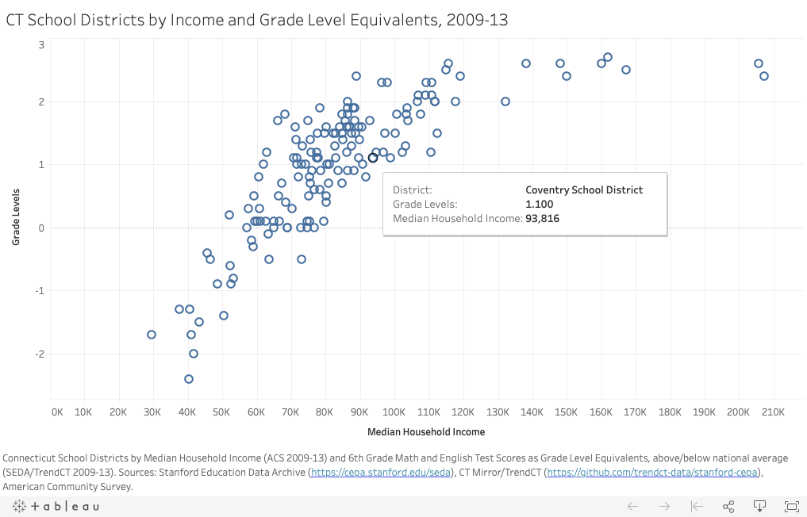

Figure 69: Household income vs test scores in Connecticut school districts. Made with Tableau Public.

#### Install Tableau and Get Data

You can download Tableau Public for Windows or Mac from Tableau’s [official website](https://public.tableau.com). You will need to provide your email address.

If you wish to use the dataset from the scatter plot in Figure 69, you can [download the sample Excel file](data/ct-districts-income-grades-2009-13.xlsx). This data file consists of three columns: district, median household income, and grade levels (above/below national average for 6th grade Math and English test scores). The Notes tab explains how this data is based on the work of Sean Reardon et al. at the [Stanford Education Data Archive](http://purl.stanford.edu/db586ns4974), Motoko Rich et al. at [The New York Times](http://www.nytimes.com/interactive/2016/04/29/upshot/money-race-and-success-how-your-school-district-compares.html), Andrew Ba Tran at [TrendCT](http://trendct.org/2016/05/06/wealth-and-grades-compare-connecticuts-school-districts/), and the American Community Survey 2009-13 via [Social Explorer](http://socialexplorer.com).

#### Connect Data and Create a Scatterplot

Tableau Public’s welcome page includes three sections: Connect, Open, and Discover.

1. Under Connect, choose Microsoft Excel if you decided to use the sample dataset or your own Excel file. To load a CSV file, choose *Text file*. If your data is in Google Sheets, click *More…* and choose Google Sheets. Once you successfully connect to your data source, you will see it under Connections in the Data Source tab. Under Sheets, you will see two tables, data and notes.
2. Drag data sheet into *Drag tables here* area, like is shown in Figure 70. You will see the preview of the table under the drag-and-drop area. You have successfully connected one data source to Tableau Public, and you are ready to build your first chart.



Figure 70: Drag data sheet into *Drag tables here* area.

1. Go to *Sheet 1* tab (in the lower-left corner of the window) to view your worksheet. Although it may feel overwhelming at first, the key is learning where to drag items from the Data pane (left) into the main worksheet. **Dimensions** are any information that is qualitative or categorical, and are shown in blue with *Abc* tables. **Measures** are quantitative information about the dimensions, shown in green with *#* icons.
2. Drag the *Grade Levels* measure into the **Rows** field above the charting area, which for now is just empty space. You can consult Figure 71 for this and two following steps. Tableau will apply a summation function to it, and you will see the SUM(Grade Levels) appearing in the Rows row, and a blue bar in the charting area. It makes little sense so far, so let’s plot another measure (variable).
3. Drag *Median Household Income* to the **Columns** field (just above the Rows field). Tableau will once again apply the summation function, so you will see SUM(Median Household Income) in the Columns. The bar chart will transform into a scatter chart with just one data point in the upper-right corner. That is because the data for both is aggregated (remember the SUM function).
4. We want to tell Tableau to disaggregate the household and grade levels variables. To do so, drag *District* dimention into the lower portion of the Marks area. You will now see a real scatter chart in the charting area. If you hover over points, you will see all three values associated with it.

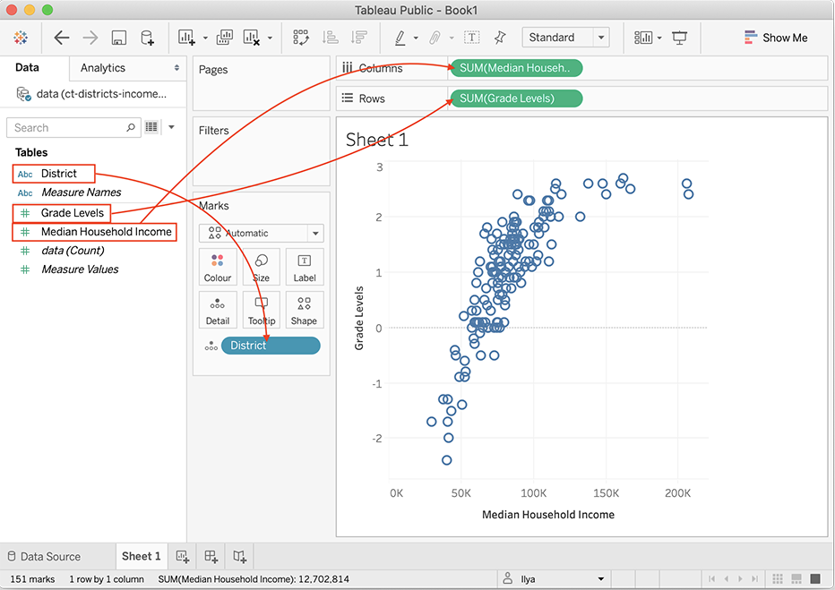

Figure 71: Drag measures and dimensions to the right places in Tableau.

#### Add Title and Caption, and Publish

Give your scatter chart a meaningful title by double-clicking on default *Sheet 1* title above the charting area.

You will normally need to provide additional information about the chart, such as source of the data, who built the visualization and when, and other important things. You can do so inside a Caption, a text block that accompanies your Tableau visualization. In the menu, go to *Worksheet > Show Caption*. Double-click the Caption block that appeared, and edit the text.

As a result, your final worksheet will look like shown in Figure 72.

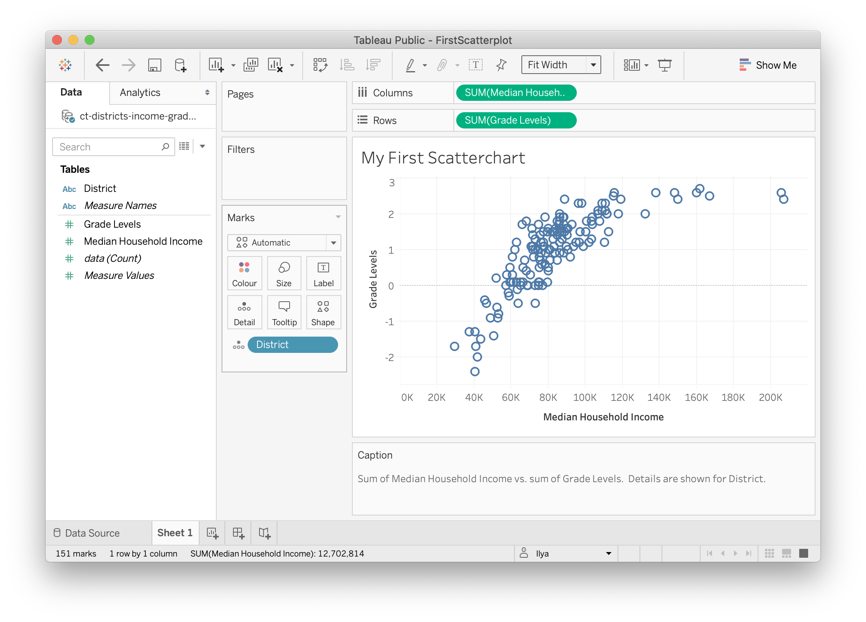

Figure 72: This scatter chart is ready to be published.

Tip: In the dropdown above Columns section, change *Standard* to *Fit Width* to ensure your chart occupies 100% of available horizontal space.

To publish the chart to the web,

1. Go to *File > Save to Tableau Public As…*. A window to sign in to your account will pop up. If you don’t have an account, click *Create one now for free* at the bottom.
2. Once signed in, a window to set the workbook title will appear. Change the deafult *Book1* title to something meaningful, as this name will appear in the URL for your published work. Click Save.
3. Once the dashboard is saved, Tableau Public will open up a window in your default browser with the visualization. In the green ribbon above the chart, click *Edit Details* to edit chart’s title or description. Under *Toolbar Settings*, see checkbox to *Allow others to download or explore and copy this workbook and its data* (Figure 73), and enable/disable it as you think is appropriate. As advocates for open and accessible data, we recommend leaving the box checked.



Figure 73: This scatter chart is ready to be published.

See the [Embed Tableau Public on Your Website](embed-tableau.html) section of this book to insert the interactive version of your chart on a web page that you control.

Tip: Your entire portfolio of Tableau Public visualizations is online at https://public.tableau.com/profile/USERNAME, where USERNAME is your unique username.

To learn more, see [Tableau Public resources page](https://public.tableau.com/en-us/s/resources).

## Create Filtered Line Chart with Tableau Public

One of the advantages of interactive visualizations over static (including printed) is the ability to store a lot more data, and show it only when required. In other words, an interactive visualization can be made into a data-exploration tool that won’t overwhelm the viewer at first sight, but will allow the viewer to “dig” and find specific data points and patterns.

In this tutorial, we will build an interactive filtered line chart with Tableau Public like is shown in Figure 74. The filter will be a collection of checkboxes that allow to add/remove lines from the chart. Viewers can hover over each line to identify the school name and data attached to it.

We will use % Population with Internet Access by the World Bank. You can download the dataset [here](data/world-bank-internet-users-1995-2018.csv).



Figure 74: Internet Access by Country, 1995–2018.

We assume that you have Tableau installed. If not, see the previous tutorial, [Create XY Scatter Chart with Tableau Public](scatter-chart-tableau.html).

### Connect Text File and Build a Line Chart

Open Tableau Public, and under Connect menu, choose *Text file*. Tableau may or may not have imported the table automatically. If you see the preview of the table with three columns: *Country Name*, *Year*, and *Percent Internet Users*, you can proceed to Sheet 1.

If not, drag and drop the file (under Files section in the left) to the *Drag tables here* area. Once you see the preview, go to Sheet 1.

Your variables will be listed under Tables in the left-hand side. The original variables are displayed in normal font, the *generated* variables will be shown in *italics* (such as *Latitude* and *Longitude* that Tableau guessed from the country names).

To build a line chart,

1. Drag Year variable to **Columns**.
2. Drag Percent Internet Users variable to **Rows**. The variable will change to SUM(Percent Internet Users). You should see a single line chart that sums up percentages for each year. That is completely incorrect, so let’s fix it.
3. In order to “break” aggregation, drag and drop Country Name to the Color box of the Marks card. Tableau will warn you that the recommended number of colors should not exceed 20. Since we will be adding filtering, we don’t care about it much. So go ahead and press *Add all members* button.
4. Now you should see an absolute spaghetti plate of lines and colors. To add filtering, drag *Country Name* to the Filters card. In the Filter window, make sure all countries are checked, and click *OK*.
5. Right-click on *Country Name* pill in Filters card, and check Show Filter (see Figure @ref(fig:tableau-filtered-show-filter.png))
6. You will see a list of options with all checkboxes on have appeared to the right of the visualization. Click *(All)* to add/remove all options, and add a few of your favorite countries to see how the interactive filtering works.



Figure 75: Once you dragged Country Name to the Filters card, make sure the Filter is displayed.

### Add Title and Caption, and Publish

Replace *Sheet 1* title (above the chart) with “Internet Access by Country, 1995–2018” by double-clicking on it. In the menu, go to *Worksheet > Show Caption* to add a Caption block under the chart. Use this space to add source of your data (World Bank), and perhaps credit yourself as the author of this visualization.

Change *Standard* to *Fit Width* in the dropdown above the Columns field.

You may notice that the x-axis (Year) starts with 1994 and ends with 2020, although our data is for 1995–2018. Double-click on the x-axis, and change **Range** from *Automatic* to *Fixed*, with the Fixed start of 1995, and the Fixed end of 2018. Close the window and see that the empty space on the edges has disappeared.

Once your filtered line chart looks like the one shown in Figure 76, you are ready to publish.



Figure 76: This workbook is ready to be published.

To publish the filtered line chart to the web, go to *File > Save to Tableau Public As…*. You may be prompted with the window to log in to your account (or create one if you don’t have it yet). The next steps are fairly self-explanatory, and you can consult [the previous tutorial](scatter-chart-tableau.html) for more information on publishing.

See the [Embed Tableau Public on Your Website](embed-tableau.html) section of this book to insert the interactive version of your chart on a web page that you control.

To learn more, see [Tableau Public resources page](https://public.tableau.com/en-us/s/resources).

**Summary**

Congratulations on creating interactive charts that pull readers deeper into your story, and encourage them to explore the underlying data! As you continue to create more, always match the chart type to your data format and the story you wish to emphasize. Also, design your charts based on the principles and aesthetic guidelines in this chapter. While anyone can click a few buttons to quickly create a chart nowadays, your audiences will greatly appreciate well-designed charts that thoughtfully call their attention to meaningful patterns in the data.

The next chapter on [Map Your Data](map.html) follows a similar format to introduce different map types, design principles, and hands-on tutorials to create interactive visualizations with spatial data. Later you’ll learn how to [embed interactive charts on your web](embed.html) in chapter 7.

To learn about more powerful charting tools, see [Chart.js code templates](chartjs.html) in chapter 9, which give you ever more control over how your design and display your data, but also require learning how to [edit and host code templates with GitHub](github.html) in chapter 8.

# Map Your Data

Maps entice readers to explore your data story and develop a stronger sense of place. But good maps require careful thought about how to clearly communicate spatial concepts with your audience. This book features free tools to create interactive maps that you can embed in your website. In this chapter, you will learn how to:

* Practice key [principles of map design](map-design.html).
* Choose a map type that matches your data story and format, with tutorial links in the table below. Beginners may start with easy-to-learn tools such as [Google My Maps](mymaps.html), then move up to more powerful tools, such as [Leaflet](leaflet.html), which require you to [Edit and Host Code with GitHub](github.html) or other web servers.

See also related chapters in this book:

* [Draw and write your data story](draw.html) to capture your ideas on paper
* [Improve spreadsheet skills](spreadsheet.html), [Find and know your data](find.html), and [Clean your data](clean.html)
* [Transform your map data](transform.html)
* [Embed your interactive chart on your website](embed.html)
* [Detect bias in data stories](detect.html), including [How to lie with maps](how-to-lie-with-maps.html)
* [Tell your data story](story.html), including its most meaningful insights and limitations

|  |  |
| --- | --- |
| Basic map types | Best use and tutorial chapters |
| Point map | Best to show specific locations, such as addresses with geocoded coordinates, with colors for different categories. Easy tool: [Google My Maps tutorial](mymaps.html)Power tool: [Leaflet Maps with Google Sheets](leaflet-maps-with-google-sheets.html) and other [Leaflet templates](leaflet.html) |
| Polygon map | Best to show regions (such as nations or neighborhoods), with colors or shading to represent data values. Also known as choropleth map. Easy tool: n/a Power tools: [Tableau Public](tableau-polygon.html) or [Leaflet Maps with Google Sheets](leaflet-maps-with-google-sheets.html) and other [Leaflet templates](leaflet.html) |
| Polyline map | Best to show routes (such as trails or transit), with colors for different categories. Easy tool: n/a Power tool: [Leaflet Maps with Google Sheets](leaflet-maps-with-google-sheets.html) and other [Leaflet templates](leaflet.html) |
| Combination map | Best to show any combination of points, polygons, or polylines. Easy tool: n/a Power tool: [Leaflet Maps with Google Sheets](leaflet-maps-with-google-sheets.html) and other [Leaflet templates](leaflet.html) |
| Storymap | Best for guided point-by-point journey through a historical narrative, with optional photos, audio, or video on an interactive map. Easy tool: [Knight Lab’s StoryMap](https://storymap.knightlab.com/), [ESRI Story Maps](https://storymaps.arcgis.com/en/) Power tool: [Leaflet Storymaps with Google Sheets](leaflet-storymaps-with-google-sheets.html) |

TODO:

* heat map
* tab-view map for historical change
* synchronized side-by-side map

## Map Design Principles

Ask Before You Map: Before you leap into a mapping project, consider these questions:

**Does your data contain geographic information?** Common examples:

* Specific locations or addresses (examples: *Trinity College*, or *300 Summit St, Hartford, CT*)
* Latitude and longitude coordinates (example: *41.756, -72.675*)
* Regions that are legally recognized (such as nations, states, counties, census tracts) or that correspond to a boundary map in your possession (such as designated neighborhoods or health districts)

While there are many more types of geographic information, these examples above are the most common. If your data lacks geographic information, or if you do not possess the corresponding boundary information, it may not be possible to map it.

**Does location really matter to your data story?**

Sometimes a well-designed chart, rather than a map, may be the best way to visualize your data story. Consider these alternatives:

* to show change over time across different locations, consider a line chart
* to show the relationship between two or more datasets across different locations, consider an XY scatter chart or bubble chart

If a map is the best way to tell your data story, then choose an appropriate type. See [table of basic map types](map) in this book.

#### Map Design Principles

1. Understand basic map vocabulary: title, legend, baselayer, marker, popup, tooltip, zoom level, polygon, polyline, source.
2. Add source credits and bylines—with links to view data tables and details—to build credibility and accountability.
3. Choose colors wisely.
   * Use color to logically organize your data. Avoid random colors (Wong pp. 40, 44).
   * Avoid bad combinations from opposite sides of color wheel, such as red/green or yellow/blue (Wong pp. 40, 44).
   * Use contrast (such as color vs gray) to call attention to your data story (Knaflic pp. 87-88)
4. Choose basemaps wisely. Basemaps themselves may contain a lot of information, such as terrain, roads, parks, town names, buildings, etc. They may also use colors that can be distracting to the viewer. Think about the minimum number of elements required in the basemap to tell your story.



The view of San Francisco with different basemaps

#### Design polygon maps with ColorBrewer

One of the most useful tools for creating meaningful polygon (or choropleth) maps is ColorBrewer <http://colorbrewer2.org> created by Cynthia Brewer, Mark Harrower and the Pennsylvania State University.



Screenshot: ColorBrewer web interface

1. Think about the **number of data classes** (or “dividers” or “buckets”). More does not necessarily mean better. Try different numbers and color schemes, and decide if you (and your audience) can easily distinguish between them.
   * A smaller number sorts your data into fewer buckets, and shows a more **coarse map**, but differences in colored ranges become **more visible**.
   * A larger number sorts your data into more buckets, and shows a more **granular map**, but differences in colored ranges become **less visible**.



Screenshots: ColorBrewer web interface

1. Think about the **nature of data** you are going to display.

* Sequential: best to show steps from lower values (light color) to higher values (dark color)
  + Example: a scale that increases from 1 to 100
* Diverging: best to show extremes (dark colors) around a neutral middle (light color)
  + Example: a scale that highlights extremes from -100 to 0 to 100
* Qualitative: best to show different categories, represented by their own color
  + Example: a map legend of the dominant crop in each area: apples, oranges, bananas



Screenshots: ColorBrewer web interface

1. Pick a **color scheme**, with options for colorblind-safe and print-friendly.
   * Think about the ideal format for your audiences. Are readers more likely to view your visualization on a computer screen, or in print, or both?
2. Click the Export tab to view all options. Some Leaflet map templates in this book use specific color names (such as “red” or “darkgreen”) and some use hexadecimal codes, abbreviated as “hex codes” (such as #ff0000 or #336600). To learn more, use a Color Picker tool, such as <https://www.w3schools.com/colors/colors_picker.asp>

Beware that polygon map design choices about data classes and colors reflect the biases of the author and the software. Read the [Detect Bias in Data Stories](detect.html) chapter in this book, especially [How to Lie with Maps](detect.html#how-to-lie-with-maps)

#### Learn more

* Axis Maps, “The Basics of Data Classification,” 2010, <http://axismaps.github.io/thematic-cartography/articles/classification.html>
* Lisa Charlotte Rost, “Your Friendly Guide to Colors in Data Visualisation,” Lisa Charlotte Rost, April 22, 2016, <https://lisacharlotterost.github.io/2016/04/22/Colors-for-DataVis/>.
* Josh Stevens, “Bivariate Choropleth Maps: A How-To Guide,” February 18, 2015, <http://www.joshuastevens.net/cartography/make-a-bivariate-choropleth-map/>.

## Point Map with Google My Maps

TODO: add text, check current documentation and features at <https://www.google.com/maps/about/mymaps/>

#### Try It

Explore the interactive point map below, or [view the full-screen version](https://drive.google.com/open?id=1OPrulm2ISYUb990DJOCoYlt_sWc), created with Google My Maps <https://www.google.com/maps/d/>.

#### Tool Review

* Pros
  + Easy-to learn free mapping tool to import and style point, polyline, and polygon layers and basemap layers
  + Share and collaborate through the Google Drive platform
  + Geocoding error warning
* Cons
  + Limited options to customize map markers
  + Cannot easily create colored polygon maps from data values
  + Cannot extract geocoded data to migrate to another tool

#### Video with Step-by-Step Tutorial

Let’s build a simple point map with sample data, using Google My Maps <https://www.google.com/maps/d/>. Requires signing up for a free Google Drive account.

1. Click this link and Save to download to your computer: [sample-address-data in CSV format](data/sample-address-data.csv). CSV means comma-separated values, a generic spreadsheet format that most tools can easily open. For help with downloading, see this [short video tutorial](https://www.youtube.com/watch?v=-04PQldP9HQ).
2. Open and sign in to Google My Maps <https://www.google.com/maps/d/>
3. Click the red + symbol to create a new map, which will be saved automatically to your Google Drive folder.



Image: Create a new map

1. In the map layers area, click the blue Import link. Drag-and-drop the CSV address data file into the web interface to import it.



Image: Import a data layer



Image: Drag-and-drop data into My Maps

1. Choose columns to position your placements. Select “Address” for this sample data, then Continue.



Image: Choose columns to position placemarks

1. Choose a column to title your markers. Select “Description” for this sample data, then Finish.



Image: Choose column to title markers

1. After My Maps uploads and geocodes your sample data, click Open Data Table to inspect the results.



Image: Open Data Table to inspect geocoding errors

1. To style the map markers, click Individual Styles. In this sample data, you can select Group Places By > Style By > Group. This will color markers according to the three categories.



1. To publish your map on the web, click Share, add a map title, change from Private to Public on the Web, so that anyone can view your map. Click Save and Done.



Image: Share link

1. To embed the map on your own website, click the three vertical dots next to the map title for more options, and select Embed On My Site. The tool will generate an iframe code for you to copy. For next steps, go to the [Embed on Your Web](embed.html) chapters in this book.



Image: Embed map on your site

#### Learn more

* Google My Maps Help Page <https://support.google.com/mymaps/answer/3024396>

## Point Map with Carto Builder

TODO:

* Test this tool and decide if it still warrants inclusion in this book
* See note about old versus newer Cartobuilder – still relevant?
* if this tool stays in the book, check the iframe below to see if update is needed

#### Try It

Explore the interactive point map below, or [view the full-screen version](https://jackdougherty.carto.com/builder/1abbb430-ec89-11e6-a661-0e05a8b3e3d7/embed) ,created with Carto Builder <https://carto.com>.

#### Tool Review

* Pros:
  + Free and powerful drag-and-drop map tool in the browser
  + Customize point markers and polygon colors by data values
  + Additional features include geographic analysis tools
* Cons:
  + Several steps required to create simple point or polygon map
  + New users may get lost when moving through multiple screens
  + Free account allows only 400 geocodes per month

#### Video with Step-By-Step Tutorial

***Before you begin:*** This tutorial uses the newer Carto Builder, rather than older Carto Editor tool. Learn more at <https://carto.com/learn/guides/intro/migrating-from-carto-editor-to-carto-builder>. If you have an old Carto account that has not automatically updated to the new Builder tool, you may need to create a brand-new account to use this tutorial.

Let’s build a simple point map with sample data, using Carto Builder <https:/carto.com>. Requires signing up for a free account.

1. Click this link and Save to download to your computer: [sample-address-data in CSV format](data/sample-address-data.csv). CSV means comma-separated-values, a generic spreadsheet format that many tools can easily open.
2. Open Carto in your browser <https://carto.com>.
3. The Carto Dashboard displays two views: Maps and Datasets. Always begin with Datasets, then move to Maps. (Hint: If your dashboard looks very different than mine, then you might still be using the older Carto Editor, rather than the newer Carto Builder.)



Image: Carto Builder dashboard: Begin with Datasets

1. First, connect your dataset, and soon we’ll turn it into a map. Click blue button to add New Dataset.
2. Drag-and-drop the CSV sample address data to upload it, and select Connect Dataset. (Be patient. Sometimes this takes more than 30 seconds.)
3. Inspect your connected dataset.
4. Click the blue Create Map button.
5. Click the Edit Your Map button.
6. In your map data layer, click Add Analysis.
7. In the next screen of Analysis options, select Georeference, then click the Add Analysis button.
8. Back in your map data layer, under Georeference options, select Type > Street Addresses (scroll down to the bottom) for this sample data.
9. Under Parameters, for Column Street Address (abbreviated as Col. Street Ad.), select the “address” field for this sample data. Press the Apply button.
10. After Carto has attempted to geocode your address data, click Style This Analysis. Or, go to the map data layer and click the Style tab.
11. In Style options, for Aggregation select none (the default).
12. Under Style options:

* select Fill Number to change circle sizes
* enter a larger size, such as 13, to make our sample points more visible
* select Fill Color to change circle color
* switch from Solid (all points are same color) to By Value, and scroll down to Group (at the bottom) to automatically color by categories for this sample data. (Hint: If you don’t see Group in the menu, click somewhere else and try it again.)



Image: Style points by value

1. In the Pop-up tab, select a Window Style, then select boxes in Show Items to display.
2. In the Legend tab, click Select a Style to display information, and your color-coded groups from above should automatically appear on your map. (Hint: A legend may automatically appear after styling your markers by color.)
3. Before publishing your map: If you wish to rename it, do it now by selecting the three vertical dots next to the file name, and select Rename.
4. To publish your map on the web: Next to your map file name, click the blue “back” arrow (NOT your browser back button) to return to the data layer. Click the green Public button, and on the next screen, click the blue Publish button.



Image: Click to rename or publish your map

1. On the next screen, Get The Link generates a weblink to your map, and Embed It generates an iframe code to insert the live map in your website. For next steps, go to the [Embed on Your Web](../../embed) chapters in this book.
2. If you make edits to your map, you must click the blue Update button to republish your map to the web.

#### Learn more

* Getting Started with Carto Builder <https://carto.com/learn/guides/intro/getting-started-with-carto-builder>

## Filtered Point Map with Socrata Open Data

TODO: decide whether to keep or not; originally co-authored with Veronica.

Open data repositories recently launched by [the State of Connecticut](http://data.ct.gov) and [the City of Hartford](http://data.hartford.gov) both use [the Socrata platform](http://www.socrata.com), which offer user-friendly ways to view, filter, and export data. Also, the Socrata platform includes built-in support to create interactive charts and maps, and to embed them on your own websites. This tutorial demonstrates these features by creating an interactive point map of selected schools from the Connecticut Education Directory in the state data portal. The final product looks like this:

CT Schools Map 2015

Powered by Socrata

One advantage of creating data visualizations directly on an open data platform is that the chart or map is linked to the data repository. For example, if the Socrata platform administrator updates the data table, then a Socrata dataviz based on that data will be automatically updated, too. This may be especially useful for “live” data that is continuously updated by agency administrators, such as fire, crime, and property data repositories.

But there are limitations to creating your chart or map on an open data repository platform. First, if the agency stops using the platform, or changes the structure of the underlying data, your online chart or map may stop functioning. Second, you are usually limited to using data tables and geographic boundaries that already exist on that platform, since importing your own may not be an option.

If these limitations concern you, a simple alternative is to export data from the open repository (which means that any “live” data would become “static” data), and import it into your preferred dataviz tool, such as those described in other chapters of this book. A second, more advanced alternative, is to learn how to pull live data from the repository directly into your dataviz, using an Application Programming Interface (API), which requires coding skills that are beyond the scope of this tutorial. To learn more about the Socrata API: <https://dev.socrata.com/>.

#### Steps to create a filtered point map

Sign up for a free account ID on any Socrata platform, such as <https://data.ct.gov/signup>. One account will work on all Socrata sites.



Select your desired dataset in Socrata. In this tutorial, we will use CT Open Data > Education > [CT Education Directory](https://data.ct.gov/Education/Education-Directory/9k2y-kqxn). The data table must include a location column that includes geocoordinates. If there is address data but no geocoordinates, then post a suggestion to the Socrata site administrator to add a geocoded column.



Filter the data to display only the desired rows. The CT Education Directory lists both district offices and school addresses, but for this map we only wish to display the latter. On the top-right corner of the table, click the Filter tab.



Add a New Filter Condition, which displays only the rows you select. In this tutorial, select “Organization Type” and “is”, then type the exact name from the table, such as “Public Schools.” Be sure to type it correctly or the filter may not work. If you wish to select multiple types, add a new filter condition for each. In this tutorial, we also will filter for other types: Public Charter Schools, CT Technical High Schools, Regional Schools, State Agency Facilities, Endowed and Incorporated Academies Schools, and Regional Education Service Center Schools.



Select the Visualize tab and choose Map, which will display several options. First, under Config for Education Direction, select Point Map as the Plot Style, and choose the Location column to identify the geocoordinates.



Further below in the Visualize > Map options, select the checkbox for Advanced Config for the Education Directory to edit the Flyout Details (similar to a pop-up information window) that displays details when users click on a map point. Select data items you wish to display, such as Title: Name, and additional Flyout Details: Organization Type, Location I, and Website. Further down, select the “w/o labels” checkbox to avoid displaying the column headers in your flyout details.



In Visualize > Map > Base Maps, select your desired background map, such as Google Roadmap.



Add a legend to display once you build the map. In the Advanced Configuration area, select the Legend Configuration checkbox and mark its position. After selecting all of these map options, click Apply. Socrata will generate your map with default point colors. Double-check to make sure your data appear, and that your Visualize settings are correct, before moving to the next step.



Assign point colors and legend labels by returning to the Filter tab, and select Conditional Formatting. Understand the difference between these two features. Previously, we used Filter to display only selected types of data (in this case, school buildings, rather than district administrative offices). Now, we will use Conditional Formatting to assign color codes and labels to our filtered data.



In the Conditional Formatting section, type a name into the Description that you wish to display in the legend. You may type a shorter name than the longer name that appears in the data table, such as “Charter Schools” instead of the longer “Public Charter Schools.” Also, select a color for each Description.



Continue to add Conditional Formatting by defining the data columns. In this example, select “All Conditions Apply,” choose “Organization Type” and “Is”, then type the category exactly as it appears in the data table (such as Public Charter Schools). For this map of schools in the CT Education Directory data table, we added several more types (Regional Schools, CT Technical High Schools, etc.) and also added a second rule to identify Magnet Schools (where Organization Type is Public Schools, and Interdistrict Schools is 1).



After setting all of your Conditional Formatting, press Apply at the bottom of the tab. Double-check that your visualization appears exactly as you wish, then Save As under an appropriate name. Note that your visualization will become **publicly visible** to other users on the Socrata open data platform, though you have the option to remove it via your individual profile view.



Visualizations created in the Socrata platform produce HTML iframe codes, which allows you to embed the dataviz in your own website. Select the Embed tab to view and copy the code. Then go to the [Embed on the Web](embed.html) chapters in this book.



## Polygon Maps and Storyboards with Social Explorer

TODO: decide whether to keep or not, since free license terms changed

The Social Explorer free edition <http://socialexplorer.com> offers one solution to creating colored polygon maps with US Census demographic data. Explore the embedded sample map below.

#### Advantages

* Quick and easy-to-learn
* Free edition includes basic census data
* Export your static maps into presentation slides
* Share link or embed iframe to your interactive map

#### Limitations

* Maps are limited to the demographic data inside the tool.
* Polygon map boundaries are limited to state, county, census tract. The tool does not display municipal data for cities, towns, etc.
* Full census and historical data requires professional subscription.
* Pro subscription available through several academic libraries, but few public libraries.

#### Quick overview of features

Start at the Social Explorer website <http://socialexplorer.com> and click on Maps. This tutorial demonstrates features available on the free edition.



The default map view shows US population density, based on the American Community Survey (ACS) 5-year estimates. Click the Change Data button to explore other options.



Geographic boundaries automatically change with the zoom level. As you zoom in, the data levels automatically shift from state, to county, to census tract.



Click the Share button to copy the link to your map, or the iframe code to embed it inside your own website.



Create a free account to save your online map views. Click the Tell a Story button, add a series of interactive map views, and show change over time.



TODO: Is this still true? All of the steps above can be done with the free version, but data is limited. Check if an academic library near you has a professional subscription.

## Polygon Map with Tableau Public

Tableau Public is freely-available software that contains powerful tools to quickly create interactive polygon maps for common boundaries (such as US States, or World Nations.) If you need to create customized maps for less-common boundaries, see our chapter on [Leaflet Maps with Google Sheets](leaflet-maps-with-google-sheets.html) in this volume.

Important: Tableau Public is designed to publicly display your data, which makes this free tool very appropriate for educators, journalists, non-profit organizations, or other users who wish to openly share their map. If you desire a private tool to restrict your data, Tableau offers other tools that require payment.

See also the Tableau Public support page <https://www.tableau.com/support/public> for additional resources, including video tutorials.

1. Download and install the free Tableau Public tool, available for Mac or Windows, at <https://public.tableau.com/en-us/s/download>. Do not confuse with other Tableau products that require payment. Installation may require up to 5-10 minutes.
2. Click this link and Save to download to your computer: [us-sample-data in CSV format](data/us-sample-data.csv). CSV means comma-separated values, a generic spreadsheet format that most tools can easily open. For help with downloading, see this [short video tutorial](https://www.youtube.com/watch?v=-04PQldP9HQ).
3. Open the us-sample-data.csv file with any spreadsheet tool to view its contents.
4. Launch Tableau Public. In the Connect column of the first screen, click “Text file” to connect to the CSV file you downloaded above. (If you had an Excel file in .xlsx format, you would click that instead.) Navigate to select the us-sample.data.csv file on your computer.
5. At first, Tableau Public does **NOT** recognize the names of US areas, which initially appear simply as “text” values (with the “Abc” symbol). Click and hold down the mouse directly on the “Abc” symbol, and use the drop-down menu to convert to Geographic role > State/Province. A tiny globe symbol will appear to show that Tableau Public now recognizes this column as geographic data, which is essential in order to make a map.



Column displayed as text data



Column converted to geographic data

1. Go to the Worksheet view, by clicking on “Sheet 1” in the bottom-left corner. The goal is to build a polygon map, based on the dimensions and variables provided by Tableau Public.

Step A - Drag the “Area” dimension to the middle of the worksheet to create the geographic areas

Step B - In the “Marks” panel, change the drop-down menu from “Automatic” to “Map”

Step C - Drag the “Type” dimension into the “Color” box of the Marks panel to show polygon colors according to type



Steps A-B-C above

Optional: Add more items, such as “Abbreviation” dimension to “Label” box to display state abbreviations, or “Area” dimension to “tooltips” to display on mouseover.

1. To display your map online, click “Dashboard” tab in the bottom-left corner.
2. Drag “Sheet 1” (the default name of your map) into your dashboard. Also, drag the map legend from the corner into the lower body of the map (or choose other legend options).
3. To publish your map online, go to File > Save to Tableau Public As… This will require you to create a free Tableau Public Account.
4. Modify your final online product as desired, and see options to embed elsewhere on the web.

# Embed On Your Web

After you create a chart or map, how do display it inside your website as an *interactive* visualization? Our goal is not a static picture, but a live chart or map that users can explore. This is an important question for beginners, since data visualizations are not valuable unless you can control where and how your work appears. This chapter walks you through the key steps.

First, you need to own a website that supports iframe codes (which we’ll explain below). If you do not have a website that supports this, then follow this quick tutorial to [Create a simple web page with GitHub Pages](github-pages.html). Even if you already have a website, still do this tutorial, because it introduces a tool used many times in this book.

Second, you need to copy or create an iframe code from your chart or map. An iframe is one line of HTML code with instructions on how to display a web page from a specific address (called a URL). A simple iframe looks like this:

<iframe src="https://handsondataviz.org/embed/index.html"></iframe>

No coding skills are necessary. See these easy-to-follow examples:

-[Copy iframe from a Google Sheets chart](iframe-google-sheets.html) -[Convert a link into an iframe](link-to-iframe.html)

Finally, you need to paste (or embed) the iframe code inside your website. Like a picture frame, an iframe allows you to display one web page (your data visualization) inside another web page (your personal website). But unlike a picture frame, where the image is static, an iframe makes content interactive, so visitors can explore the chart or map on your site, even though it may actually be hosted on an entirely different website. Go to this third tutorial, which combines the two steps above, called [Embed Iframe in GitHub Pages](iframe-github.html).

See more tutorials in this chapter to copy iframes from other visualization tools (such as [Tableau Public](iframe-tableau.html) and embed them in other common websites (such as [WordPress](iframe-wordpress.html), etc.) ** TO DO: add more tutorials and links **

Enroll in our free online course **link to do**, which introduces these topics in the brief video below, and offers more exercises and opportunities to interact with instructors and other learners.

## Create a Simple Web Page with GitHub Pages

Question: After you create an interactive chart or map, how do you embed the live version in a website that you control?

The full answer requires three steps:

* 1. Create a web page that supports iframe codes
  2. Copy or create an iframe code from your visualization
  3. Embed (or paste) the iframe code into your web page

This tutorial focuses on the **first step**. If you don’t already have your own website, or if you are not sure whether your site supports iframe codes, then follow the steps below. We will create a simple web page with a free and friendly tool called GitHub <http://github.com>, and host it on the public web with the built-in GitHub Pages feature. For **steps 2 and 3**, see the [Copy iframe from Google Sheets](iframe-google-sheets.html) tutorial and the [Embed iframe in GitHub Pages](iframe-github.html) tutorial in this chapter.

#### Tool Review

GitHub <http://github.com> is a versatile tool that can be used to create simple web pages.

* Pros:
  + Free and easy-to-learn tool to edit and host simple pages on the public web.
  + All steps below can be completed in your web browser.
* Cons:
  + All work on GitHub is public by default. Private repositories (folders) require payment.
  + New users sometimes confuse the links for code repositories versus published web pages.

#### Video with step-by-step tutorial

1. Sign up for free GitHub account, then sign in, at <http://github.com>.
2. Create a new repository (also called a “project” or similar to a “folder”).
3. Name your repository (or “repo”), and select Initialize with a README file. Optional steps: add a description and select a license.
4. Scroll down and click the green button to Create your repo, which will appear in a new browser tab, with this URL format:

https://github.com/YOUR-USERNAME/YOUR-REPO-NAME

1. In your GitHub repo, click on Settings, scroll down to GitHub Pages, select Master branch as your source, then Save. This publishes the code from your repo to the public web.

Hint: Do NOT select Theme Chooser for this exercise. It will create additional files that will interfere with displaying an iframe in your README.md file.

1. When the Settings page refreshes, scroll back down to GitHub Pages to see the new link to your published website, which will appear in this format:

https://YOUR-USERNAME.github.io/YOUR-REPO-NAME

1. Right-click and Copy the link to your published web site.
2. At the top of the page, click on the repo name to return to the main level.
3. Click the README.md file to open it in your browser, and click the pencil symbol to edit it.
4. Inside your README.md file, paste the link to your published web site, and type any text you wish to appear. The .md extension refers to Markdown, an easy-to-read computer language that GitHub Pages can process.
5. Scroll down and click the green Commit button to save your edits.
6. When your GitHub repo page refreshes, click on the new link to go to your published web site. **BE PATIENT!** Your new site may not appear instantly. Refresh the browser every 10 seconds. You may need to wait up to 1 minute for a new site to appear the first time, but later changes will be much faster.

Remember that GitHub Pages is designed to create simple web pages and sites. See other web publishing tools mentioned in this chapter to create more sophisticated web sites.

## Copy an iframe code from a Google Sheets interactive chart

Question: After you create an interactive chart or map, how do you embed the live version in a website that you control?

The full answer requires three steps:

1. Create a web page that supports iframe codes
2. Copy the iframe code from your visualization
3. Embed (or paste) the iframe code into your web page

This tutorial focuses on the **second step**, and shows how to publish a Google Sheets interactive chart, and copy its iframe code. Details may differ for other visualization tools, but the general iframe concept will be similar to most cases. For **steps 1 and 3**, see the [Create a Simple Web Page with GitHub Pages](github-pages.html) tutorial and the [Embed iframe in GitHub Pages](iframe-github.html) tutorial in this chapter.

#### Tutorial

1. Create a Google Sheets chart, which requires a free Google Drive account. Learn more in the [Google Sheets Charts tutorial](charts-google-sheets.html) in this book.
2. Click the drop-down menu in the upper-right corner of the interactive chart and select Publish chart. Click OK on next screen.



Screenshot: Drop-down menu to publish a Google Sheets chart

1. Select the Embed tab, select the Interactive version, and click the blue Publish button. If you make changes to the chart, they will continue to be published to the web automatically, unless you click the Stop button or checkbox at the bottom.



Screenshot: Publish to the web for a Google Sheets chart

1. Copy the iframe embed code.



Screenshot: Copy the iframe code from a Google Sheets chart

No coding skills are necessary, but it helps to be code-curious. This iframe is a line of HTML code that contains these instructions:

* iframe tags to mark the beginning and end
* width and height: to display your chart in a second site, in pixels
* seamless frameborder: “0” means no border will appear around the chart in the second site
* scrolling: “no” means the chart will not include its own web scrolling feature
* src: the web address (or URL) of the visualization to be displayed in the second site

See the next tutorial in this chapter, [Embed iframe in GitHub Pages](iframe-github.html), to learn how to paste the iframe into a simple web page. Or see related tutorials in this chapter to embed an iframe in other common web sites.

## Convert a Weblink into an Iframe

After you publish your data visualization to the web, how do you convert its weblink (or URL) into an iframe, to embed in your personal website?

The answer depends: did you publish your visualization as a code template on GitHub Pages? Or did you publish it using a drop-and-drag tool such as Google Sheets or Tableau Public?

#### Published with a code template on GitHub Pages

If you published your visualization from a code template (such as Leaflet or Chart.js) with GitHub Pages, follow these easy steps:

1. Copy the URL of your published visualization on GitHub, which will be in this format:

https://USERNAME.github.io/REPOSITORY

1. Add iframe tags to the beginning and end, insert src= and enclose the URL inside quotation marks, like this:

<iframe src="https://USERNAME.github.io/RESPOSITORY"></iframe>

1. Optional: Insert preferred width and height (in pixels by default, or percentages), like this:

<iframe src="https://USERNAME.github.io/RESPOSITORY" width="90%" height="400"></iframe>

1. Go to the appropriate tutorial to embed your iframe in your personal website:

* [Embed an iframe in GitHub Pages](iframe-github.html)
* [Embed an iframe in WordPress.org](iframe-wordpress.html)

#### Published with Google Sheets or Tableau Public

Or, if you published your visualization using a drop-and-drag tool, see these tutorials:

* [Copy an iframe code from a Google Sheets interactive chart](iframe-google-sheets.html)
* [Embed Tableau Public on your Website](iframe-tableau.html)

## Embed an Iframe in GitHub Pages

Question: After you create an interactive chart or map, how do you embed the live version in a website that you control?

Here’s the full three-step answer that combines lessons from the [Embed on the Web chapter introduction](embed.html) and the two previous tutorials:

1. First, create a web page that supports iframe embed codes. If you don’t know what that means or don’t yet have a personal website, go back to the previous tutorial, [Create a Simple Web Page with GitHub Pages](github-pages.html), or see the video and step-by-step instructions below.
2. Second, copy or create an iframe code from your data visualization. Go back to the previous tutorial, [Copy an iframe code from a Google Sheets interactive chart](iframe-google-sheets.html), or see the video and step-by-step instructions below.
3. Third, embed (or paste) the iframe code into your website. The video and instructions below show how to paste an iframe from a Google Sheets interactive chart into a simple web page with GitHub Pages.

#### Try it

The goal is to embed the iframe code from a Google Sheets interactive chart, which resides on a Google web server, into your GitHub Pages web site. The result will be similar to the one below:

#### Video tutorial and step-by-step instructions

1. Sign up for free GitHub account, then sign in, at <https://github.com>.
2. Create a **new repository** (think of it as a folder that contains your project).
3. Name your repository (or “repo”), and select *Initialize this repository with a README*. Optional steps: add a description and select a license.
4. Scroll down and click the green button to Create your repo, which will appear in a new browser tab, with this URL format:

https://github.com/YOUR-USERNAME/YOUR-REPO-NAME

1. In your GitHub repo, click on Settings tab, scroll down to *GitHub Pages*, select **master branch** as your Source, then Save. This publishes the code from your repo to the public web.
2. When the Settings page refreshes, scroll back down to GitHub Pages to see the new link to your published website, which will appear in this format:

https://YOUR-USERNAME.github.io/YOUR-REPO-NAME

1. Right-click and Copy this link to your published web site.
2. At the top of the page, click on the repo name to return to the main level.
3. Click the README.md file to open it in your browser, and click the pencil symbol in the upper right corner to edit it.
4. Inside your README.md file, paste the link to your published web site, and type any text you wish to appear. The .md extension refers to Markdown, an easy-to-read markup language that GitHub Pages can process and display as HTML.
5. Go to a data visualization you have created, such as a Google Sheets chart, select Publish > Embed, and copy the iframe code. This line of HTML code displays the interactive visualization website inside your personal website.
6. Scroll down and click Commit to save your edits.
7. When your GitHub repo page refreshes, click on the new link to go to your published web site. **BE PATIENT!** Your new site may not appear instantly. Refresh the browser every 10 seconds. You may need to wait for a few minutes for a new site to appear the first time, but later changes will be much faster.

Important:

* A published README.md file will display an HTML iframe code, unless you add other HTML files (such as index.html) to your repository.

Remember that GitHub Pages is designed to create simple web pages and sites. See other web publishing tools mentioned in this chapter to create more sophisticated web sites.

## Embed an Iframe on WordPress.org

TODO:

* rewrite this tutorial to merge the two versions (top and bottom)
* then update all links and check all code tags

To embed one web page (the data visualization) inside a second web page (the organization’s website), we use a simple HTML code known as **iframe**. (Read more about the iframetag at W3Schools.)

The **general iframe concept** works across many data visualization tools and many websites: - Copy the embed code or URL from your dataviz website - Paste (and modify) the code as an iframe in your destination website

To embed your dataviz in a self-hosted Wordpress.org site, the [iframe plugin] (<http://wordpress.org/plugins/iframe/>) must be installed and activated. This plugin allows authors to embed iframe codes inside posts/pages, in a modified “shortcode” format surrounded by square brackets. Without the plugin, self-hosted WordPress.org sites will usually “strip out” iframe codes for all users except the site administrator. **I have already installed and activated** the iframe plugin on my site, and the Dashboard view looks like this:



Note that most WordPress.com sites do NOT support an iframe embed code.

But details vary, so read and experiment with the examples that follow.

1. To embed the iframe in a WordPress.org site, the iframe plugin must be installed, as explained in the [Embed with iframe on WordPress.org](iframe-wordpress.html) chapter. **TO DO** fix self-reference
2. Log into your Wordpress.org site and create a new post. In the editor window, switch from the Visual to the Text tab, which allows users to modify the code behind your post. Paste the iframe code from your interactive dataviz.



1. Initially, the code you pasted includes HTML iframe tags at the front <iframe... and the end ...></iframe>, which looks like this:

<iframe width="600" height="371" seamless frameborder="0" scrolling="no" src="https://docs.google.com/spreadsheets/d/1fwnl5hvkkwz-YDZrogyGnx274BqmozGlIeXyjJ2TKmE/pubchart?oid=462316012&amp;format=interactive"></iframe>

1. Modify the front end of the iframe code by replacing the less-than symbol ( < ) with a square opening bracket ( [ ). Modify the back end by erasing the greater-than symbol ( > ) and the end tag ( ). Replace the back end with a square closing bracket ( ] ).



Your modified code should look like this:

[iframe width="600" height="371" seamless frameborder="0" scrolling="no" src="https://docs.google.com/spreadsheets/d/1fwnl5hvkkwz-YDZrogyGnx274BqmozGlIeXyjJ2TKmE/pubchart?oid=462316012&amp;format=interactive"]

1. Click Preview or Publish/View Post to see how it appears on the web.
2. If desired, continue to modify the iframe code to improve the display of your dataviz on your website. For example, the initial code was 600 pixels wide (width=“600”). To display the dataviz across the full width of your website, change this part of the code to 100% (width=“100%”).

The goal is to embed an interactive chart inside your website, so that users can explore the data. This tutorial displays a *very basic chart* to simplify the process, and the end result will appear like the one below. Try it.

## Embed Tableau Public on your Website

Question: After learning [how to create an interactive data visualization with Tableau Public](tableau-public.html) in this book, how do I embed it on my website?

Answer: Tableau Public supports two embedding methods, and your choice depends on your type of website.

* 1. Embed code: if you can paste directly into an HTML web page
  2. Convert Link to iframe: to paste into WordPress.org, Wix, SquareSpace, Weebly, and many other web platforms

#### Try it

Both methods produce an embedded visualization like the one below. Float your cursor over points to view data details.

#### A) Embed code method for HTML web pages

1. Use this method if you can paste HTML and JavaScript code directly into a website with HTML pages.
2. Go to the public web page of any Tableau Public visualization, such as this sample: <https://public.tableau.com/profile/jackdougherty#!/vizhome/CTSchoolDistrictsbyIncomeandGradeLevels2009-13/Sheet1>
3. Before you begin the embed process, click the upper-right Edit Details button to make any final modifications to the title or toolbar settings.
4. Click the bottom-right Share button, click inside the **Embed Code** field, and copy its contents. A typical embed code is a long string of HTML and JavaScript instructions to display the visualization.



Screenshot: Edit and Share buttons in Tableau Public web page

1. Open an HTML page on your website and paste the embed code in the body section. Below is an example of a sample Tableau Public embed code pasted between the body tags of a simple HTML page.

<!DOCTYPE html>  
<html>  
<head>  
 <title>sample web page</title>  
 <meta name="viewport" content="width=device-width, initial-scale=1.0">  
 <meta charset="utf-8">  
</head>  
<body>  
 <div class='tableauPlaceholder' id='viz1489158014225' style='position: relative'><noscript><a href='https:&#47;&#47;handsondataviz.org&#47;chart&#47;scatter-chart-tableau&#47;'><img alt='CT School Districts by Income and Grade Level Equivalents, 2009-13 ' src='https:&#47;&#47;public.tableau.com&#47;static&#47;images&#47;CT&#47;CTSchoolDistrictsbyIncomeandGradeLevels2009-13&#47;Sheet1&#47;1_rss.png' style='border: none' /></a></noscript><object class='tableauViz' style='display:none;'><param name='host_url' value='https%3A%2F%2Fpublic.tableau.com%2F' /> <param name='site_root' value='' /><param name='name' value='CTSchoolDistrictsbyIncomeandGradeLevels2009-13&#47;Sheet1' /><param name='tabs' value='no' /><param name='toolbar' value='yes' /><param name='static_image' value='https:&#47;&#47;public.tableau.com&#47;static&#47;images&#47;CT&#47;CTSchoolDistrictsbyIncomeandGradeLevels2009-13&#47;Sheet1&#47;1.png' /> <param name='animate_transition' value='yes' /><param name='display_static_image' value='yes' /><param name='display_spinner' value='yes' /><param name='display_overlay' value='yes' /><param name='display_count' value='yes' /></object></div> <script type='text/javascript'> var divElement = document.getElementById('viz1489158014225'); var vizElement = divElement.getElementsByTagName('object')[0]; vizElement.style.width='100%';vizElement.style.height=(divElement.offsetWidth*0.75)+'px'; var scriptElement = document.createElement('script'); scriptElement.src = 'https://public.tableau.com/javascripts/api/viz_v1.js'; vizElement.parentNode.insertBefore(scriptElement, vizElement); </script>  
</body>  
</html>

#### B) Convert Link to iframe method

1. Use this method if you need to paste an iframe into common web authoring platforms (such as WordPress.org, Squarespace, Wix, Weebly, etc.), since these platforms typically do not support HTML and JavaScript code pasted directly into content.
2. Go to the public web page of any Tableau Public visualization, such as this sample: <https://public.tableau.com/profile/jackdougherty#!/vizhome/CTSchoolDistrictsbyIncomeandGradeLevels2009-13/Sheet1>
3. Before you begin the embed process, click the upper-right Edit Details button to make any final modifications to the title or toolbar settings.
4. Click the bottom-right Share button, click inside the **Link** field (NOT the Embed Code field), and copy its contents.



Screenshot: Edit and Share buttons in Tableau Public web page

1. A typical link will look similar to this example (scroll to right to see all):

https://public.tableau.com/views/CTSchoolDistrictsbyIncomeandGradeLevels2009-13/Sheet1?:embed=y&:display_count=yes

1. We need to edit the link to convert it into an iframe format. First, delete any code that appears after the question mark, to make it look like this (scroll to right to see all):

https://public.tableau.com/views/CTSchoolDistrictsbyIncomeandGradeLevels2009-13/Sheet1?

1. Add this snippet of code to the end, to replace what you deleted above:

:showVizHome=no&:embed=true

1. Now your edited link should look similar to this (scroll to right to see all):

https://public.tableau.com/views/CTSchoolDistrictsbyIncomeandGradeLevels2009-13/Sheet1?:showVizHome=no&:embed=true

1. Enclose the link inside an iframe source tag src= with quotes, to make it look similar to this (scroll to right to see all):

src="https://public.tableau.com/views/CTSchoolDistrictsbyIncomeandGradeLevels2009-13/Sheet1?:showVizHome=no&:embed=true"

1. Add iframe tags for width and height in percentages or pixels (default), to make it look similar to this (scroll to right to see all):

src="https://public.tableau.com/views/CTSchoolDistrictsbyIncomeandGradeLevels2009-13/Sheet1?:showVizHome=no&:embed=true" width="90%" height="500"

Hint: Insert 90% width, rather than 100, to help readers easily scroll down your web page

1. Add iframe tags at the beginning and end, to make it look similar to this (scroll to right to see all):

<iframe src="https://public.tableau.com/views/CTSchoolDistrictsbyIncomeandGradeLevels2009-13/Sheet1?:showVizHome=no&:embed=true" width="90%" height="500"></iframe>

Exceptions to the last step above. As described in the [Embed iframe on WordPress](embed.html#iframe-wordpress) chapter in this book, in a self-hosted WordPress.org site, with the iframe plugin, insert iframe brackets rather than HTML tags to make a shortcode like this (scroll to right to see all):

[iframe src="https://public.tableau.com/views/CTSchoolDistrictsbyIncomeandGradeLevels2009-13/Sheet1?:showVizHome=no&:embed=true" width="90%" height="500"]

#### Learn more

Embedding Tableau Public Views in iframe, Tableau Support page <http://kb.tableau.com/articles/howto/embedding-tableau-public-views-in-iframes>

# Edit and Host Code with GitHub

**TODO:** GitHub recently updated its web interface, so need to redo selected screenshots. Also, GitHub announced that it will change the default branch from “master” to “main,” so update text and images when done.

In the first half of this book, you created interactive charts and maps on free drag-and-drop tool platforms created by companies such as Google and Tableau. These platforms are great for beginners, but their pre-set tools limit your options for designing and customizing your visualizations, and they also require you to depend upon their web servers and terms of service to host your data and work products. If these companies change their tools or terms, you have little choice in the matter, other than deleting your account and switching services, which means that your online charts and maps would appear to audiences as dead links.

In the second half of this book, get ready to make a big leap—and we’ll help you through every step—by learning how to copy, edit, and host code templates. These templates are pre-written software instructions that allow you to upload your data, customize its appearance, and display your interactive charts and maps on a web site that you control. No prior coding experience is required, but it helps if you’re *code-curious* and willing to experiment with your computer.

Code templates are similar to cookbook recipes. Imagine you’re in your kitchen, looking at our favorite recipe we’ve publicly shared to make brownies (yum!), which begins with these three steps: Melt butter, Add sugar, Mix in cocoa. Recipes are templates, meaning that you can follow them precisely, or modify them to suit your tastes. Imagine that you copy our recipe (or “fork” it, as coders say) and insert a new step: Add walnuts. If you also publicly share your recipe, now there will be two versions of instructions, to suit both those who strongly prefer or dislike nuts in their brownies. (We do not take sides in this deeply polarizing dispute.)

Currently, the most popular cookbook among coders is [GitHub](https://github.com), with more than 40 million users and over 100 million recipes (or “code repositories” or “repos”). You can sign up for a free account and choose to make your repos private (like Grandma’s secret recipes) or public (like the ones we share below). Since GitHub was designed to be public, think twice before uploading any confidential or sensitive information that should not be shared with others. GitHub encourages sharing *open-source code*, meaning the creator grants permission for others to freely distribute and modify it, based on the conditions of the type of license they have selected.

When you create a brand-new repo, GitHub invites you to [Choose a License](https://choosealicense.com/). Two of the most popular open-source software licenses are the [MIT License](https://choosealicense.com/licenses/mit/), which is very permissive, and the [GNU General Public License version 3](https://choosealicense.com/licenses/gpl-3.0/), which mandates that any modifications be shared under the same license. The latter version is often described as a *copyleft* license that requires any derivatives of the original code to remain publicly accessible, in contrast to traditional *copyright* that favors private ownership. When you fork a copy of someone’s open-source code on GitHub, look at the type of license they’ve chosen (if any), keep it in your version, and respect its terms.

To be clear, the GitHub platform is also owned by a large company (Microsoft purchased it in 2018), and when using it to share or host code, you’re also dependent on its tools and terms. But the magic of code templates is that you can migrate and host your work anywhere on the web. You could move to a competing repository-hosting service such as [GitLab](http://gitlab.com), or purchase your own domain name and server space through one of many web hosting services. Or you can choose a hybrid option, such as hosting your code on GitHub and choosing its custom domain option, to display it under a domain name that you’ve purchased, just like the web version of this book is hosted on GitHub under our domain name, <https://HandsOnDataViz.org>. If we choose to move the code away from GitHub, we have the option to repoint our domain to a different web host.

In the next section of this chapter, we will introduce basic steps to [fork, edit, and host a simple Leaflet map code template on GitHub](fork-leaflet.html).

Later you’ll learn how to [create a new GitHub repo and upload code files](create-repo.html).

This chapter introduces GitHub using its web browser interface, which works best for beginners. Later you’ll learn about more advanced tools, such as [GitHub Desktop and Atom Editor to work more efficiently](github-desktop-atom.html) on your personal computer.

If problems arise, turn to the [Fix Common Mistakes](fix.html) section in the appendix. All of us make mistakes and accidentally “break our code” from time to time, and it’s a great way to learn how things work—and what to do when it doesn’t work!

## Fork, Edit, and Host a Simple Leaflet Map Template

Now that you understand how [GitHub](http://github.com) code repositories are like a public cookbook of recipes, which anyone can copy and modify, let’s get into the kitchen and start baking! In this section, we’ll introduce you to a very simple code template that creates an interactive map using [Leaflet](http://leafletjs.com), an open-source code library that’s very popular with coders, journalists, businesses, and government agencies. Many people chose Leaflet because the code is freely available to everyone, relatively easy to use, and has an active community of supporters who regularly update it. But unlike drag-and-drop tools that we covered in previous chapters, such as Google My Maps or Tableau Public, Leaflet requires you to write (or copy and paste) several lines of code, which need to be hosted on a web server so that other people can view your map in their web browser. Fortunately, we can do all of these steps in our web browser on GitHub. This means you can do this on any type of computer: Mac, Windows, Chromebook, etc.

Here’s an overview of the key steps we’ll cover in this section:

* Get a free GitHub account and fork your copy of a simple Leaflet map code template
* Edit the Leaflet map title, starting position, background layer, and marker
* Host a live online version of your modified map code on the public web

Your goal is to create your own version of this simple interactive map, with your edits, as shown in Figure 77.



Figure 77: Create your own version of this [simple interactive Leaflet map](https://handsondataviz.github.io/leaflet-map-simple/).

Before you begin, create your own free account on [GitHub](http://github.com). It may ask you to do a simple quiz to prove you’re a human! If you don’t see a confirmation message in your email, check your spam folder.

Tip: Choose a GitHub username that’s relatively short, and one that you’ll be happy seeing in the web address of charts and maps you’ll publish online. In other words, DrunkBrownieChef6789 may not be the wisest choice for a username, if BrownieChef is also available.

1. After you log into your GitHub account in your browser, go to our simple Leaflet map template at <https://github.com/HandsOnDataViz/leaflet-map-simple>
2. To create your own copy of our template, click the Fork button as shown in Figure 78.

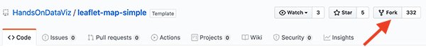

Figure 78: Click the Fork button to make your own copy of the code template.

When you fork someone else’s repo, in the upper-right corner of your browser you should see something like USERNAME/leaflet-map-simple forked from HandsOnDataViz/leaflet-map-simple, where USERNAME refers to your GitHub account username. This proves that you copied our template into your GitHub account. This very simple repo includes only three files: LICENSE shows that we’ve selected the MIT License, which allows anyone to copy and modify the code as they wish; README.md provides a simple description and link to the live demo, which we’ll come back to later; index.html is the key file that contains the map code.

Tip: By design, GitHub allows you to fork a repo *one time*, so that you don’t accidentally create two versions with the same name. If you wish to create a second version, go to the [Create a New Repo and Upload Files on GitHub](create-repo.html) section of this chapter.

1. Click on the index.html file to view the code, as shown in Figure 79.

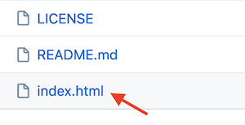

Figure 79: Click the Index file to view the code.

In case this is the first time you’re looking at computer code, we’ve inserted several “code comments” to explain what’s happening. The first block you see is written in HyperText Markup Language (HTML) that tells web browsers the formatting to read the rest of the page of code. The second block instructs the browser to load the [Leaflet](http://leafletjs.com) code library, the open-source software that constructs the interactive map. The third block describes where the map and title should be positioned on the screen, written in a language called Cascading Style Sheet (CSS). The good news is that you don’t need to touch any of those blocks of code, so leave them as-is. But you do want to modify a few lines further below.

1. To edit the code, click on the the pencil symbol in the upper-right corner, as shown in Figure 80.



Figure 80: Click the pencil button to edit the code.

Let’s start by making one simple change to prove to everyone that you’re now editing *your* map, by modifying the map title, which appears in the HTML division tag block around lines 21-23.

1. In this line <div id="map-title">EDIT your map title</div>, type your new map title in place of the words EDIT your map title. Be careful not to erase the HTML tags which appear on both ends inside the < > symbols.
2. To save your edit, scroll to the bottom of the page and click the green *Commit Changes* button, as shown in Figure 81.

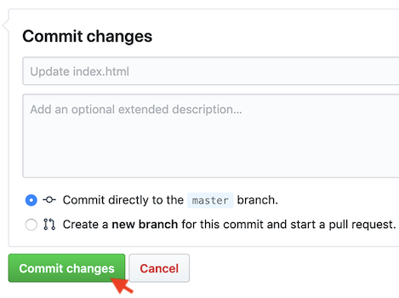

Figure 81: Click the green *Commit Changes* button to save your edits.

In the language of coders, we “commit” our changes in the same way that most people “save” a document, and later you’ll see how GitHub tracks each code commit so that you can roll them back if needed. By default, GitHub inserts a short description of your commit as “Update index.html”, and you have the option to customize that description when you start making lots of commits to keep track of your work. Also by default, GitHub commits your changes directly to the master branch of your code, which we’ll explain later.

Now let’s publish your edited map to the public web to see how it looks in a web browser. GitHub not only stores open-source code, but its built-in [GitHub Pages](https://pages.github.com/) feature allows you to host a live online version of your HTML-based code, which anyone with the web address can view in their browser. While GitHub Pages is free to use, there are [some restrictions on size and content](https://help.github.com/en/github/working-with-github-pages/about-github-pages) and it is not intended for running an online business or commercial transactions. But one advantage of code templates is that you can host them on any web server you control. Since we’re already using GitHub to store and edit our code template, it’s easy to turn on GitHub Pages to host it online.

1. To access GitHub Pages, scroll to the top of your repo page and click the *Settings* button as shown in Figure 82.

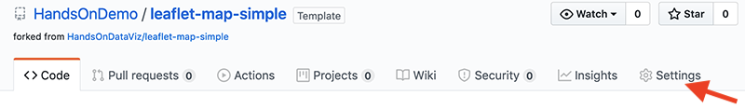

Figure 82: Click the *Settings* button to access GitHub Pages and publish your work on the web.

1. In the Settings screen, scroll down to the GitHub Pages area, and use the drop-down menu to change *Source* from *None* to *Master Branch*, as shown in Figure 83. There is no *commit* or *save* button here, and the change will happen automatically. This step tells GitHub to publish a live version of your map on the public web, where anyone can access it in their browser, if they have the web address.



Figure 83: Under GitHub Pages, switch the source from *None* to *Master* as shown in this [animated GIF](https://handsondataviz.org/images/08-github/leaflet-github-pages.gif).

1. Scroll back down to the GitHub Pages area to see the web address where your live map has been published online, and right-click it to open in a new browser tab, as shown in Figure 84.

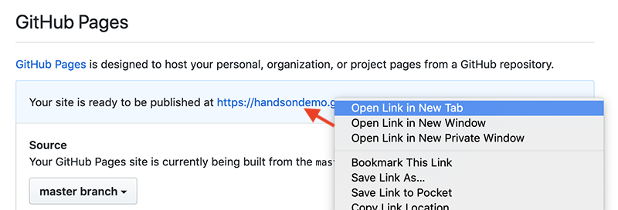

Figure 84: Under GitHub Pages, double-click your published map link as shown in this [animated GIF](https://handsondataviz.org/images/08-github/leaflet-github-pages2.gif).

1. Click on the new tab to view your live map, with your new title at the top. GitHub Pages automatically generates a public web address for your repo in this format, https://USERNAME.github.io/leaflet-map-simple, where USERNAME is your GitHub account username. Remember why we told you not to create your account with a username like DrunkBrownieChef6789? Here’s why.

Tip: If your map does *not* appear right away, wait up to 30 seconds for GitHub Pages to finish processing your edits. Then do a “hard refresh” to [bypass any saved content in your browser cache](https://en.wikipedia.org/wiki/Wikipedia:Bypass_your_cache) and re-download the entire web page from the server, using one of these key combinations:

* Ctrl + F5 (most browsers for Windows or Linux)
* Command + Shift + R (Chrome or Firefox for Mac)
* Shift + Reload button toolbar (Safari for Mac)
* Ctrl + Shift + Backspace (on Chromebook)

Note: GitHub creates two different types of web addresses, where you should replace USERNAME and REPOSITORY with your own:

* The GitHub repo address, where you can edit your code:
  + https://github.com/USERNAME/REPOSITORY
* The GitHub Pages address, which publishes a live version of your code:
  + https://USERNAME.github.io/REPOSITORY

The live version of your code points to the index.html page by default, so you do not need to include it in the web address.

Finally, web addresses are *not* case sensitive, meaning that you can type all of it in lower-case to save time!

Tip: When working with the GitHub web interface, keep two browser tabs open. The first tab contains your GitHub repo, where you can edit your code. The second tab contains your GitHub Pages live version, where you can view the results of your edits. By opening your live map in a new tab, you can easily go back to edit your code repo in the first tab, and flip back to view the live results in the second tab.

Let’s go back to your GitHub repo and edit the GitHub Pages links so that they point to *your* live map, in place of *our* live map.

1. Go back to your first browser tab with your GitHub repo, and click on the repo title to return to its home page, as shown in Figure 85.

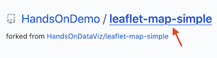

Figure 85: On your first browser tab, click the repo title.

If you can’t find your first browser tab, you can retype your repo home page address in this format, and insert your GitHub username: https://github.com/USERNAME/leaflet-map-simple.

1. Copy the web address of your live map (in your second browser tab) and paste it into two places on your repo home page (in your first tab). First, click the *Edit* button near the top-right corner of your repo, paste your link there, and save. Second, open the README.md file or scroll down to the bottom of the repo home page, click the pencil symbol to edit it, paste your link under the label *(replace with link to your site)*, and scroll down to commit the change. See both steps in Figure 86.

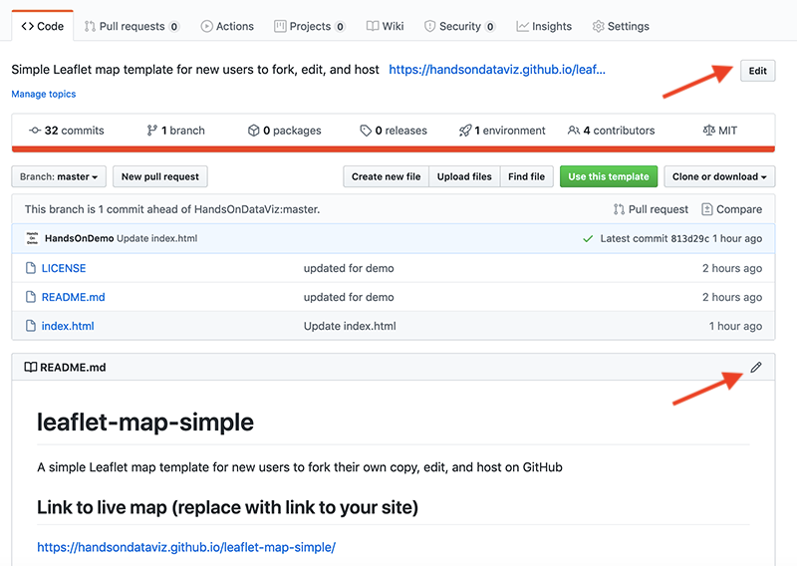

Figure 86: Paste the link to your live map at the top of your repo page, and also in your README page.

Pasting both of these links helps point people who discover your GitHub repo to *your* live map, rather than *our* version for this book.

Now that you’ve successfully made simple edits and published your live map, let’s make more edits to jazz it up and help you learn more about how Leaflet code works.

1. On your repo home page, click to open the index.html file, and click the pencil symbol to edit more code.

Wherever you see the EDIT code comment, this points out a line that you can easily modify. For example, look for the code block shown below that sets up the initial center point of the map and its zoom level. Insert a new latitude and longitude coordinate to set a new center point, and find your coordinates with online tools such as [LatLong.net](https://www.latlong.net/) or Google Maps. **TODO:** Show how to find coords in GMaps here, or link if it appears earlier in the book.

var map = L.map('map', {  
 center: [41.77, -72.69], // EDIT latitude, longitude to re-center map  
 zoom: 12, // EDIT from 1 to 18 -- decrease to zoom out, increase to zoom in  
 scrollWheelZoom: false  
 });

The next code block displays the basemap tile layer that serve as the map background. Our template uses a light map with all labels, publicly provided by CARTO, with credit to OpenStreetMap. One simple edit is to change light_all to dark_all, which will substitute a different CARTO basemap with inverted coloring. Or see many other Leaflet basemap code options that you can paste in at <https://leaflet-extras.github.io/leaflet-providers/preview/>. Make sure to attribute the source, and also keep }).addTo(map); at the end of this code block, which displays the basemap.

L.tileLayer('https://{s}.basemaps.cartocdn.com/light_all/{z}/{x}/{y}{r}.png', {  
 attribution: '&copy; <a href="http://www.openstreetmap.org/copyright">OpenStreetMap</a>,  
 &copy; <a href="https://carto.com/attribution">CARTO</a>'  
 }).addTo(map);

The last code block displays a single point marker on the map, colored blue by default in Leaflet, with a pop-up message when users click it. You can edit the marker coordinates, insert the pop-up text, or copy and paste the code block to create a second marker.

L.marker([41.77, -72.69]).addTo(map) // EDIT latitude, longitude to re-position marker  
.bindPopup("Insert pop-up text here"); // EDIT pop-up text message

1. After making edits, remember to scroll down and press the *Commit* button to save changes. Then go to your browser tab with the live map, and do a hard-refresh to view changes. If your map edits do not appear right away, remember that GitHub Pages sometimes requires up to 30 seconds to process code edits. If you have problems, see the [Fix Common Mistakes](fix.html) section in the appendix.

Congratulations! If this is the first time that you’ve edited computer code and hosted it online, you can now call yourself a “coder”. The process is similar to following and modifying a cookbook recipe, just like you also can call yourself a “chef” after baking your first batch of brownies! Although no one is likely to hire you as a full-time paid coder (or chef) at this early stage, you now understand several of the basic skills needed to copy, edit, and host code online, and you’re ready to dive into the more advanced versions, such as [Chart.js code templates in chapter 9](chartjs.html) and [Leaflet map code templates in chapter 10](leaflet.html).

The next section describes how to enhance your GitHub skills by creating new repos and uploading your files. These are essential steps to create a second copy of a code template or to work with more advanced templates in the next two chapters.

## Create a New Repo and Upload Files on GitHub

Now that you’ve forked an existing repo on GitHub, the next step is to learn how to create a brand-new repo and upload different types of files. These skills will be helpful for several scenarios later in this book. First, since GitHub allows you to create only *one fork* of an existing repository, if you wish to make a *second* copy, you’ll need to download the code and upload it into a new repo. Second, [Chapter 9 on Chart.js code templates](chartjs.html) and [chapter 10 on Leaflet map code templates](leaflet.html) allow you to upload your own files to create data visualizations. Once again, we’ll demonstrate how to do all of these steps in GitHub’s beginner-level browser interface.

Let’s start with GitHub’s *one fork* rule. Imagine that you wish to create a second copy of the [leaflet-map-simple template](https://github.com/HandsOnDataViz/leaflet-map-simple) described in the prior section. If you attempt to create a second fork, GitHub will “gray out” the Fork button and display an error message stating that you “Cannot fork because you own this repository…” as shown in Figure 87. There’s a good reason for GitHub’s one-fork rule: it’s designed to prevent you from accidentally creating a second copy, with the same name as your first fork, which would overwrite and erase your previous work.

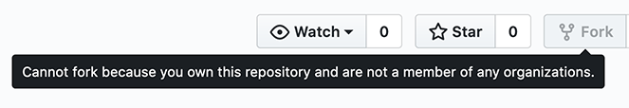

Figure 87: GitHub’s one-fork rule prevents you from creating a second fork of a repo.

So how do you create a second copy of a GitHub repo? We’ll show you two solutions. The first solution, if it exists in your case, is easy. Look for a green “Use this template” button in the upper-right screen, as shown in Figure 88, and if you see it, click it. GitHub will ask you to create a brand-new repository name for the second copy of this template, to avoid confusing it with the first copy you made. The “Use this template” button will appear only if the people who created the GitHub repo set it up as a template, and that’s exactly what we, the authors of this book, did to make it super-simple for all of you to create multiple copies of our GitHub repos.

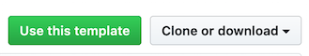

Figure 88: If a green *Use this template* button appears, click it to work around GitHub’s one-fork rule.

But what if you’re trying to make a second copy of a GitHub repo where the *Fork* button is grayed-out and there’s no green *Use this template* button? Here’s a recommended workaround that follows three general steps:

* Download the existing GitHub repo to your local computer
* Create a brand-new GitHub repo, with a new name
* Upload the existing code repo files to your brand-new repo

Imagine that you’ve already created one fork of the [leaflet-map-simple](https://github.com/HandsOnDataViz/leaflet-map-simple) repo, as we did in the prior section. You wish to create a second copy, but the *Use this template* green button does not appear, either because the repo was created before that feature existed, or the people who created the repo didn’t set it up that way.

1. Click on the gray *Clone or download* drop-down menu button on the right-side of the screen, as shown in Figure 88, and select *Download ZIP*. Your browser will download a zipped compressed folder with the contents of the repo to your local computer, and it may ask you where you wish to save it. Decide on a location and click OK.
2. Navigate to the location on your computer where you saved the folder. Its file name should end with .zip, which means you need to double-click to “unzip” or de-compress the folder. After you unzip it, a new folder will appear named leaflet-map-simple-master with three files: index.html and LICENSE and README.md. The word master refers to the master branch of your repo.
3. Go back to your GitHub account in your web browser, click on the plus (+) symbol in the upper-right corner of your account, and select *New repository*, as shown in Figure 89.

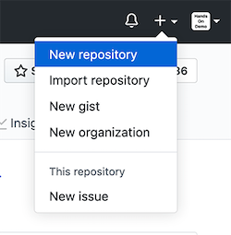

Figure 89: Click the plus (+) symbol in upper-right corner to create a new repo.

1. On the next screen, GitHub will ask you to create a new repo name. Choose a short one, preferably all lower-case, and separate words with hyphens if needed. Let’s name it practice because we’ll delete it at the end of this tutorial.

Check the box to *Initialize this repository with a README* to simplify the next steps. Also, select *Add a license* that matches the code you plan to upload, which in this case is “MIT License.” Other fields are optional. Click the green *Create Repository* button at the bottom when done, as shown in Figure 90.

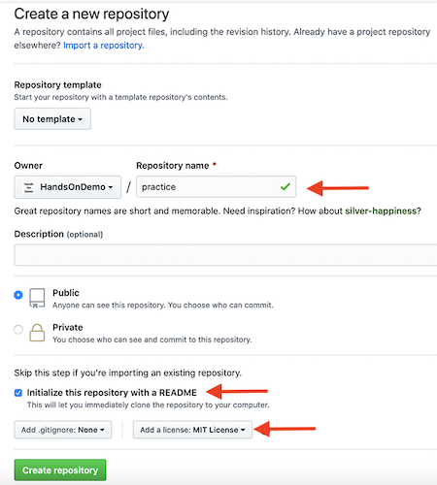

Figure 90: After naming your new repo, check the box to *Initialize this repo with a README* and *Add a license* to match the code (select “MIT”).

Your new repo will have a web address similar to https://github.com/USERNAME/practice.

1. On your new repo home page, click the *Upload Files* button, near the middle of the screen, as shown in Figure 91.

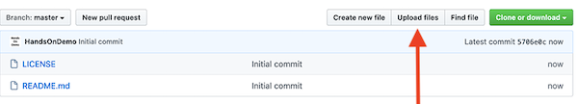

Figure 91: Click the *Upload Files* button.

1. Upload the index.html file that you previously downloaded to your local computer by dragging-and-dropping it into the upload area of your GitHub repo in your browser, as shown in Figure 92. Do not upload LICENSE or README.md because your new repo already contains those two files. Scroll down to click the green *Commit Changes* button.



Figure 92: Drag-and-drop the file to the upload screen.

When the upload is complete, your repo should contain three files, now including a copy of the index.html code that you previously downloaded from the leaflet-map-simple template. This achieved our goal of working around GitHub’s one-fork rule, by creating a new repo and manually uploading a second copy of the code.

Optionally, you could use GitHub Pages to publish a live version of the code online, and paste the links to the live version at the top of your repo and your README.md file, as described in the [Fork, Edit, and Host a Simple Leaflet Map Template](fork-leaflet.html) section of this chapter.

1. Since this was only a practice repo, let’s delete it from GitHub. In the repo screen of your browser, click the top-right *Settings* button, scroll all the way down to the *Danger Zone*, and click *Delete this repository*, as shown in Figure 93. GitHub will ask you to type in your username and repo name to ensure that you really want to delete the repo, to prove you are not a drunken brownie chef.

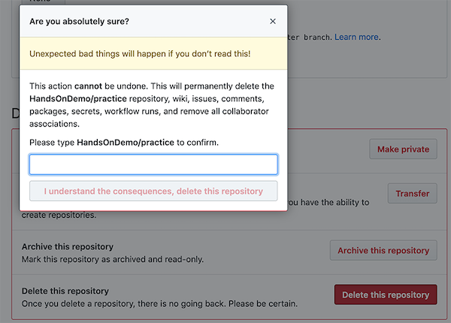

Figure 93: After clicking the Delete Repository button, GitHub will ask you to type your username and repo name to confirm.

So far, you’ve learned how to copy, edit, and host code using the GitHub web interface, which is a great introduction for beginners. Now you’re ready to move up to tools that will allow you to work more efficiently with GitHub, such as GitHub Desktop and Atom Editor, to quickly move entire repos to your local computer, edit the code, and move them back online.

## GitHub Desktop and Atom Editor to Code Efficiently

Editing your code through the GitHub web interface is a good way to start, but it can be very slow, especially if you need to modify or upload multiple files in your repo. To speed up your work, we recommend that you download two free tools—[GitHub Desktop](https://desktop.github.com) and [Atom Text Editor](https://atom.io)—which run on Mac or Windows computers. When you connect your GitHub web account to GitHub Desktop, it allows you to “pull” the most recent version of the code to your local computer’s hard drive, make and test your edits, and “push” your commits back to your GitHub web account. Atom Text Editor, which is also created by the makers of GitHub, allows you to view and edit code repos on your local computer more easily than the GitHub web interface. While there are many text editors for coders, Atom is designed to work well with GitHub Desktop.

Tip: Currently, neither GitHub Desktop nor Atom Editor are supported for Chromebooks, but [Google’s Web Store](https://chrome.google.com/webstore) offers several text editors, such as Text and Caret, which offer some of the functionality described below.)

Let’s use GitHub Desktop to pull a copy of your leaflet-map-simple template to your local computer, make some edits in Atom Editor, and push your commits back up to GitHub.

1. Go to the GitHub web repo you wish to copy to your local computer. In your browser, navigate to https://github.com/USERNAME/leaflet-map-simple, using your GitHub username, to access the repo you created in the [Fork, Edit, and Host a Simple Leaflet Map Template](fork-leaflet.html) section of this chapter. Click the *Clone or download* button on the right side, and select *Open in Desktop*, as shown in Figure 94. The next screen will show a link to the GitHub Desktop web page, and you should download and install the application.

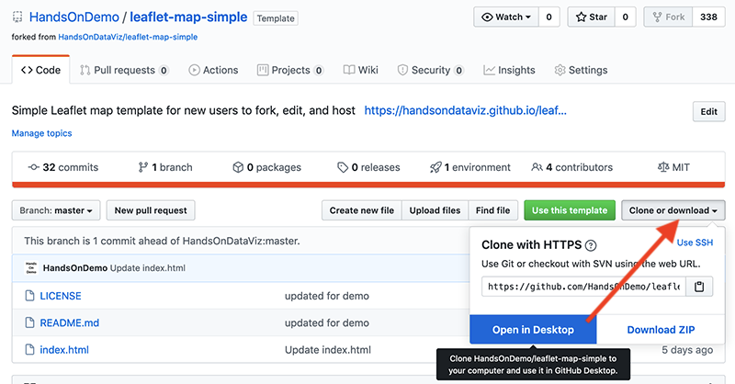

Figure 94: In your GitHub web repo, click *Clone or download* and *Open in Desktop* to download and install GitHub Desktop.

1. When you open GitHub Desktop for the first time, you’ll need to connect it to the GitHub web account you previously created in this chapter. On the welcome screen, click the blue *Sign in to GitHub.com* button, as shown in Figure 95, and login with your GitHub username and password. On the next screen, GitHub will ask you to click the green *Authorize desktop* button to confirm that you wish to connect to your account.

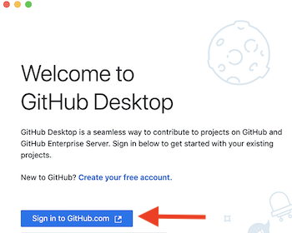

Figure 95: Click the blue *Sign in to GitHub.com* button to link GitHub Desktop to your GitHub account.

1. In the next setup screen, GitHub Desktop asks you to configure Git, the underlying software that runs GitHub. Confirm that it displays your username and click *Continue*, as shown in Figure 96.



Figure 96: Click the *Continue* button to authorize GitHub Desktop to send commits to your GitHub account.

1. On the “Let’s Get Started” with GitHub Desktop screen, click on *Your Repositories* on the right side to select your leaflet-map-sample, and further below click the blue button to *Clone* it to your local computer, as shown in Figure 97.



Figure 97: Select your “leaflet-map-simple” repo and click the *Clone* button to copy it to your local computer.

1. When you clone a repo, GitHub Desktop asks you to select the Local Path, meaning the location where you wish to store a copy of your GitHub repo on your local computer, as shown in Figure 98. Before you click the *Clone* button, remember the path to this location, since you’ll need to find it later.

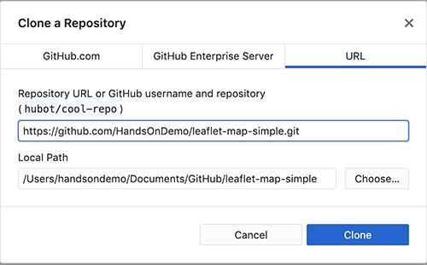

Figure 98: Select the Local Path where your repo will be stored on your computer, then click *Clone*.

1. On the next screen, GitHub Desktop may ask, “How are you planning to use this fork?” Select the default entry “To contribute to the parent project,” which means you plan to send your edits back to your GitHub web account, and click *Continue*, as shown in Figure 99.

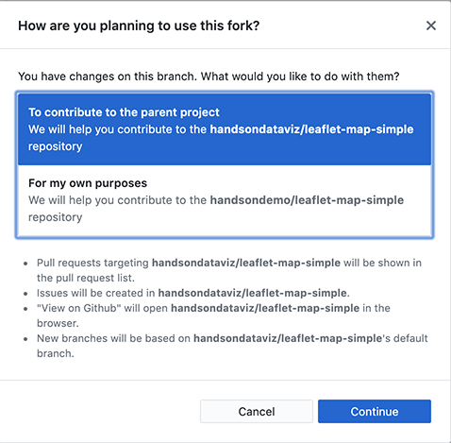

Figure 99: If asked how you plan to use this fork, select the default “To contribute to the parent project” and click *Continue*.

1. Now you have copies of your GitHub repo in two places—in your GitHub web account and on your local computer—as shown in Figure 100. Your screen may look different, depending on whether you use Windows or Mac, and the Local Path you selected to store your files.

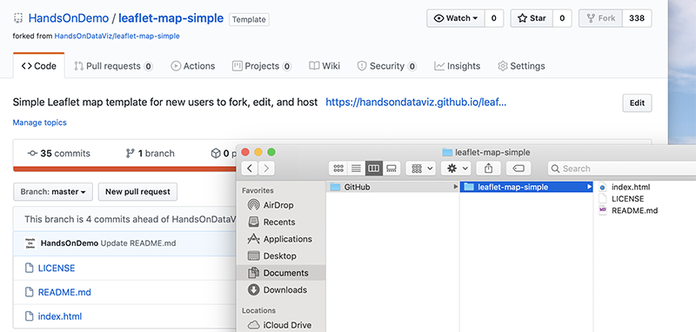

Figure 100: Now you have two copies of your repo: in your GitHub web account (on the left) and on your local computer (on the right, as shown in the Mac Finder). Windows screens will look different.

1. Before we can edit the code in your local computer, [download and install the Atom Editor application](https://atom.io). Then go to your GitHub Desktop screen, confirm that the Current Repository is leaflet-map-simple, and click the *Open in Atom* button as shown in Figure 101.



Figure 101: In GitHub Desktop, confirm the Current Repo and click the *Open in Atom* button to edit the code.

1. Since Atom Editor is integrated with GitHub Desktop, it opens up your entire repo as a “project,” where you can click files in the left window to open as new tabs to view and edit code, as shown in Figure 102. Open your index.html file and edit the title of your map, around line 22, then save your work.



Figure 102: Atom Editor opens your repo as a “project,” where you can click files to view code. Edit your map title.

1. After saving your code edit, it’s a good habit to clean up your Atom Editor workspace. Right-click on the current Project and select *Remove Project Folder* in the menu, as shown in Figure 103. Next time you open up Atom Editor, you can right-click to *Add Project Folder*, and choose any GitHub repo that you have copied to your local computer.



Figure 103: To clean up your Atom Editor workspace, right-click to *Remove Project Folder*.

1. Now that you’ve edited the code for your map on your local computer, let’s test how it looks before uploading it to GitHub. Go to the location where you saved the repo on your local computer, and right-click the index.html file, select Open With, and choose your preferred web browser, as shown in Figure 104.



Figure 104: Right-click the index.html file on your local computer and open with a browser to check your edits.

Note: Since your browser is displaying only the *local computer* version of your code, the web address will begin with file:///... rather than https://..., as appears in your GitHub Pages online map. Also, if your code depends on online elements, those features may not function when viewing it locally. But for this simple Leaflet map template, your updated map title should appear, allowing you to check its appearance before pushing your edits to the web.

Now let’s transfer your edits from your local computer to your GitHub web account, which you previously connected when you set up GitHub Desktop.

1. Go to GitHub Desktop, confirm that your Current Repo is leaflet-map-simple, and you will see your code edits summarized on the screen. In this two-step process, first click the blue *Commit to Master* button at the bottom of the page to save your edits to your local copy of your repo. (If you edit multiple files, GitHub Desktop will ask you write a summary of your edit, to help you keep track of your work.) Second, click the blue *Push origin* button to transfer those edits to the parent copy of your repo on your GitHub web account. Both steps are shown in Figure 105.



Figure 105: In this two-step process, click *Commit to Master*, then click *Push origin* to save and copy your edits from your local computer to your GitHub web account, as shown in this [animated GIF](https://handsondataviz.org/images/08-github/desktop-commit-push.gif).

Congratulations! You’ve successfully navigated a round-trip journey of code, from your GitHub account to your local computer, and back again to GitHub. Since you previously used the GitHub Pages settings to create an online version of your code, go see if your edited map title now appears on the public web. The web address you set up earlier follows this format https://USERNAME.github.io/REPOSITORY, substituting your GitHub username and repo name.

While you could have made the tiny code edit above in the GitHub web interface, hopefully you’ve begun to see many advantages of using GitHub Desktop and Atom Editor to edit code and push commits from your local computer. First, you can make more complex code modifications with Atom Editor, which includes search, find-and-replace, and other features to work more efficiently. Second, when you copy the repo to your local computer, you can quickly drag-and-drop multiple files and subfolders for complex visualizations, such as data, geography, and images. Third, depending on the type of code, you may be able to test how it works locally with your browser, before uploading your commits to the public web.

Tip: Atom Editor has many built-in features that recognize and help you edit code, plus the option to install more [packages](https://atom.io/packages) in the Preferences menu. One helpful built-in tool is *Edit > Toggle Comments*, which automatically detects the coding language and converts the selected text from executable code to non-executed code comments. Another built-in tool is *Edit > Lines > Auto Indent*, which automatically cleans up selected text or an entire page of code for easier reading.

GitHub also offers a powerful platform for collaborative projects, such as *Hands-On Data Visualization*. As co-authors, we composed the text of these book chapters and all of the sample code templates on GitHub. Jack started each day by “pulling” the most recent version of the book from our shared GitHub account to his local computer using GitHub Desktop, where he worked on sections and “pushed” his commits (aka edits) back to GitHub. At the same time, Ilya “pulled” the latest version and “pushed” his commits back to GitHub as well. Both of us see the commits that each other made, line-by-line in green and red (showing additions and deletions), by selecting the GitHub repo *Code* tab and clicking on one of our commits, as shown in Figure 106.

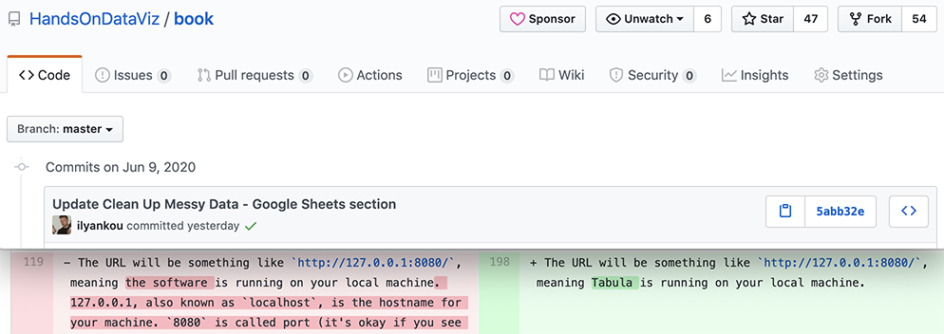

Figure 106: Drag-and-drop the file to the upload screen.

Although GitHub does not operate like Google Documents, which displays live edits, the platform has several advantages when working collaboratively with code. First, since GitHub tracks every commit we make, it allows us to go back and restore a very specific past version of the code if needed. Second, when GitHub repos are public, anyone can view your code and submit an “issue” to notify the owner about an idea or problem, or send a “pull request” of suggested code edits, which the owner can accept or reject. Third, GitHub allows collaborators to create different “branches” of a repo (the default is called “master”) in order to make edits, and then “merge” the branches back together if desired. Occasionally, if two or more coders attempt to push incompatible commits to the same repo, GitHub will warn about a “Merge Conflict.” To resolve this conflict and preserve everyone’s work, you may need to use the Command Line Interface (CLI) version of GitHub, which means typing commands directly into the Terminal application on Mac or Windows. Many professional coders regularly work on the Command Line with GitHub, but this requires memorizing a list of commands and is beyond the scope of this introductory book.

**Summary**

If this is the first time you’ve forked, edited, and hosted live code on the public web, welcome to the coding family! We hope you agree that GitHub is a powerful platform for engaging in this work and sharing with others. While beginners will appreciate the web interface, you’ll find that the GitHub Desktop and Atom Editor tools makes it much easier to work with [Chart.js code templates in Chapter 9](chartjs.hmtl) and the [Leaflet map code templates in Chapter 10](leaflet.html). Let’s build on your brand-new coding skills to create more customized charts and maps in the next two chapters.

# Chart.js Code Templates

While beginners appreciate the drag-and-drop chart tools and tutorials described earlier in this book, such as [Google Sheets](google-sheets.html) and [Tableau Public](tableau-public.html), more advanced users may wish to customize their visualizations, add more complex data, and control exactly how and where their work appears on the web. A more powerful and relatively easy-to-learn solution is to use code templates built with Chart.js <https://www.chartjs.org/>, an open-source library, which you can [modify and host on GitHub](github.html), as described in this book.

#### Working with Chart.js

##### Pros

* Open-source code that is distributed under MIT license and is free for all and
* Easier for beginners to understand than more complex visualization code libraries such as D3.js

##### Cons

* Must host your own code repositories to publish to the web (with a free service such as GitHub Pages)

#### List of Chart.js templates

|  |  |
| --- | --- |
| Templates | Best use and tutorial chapters |
| Chart.js Bar Chart | Bar charts (vertical bar charts are often called column charts) can be used to compare categorical data. Template with tutorial: [Bar Chart.js with CSV Data](chartjs-bar-csv.html) |
| Chart.js Line Chart | Line charts are normally used to show trends (temporal data). Template with tutorial: [Line Chart with CSV Data](chartjs-line-csv.html) |
| Chart.js Scatter Chart | Scatter charts (also scatterplots) are used to display data of 2 or more dimensions. Template with tutorial: [Scatter Chart with CSV Data](chartjs-scatter-csv.html) |
| Chart.js Bubble Chart | Bubble charts are used to display data of 3 or more dimensions. Template with tutorial: [Bubbble Chart with CSV Data](chartjs-bubble-csv.html) |

#### Inside the templates

The templates featured above vary from simple to complex, but all of them rely on four basic pillars:

* HTML: language to structure content on the web (example: index.html)
* CSS, or Cascading Style Sheet: to shape how content appears on the web (example: style.css)
* JavaScript: code to create the chart and interactivity (example: script.js)
* CSV: data that powers the visualization that is expressed in comma-separated format (example: data.csv)

Also, these templates refer to other code elements:

* library: link to online instructions to complete routine tasks (example: Chart.js)
* data: content to appear in chart, typically in CSV format (example: data.csv) or pulled from Google Sheets

#### Learn more

* Chart.js Samples, <https://www.chartjs.org/samples/latest/>

## Bar Chart.js with CSV Data

Bar charts (vertical bar charts are often called *column charts*) can be used to compare categorical data. The y-axis (or x-axis for horizontal bar chart) should always start at 0.

Demo: <https://handsondataviz.github.io/chartjs-templates/bar-chart/index.html>

Source and instructions: <https://github.com/handsondataviz/chartjs-templates/tree/master/bar-chart>

## Line Chart.js with CSV Data

Line charts are often used to show temporal data (trends). The x-axis often represents time intervals. Unlike column or bar charts, y-axes of line charts do not necessarily start at 0.

Demo: <https://handsondataviz.github.io/chartjs-templates/line-chart/index.html>

Source and instructions: <https://github.com/handsondataviz/chartjs-templates/tree/master/line-chart>

## Scatter Chart.js with CSV Data

Scatter charts (also *scatterplots*) are used to display data of 2 or more dimensions. The scatter chart below shows the relationship between household income and test performance for school districts in Connecticut. Using x- and y-axes to show two dimensions, it is easy to see that test performance improves as household income goes up.

Demo: <https://handsondataviz.github.io/chartjs-templates/scatter-chart/index.html>

Source and instructions: <https://github.com/handsondataviz/chartjs-templates/tree/master/scatter-chart>

#### Going beyond two dimensions

To show more than two dimensions in scatter charts, one can:

* **color** each data point differently to show third dimension, eg use shades of red and green to show 5-year trend in test performance;
* **resize** each data point to display fourth dimension, eg number of students in each school district;
* use different **icons or glyphs** to display fifth dimension, eg circles for male students and squares for female students.

Remember not to overwhelm the viewer and communicate only the data that are necessary to prove or illustrate your idea.

## Bubble Chart.js with CSV Data

Bubble charts are similar to [scatter plots](chartjs-scatter-csv.html). The size of each dot (marker) is used to represent an additional dimension.

In the demo below, the bubble chart shows the relationship between median household income (x-axis) and test performance (y-axis) in 6 school districts in Connecticut. The size of data point (marker) corresponds to the number of students enrolled in the school district: bigger circles represent larger school districts.

Demo: <https://handsondataviz.github.io/chartjs-templates/bubble-chart/index.html>

Source and instructions: <https://github.com/handsondataviz/chartjs-templates/tree/master/bubble-chart>

#### Tip: Use semi-transparent circles

Data points may obstruct each other. To avoid this, play with color transparency. For example, rgba(160, 0, 0, 0.5) is a semi-transparent red in RGBA color model. The a stands for alpha, and is a number between 0 and 1, where 1 is solid, and 0 is completely transparent. Using transparency, you will be able to see data points that are hidden behind bigger neighbors.

#### Going beyond three dimensions

To show more than three dimensions in bubble charts, one can:

* **color** each data point differently to show fourth dimension, eg use shades of red and green to show 5-year trend in test performance;
* use different **icons or glyphs** to display fifth dimension, eg circles for male students and squares for female students.

Remember not to overwhelm the viewer and communicate only the data that are necessary to prove or illustrate your idea.

# Leaflet Map Templates

While beginners appreciate the drag-and-drop map tools and tutorials described earlier in this book, [Google My Maps](mymaps.html) and [Carto](carto.html), more advanced users may wish to customize their visualizations, add more complex data and interactivity, and control exactly how and where their work appears on the web. A more powerful and relatively easy-to-learn solution is to use code templates built with Leaflet <https://leafletjs.com>, an open-source library, which you can [modify and host on GitHub](github.html), as described in this book.

#### Working with Leaflet

Pros:

* Open-source code, which anyone can freely use online, download, modify, or expand with plugins
* Easier for beginners to understand than some other map code libraries
* Compact code library (less than 40 KB) that runs on JavaScript in all modern web browsers

Cons:

* Must host your own code repositories to publish to the web (with a free service such as GitHub Pages)
* Must rely on open-source community of developers to maintain the core code or specific plugins

#### Leaflet Map Templates

TODO: add and clean up Leaflet Map CSV <https://github.com/HandsOnDataViz/leaflet-map-csv> to serve as a fuller tutorial for Leaflet Maps, and explain how this will teach more principles of modifying Leaflet code. …then geocode and upload more data points:

|  |  |
| --- | --- |
| Template | Best use and tutorial chapter |
| Leaflet Maps with Google Sheets | Best to show points, polygons, polylines, or point table data. Upload your GeoJSON data and modify settings in linked Google Sheet (or CSV) and GitHub repo. Template with tutorial: [Leaflet Maps with Google Sheets](leaflet-maps-with-google-sheets.html) |
| Leaflet Storymaps with Google Sheets | Create a scrolling narrative with points, text, images, and links. Template with tutorial: [Leaflet Storymaps with Google Sheets](leaflet-storymaps-with-google-sheets.html) |
| Leaflet Maps with Open Data API | Create a Leaflet map powered by an open data repository application programming interface (API), such as a Socrata data repository endpoint. Template with tutorial: [Leaflet Maps with Open Data API](leaflet-maps-with-api.html) |

#### Inside Leaflet code templates

The templates featured below vary from simple to complex, but all of them include three basic types of code:

* HTML: to structure content on the web (example: index.html)
* CSS, or Cascading Style Sheet: to shape how content appears on the web (example: style.css)
* JavaScript: to create the map and interactivity (example: script.js)

Also, these templates refer to other types of code:

* library: link to online instructions to complete routine tasks (examples: Leaflet, jQuery)
* basemap tiles: link to online background map (example: Carto Positron, a light-gray street map)
* data: content to appear on map, typically in CSV or GeoJSON format (examples: data.csv, data.geojson)

## Fork and Edit Leaflet Map with CSV Data

TODO: REWRITE this to serve as a more advanced version (with repo leaflet-map-csv) than the prior chapter (with leaflet-map-simple)

This tutorial introduces more sophisticated Leaflet map code templates (<http://leafletjs.com>) that you can modify and host online with GitHub in your browser (<http://github.com>). You will learn how to:

* 1. Fork (copy) Leaflet template to your GitHub account
  2. Publish your live map to public web with GitHub Pages
  3. Modify your map title and add layer controls
  4. Geocode addresses [in a Google Sheet](https://docs.google.com/spreadsheets/d/1z_0hKbw8Ff_fdp-XRoRL4YWe6ue0c0EpITveZ2rz1e8/) and upload points from data.csv

Code templates help us to move beyond the limits of drag-and-drop web mapping services (such as Google MyMaps) and to create more customized visualizations on a web server that you control. Before you begin, learn the broad concepts in the chapter introduction [Edit and Host Code with GitHub](github.html). If you have problems with this tutorial, go to the [Fix Common Mistakes](fix.html) section of the appendix.

TODO: add demo, remove unnecessary basic steps from below (covered in prior chapter)

#### Video with step-by-step tutorial

#### A) Fork (copy) Leaflet template to your GitHub account

Before you begin, sign up for a free GitHub account: <http://github.com>

1. Right-click to open this GitHub code template in a new tab: <https://github.com/handsondataviz/leaflet-map-simple>
2. In the upper-right corner of the code template, sign in to your free GitHub account
3. In the upper-right corner, click Fork to copy the template (also called a code repository, or repo) into your GitHub account. The web address (URL) of the new copy in your account will follow this format:

https://github.com/USERNAME/REPOSITORY

Reminder: You can only fork a GitHub repo **one time**. If needed, see how to make a second copy in the [Create a New Repo in GitHub](create-repo.html) chapter in this book.

#### B) Publish your live map to public web with GitHub Pages

1. In your new copy of the code repo, click on Settings, scroll down to the GitHub Pages area, select Master, and Save. This publishes your code template to a live map on a public website that you control.
2. Scroll down to GitHub Pages section again, to select and copy the link to your published web site, which will follow this format:

https://USERNAME.github.io/REPOSITORY

1. Scroll up to the top, and click on your repo name to go back to its main page.
2. At the top level of your repo main page, click on README.md, and click the pencil icon to edit this file, written in easy-to-read Markdown code.
3. Delete the link to the current live site, and paste in the link to your site. Scroll down and Commit to save your edits.
4. On your repo main page, right-click on the link to your published site to open in a new tab. **Be patient** during busy periods, because your website may take up to 1 minute to appear the first time.

#### C) Modify your map title and add layer controls

1. Go back to your browser tab for your code repo. Click on the index.html file (which contains the map code), and click the pencil icon to edit it.
2. Explore the map code, which contains HTML, CSS, and JavaScript. Look for sections that begin with “EDIT” for items that you can easily change. Scroll down to Commit your changes.
3. Go to your live website browser tab and refresh the page to view your edits. **Be patient** during busy periods, when some edits may take up to 1 minute to appear.
4. To change your map title in the index.html file, click the pencil symbol (to edit) and go to lines 23-25. Replace “EDIT your map title” with your new title:

<!-- Display the map and title with HTML division tags -->  
<div id="map-title">EDIT your map title</div>  
<div id="map"></div>

1. To change your initial map zoom level, edit the index.html file and go to line 33. The zoom range for this map is from 1 (max zoom out) to 18 (max zoom in).

// Set up initial map center and zoom level  
var map = L.map('map', {  
 center: [41.77, -72.69], // EDIT latitude, longitude to re-center map  
 zoom: 12, // EDIT from 1 to 18 -- decrease to zoom out, increase to zoom in  
 scrollWheelZoom: false  
});

1. To change the default basemap, edit lines 46 and 52 to delete “.addTo(map)” from the Carto light layer, then add it to the Stamen colored terrain layer. DO NOT erase the semicolons!

Your original code looks like this (scroll to right to see all):

/* Carto light-gray basemap tiles with labels */  
 var light = L.tileLayer('https://cartodb-basemaps-{s}.global.ssl.fastly.net/light_all/{z}/{x}/{y}.png', {  
 attribution: '&copy; <a href="http://www.openstreetmap.org/copyright">OpenStreetMap</a>, &copy; <a href="https://carto.com/attribution">CARTO</a>'  
 }).addTo(map); // EDIT - insert or remove ".addTo(map)" before last semicolon to display by default  
 // controlLayers.addBaseLayer(light, 'Carto Light basemap');  
 /* Stamen colored terrain basemap tiles with labels */  
 var terrain = L.tileLayer('https://stamen-tiles.a.ssl.fastly.net/terrain/{z}/{x}/{y}.png', {  
 attribution: 'Map tiles by <a href="http://stamen.com">Stamen Design</a>, under <a href="http://creativecommons.org/licenses/by/3.0">CC BY 3.0</a>. Data by <a href="http://openstreetmap.org">OpenStreetMap</a>, under <a href="http://www.openstreetmap.org/copyright">ODbL</a>.'  
 }); // EDIT - insert or remove ".addTo(map)" before last semicolon to display by default  
 // controlLayers.addBaseLayer(terrain, 'Stamen Terrain basemap');

After you edit the code, it should look like this (scroll to right to see all):

/* Carto light-gray basemap tiles with labels */  
var light = L.tileLayer('https://cartodb-basemaps-{s}.global.ssl.fastly.net/light_all/{z}/{x}/{y}.png', {  
 attribution: '&copy; <a href="http://www.openstreetmap.org/copyright">OpenStreetMap</a>, &copy; <a href="https://carto.com/attribution">CARTO</a>'  
}); // EDIT - insert or remove ".addTo(map)" before last semicolon to display by default  
// controlLayers.addBaseLayer(light, 'Carto Light basemap');  
/* Stamen colored terrain basemap tiles with labels */  
var terrain = L.tileLayer('https://stamen-tiles.a.ssl.fastly.net/terrain/{z}/{x}/{y}.png', {  
 attribution: 'Map tiles by <a href="http://stamen.com">Stamen Design</a>, under <a href="http://creativecommons.org/licenses/by/3.0">CC BY 3.0</a>. Data by <a href="http://openstreetmap.org">OpenStreetMap</a>, under <a href="http://www.openstreetmap.org/copyright">ODbL</a>.'  
}).addTo(map); // EDIT - insert or remove ".addTo(map)" before last semicolon to display by default  
// controlLayers.addBaseLayer(terrain, 'Stamen Terrain basemap');

1. To add a control panel that turns on/off map layers, delete the code comment symbols (//) that appear in front of lines 38-41, 47, and 53 to activate these sections. When you remove code comments in GitHub, the color changes from gray text (inactive code) to colored text (active code). After you remove the code comments, your file should look like this (scroll to right to see all):

/* Control panel to display map layers */  
 var controlLayers = L.control.layers( null, null, {  
 position: "topright",  
 collapsed: false  
 }).addTo(map);  
  
/* Carto light-gray basemap tiles with labels */  
var light = L.tileLayer('https://cartodb-basemaps-{s}.global.ssl.fastly.net/light_all/{z}/{x}/{y}.png', {  
 attribution: '&copy; <a href="http://www.openstreetmap.org/copyright">OpenStreetMap</a>, &copy; <a href="https://carto.com/attribution">CARTO</a>'  
}); // EDIT - insert or remove ".addTo(map)" before last semicolon to display by default  
 controlLayers.addBaseLayer(light, 'Carto Light basemap');  
/* Stamen colored terrain basemap tiles with labels */  
var terrain = L.tileLayer('https://stamen-tiles.a.ssl.fastly.net/terrain/{z}/{x}/{y}.png', {  
 attribution: 'Map tiles by <a href="http://stamen.com">Stamen Design</a>, under <a href="http://creativecommons.org/licenses/by/3.0">CC BY 3.0</a>. Data by <a href="http://openstreetmap.org">OpenStreetMap</a>, under <a href="http://www.openstreetmap.org/copyright">ODbL</a>.'  
}).addTo(map); // EDIT - insert or remove ".addTo(map)" before last semicolon to display by default  
 controlLayers.addBaseLayer(terrain, 'Stamen Terrain basemap');

1. To change one point on the map, you could edit the latitude and longitude coordinates of the single marker in lines 55-57. To find coordinates for any location and to learn more, go to <http://www.latlong.net>

/* Display a blue point marker with pop-up text */  
L.marker([41.77, -72.69]).addTo(map) // EDIT latitude, longitude to re-position marker  
.bindPopup("Insert pop-up text here"); // EDIT pop-up text message

But a better way to display several points is to remove the code comment symbols (//) in front of lines 60-69 to activate this section of code, which pulls map points from the data.csv file in your GitHub repository. After your edits, this section should look like this (scroll right to see all):

/* Upload Latitude/Longitude markers from data.csv file, show Title in pop-up, and override initial center and zoom to fit all in map */  
 var customLayer = L.geoJson(null, {  
 onEachFeature: function(feature, layer) {  
 layer.bindPopup(feature.properties.Title);  
 }  
 });  
 var runLayer = omnivore.csv('data.csv', null, customLayer)  
 .on('ready', function() {  
 map.fitBounds(runLayer.getBounds());  
 }).addTo(map);  
 controlLayers.addOverlay(customLayer, 'Markers from data.csv');

#### D) Geocode addresses in Google Sheet and upload points from data.csv

1. A better way to display multiple points on your map is to prepare and upload a new data.csv file to your GitHub repository. First, right-click to open this Google Sheets template in a new tab: [Leaflet Maps Simple data points with Geocoder](https://docs.google.com/spreadsheets/d/1z_0hKbw8Ff_fdp-XRoRL4YWe6ue0c0EpITveZ2rz1e8/)
2. Since this sheet is view-only, you cannot edit it. Instead, sign in to your Google account in the upper-right corner.
3. Go to File > Make a Copy, which will save a duplicate version to your Google Drive, which you can edit.
4. In your copy of the Google Sheet, select any cells and press Delete on your keyboard to erase contents. Type new titles and addresses into columns A and B.
5. To geocode your new addresses (which means converting them into latitude and longitude coordinates), select all of the contents across 6 columns, from Address (B) to Source (G).
6. Go to the Geocoder menu that appears in this special Google Sheet template, and select any service, such as US Census (for US addresses) or Google Maps. The first time you run the geocoder, the script will ask for permission.
7. After you have geocoded your addresses, go to File > Download As > Comma-separated values (.CSV format) to save the file to your computer.
8. In your computer, right-click the downloaded file to rename it to: data.csv
9. In your GitHub repository, click Upload Files, then drag-and-drop your new data.csv file, and Commit to upload it. Go to your live map browser tab and refresh to view changes. **Be patient* during busy periods, when some edits may take up to 1 minute to appear.**

## Leaflet Maps with Google Sheets template

Question: If you have moved beyond simple drag-and-drop point map tool, such as [Google My Maps](mymaps.html) tutorials in this book, and want to create point and/or polygon and/or polyline maps, where should you go?

Answer: Copy and customize our open-source template for Leaflet Maps with Google Sheets. Control the map options display data that you upload to your Google Sheet and GitHub repository. No coding skills required, other than pasting one line of code to link your map with your sheet. Requires two free accounts: Google and GitHub.

#### Video and list of features

* Best to show points, polygons, and/or polylines, with table of points in map view
* Free and open-source code template, built on Leaflet and linked to Google Sheets
* Fork the code and host your live map on the web for free with GitHub Pages
* Geocode location data with US Census or Google, using script inside the Google Sheet
* Easy-to-modify data labels and map options in Google Sheet tabs or uploaded CSV files
* Upload your polygon and polyline GeoJSON files, and custom markers, to your GitHub repo
* Show multiple polygon layers, each with their own color legend and ranges (numerical or text)
* Responsive design resizes your maps to display inside most mobile devices

#### Try it

Explore the map or right-click to [view full-screen map in a new tab](https://handsondataviz.github.io/leaflet-maps-with-google-sheets/)

The map pulls the point data and settings from a linked Google Sheet, which you can explore below or right-click to [view full-screen Sheet in a new tab](https://docs.google.com/spreadsheets/d/1ZxvU8eGyuN9M8GxTU9acKVJv70iC3px_m3EVFsOHN9g)

#### Part 1: Create and customize your map

In the first part of this tutorial, you will learn how to create your own copy of the Leaflet Maps with Google Sheets template, publish your Google Sheet, and paste its web address into your GitHub repo.

* 1. Fork (copy) the code template and publish your version with GitHub Pages
  2. File > Make a Copy of Google Sheet template, Share, and File > Publish
  3. Paste your Google Sheet URL in two places in your GitHub repo
  4. Modify your map settings in the Options tab and test your live map

#### Part 2: Upload and display your map data

In the second part of this tutorial, you will learn how to geocode and customize your own point markers, and either hide or upload your own polygon and/or polyline GeoJSON data.

* 1. Geocode locations and customize new markers in the Points tab
  2. Hide the polygon and polyline legends and default GeoJSON data
  3. Upload and display your own polygon GeoJSON data
  4. Upload and display your own polyline GeoJSON data
  5. Upload and display customized marker icons
  6. Optional: Save Google Sheets as CSV and upload to GitHub
* ** TO DO: second half video**

To solve problems, see the [Fix Common Mistakes](fix.html) section of the appendix.

#### A) Fork (copy) the code template and publish your version with GitHub Pages

**Before you begin**, this tutorial assumes that you:

* have a [free Google Drive account](http://drive.google.com), and learned the [File > Make a Copy in Google Sheets](copy.html) tutorial in this book
* have a [free GitHub account](http://github.com), and understand concepts from the [Edit and Host Code with GitHub](github.html) chapter in this book

1. Right-click to open this GitHub code template in a new tab: <https://github.com/handsondataviz/leaflet-maps-with-google-sheets>
2. In the upper-right corner of the code template, sign in to your free GitHub account
3. In the upper-right corner, click Fork to copy the template (also called a code repository, or repo) into your own account. The web address (URL) of the new copy in your account will follow this format:

https://github.com/USERNAME/leaflet-maps-with-google-sheets

Reminder: You can only fork a GitHub repo **one time**. If needed, see how to make a second copy in the [Create a New Repo in GitHub](create-repo.html) chapter in this book.

1. In your new copy of the code repo, click on Settings, scroll down to the GitHub Pages area, select Master, and Save. This publishes your code to a live map on a public website that you control.
2. Scroll down to GitHub Pages section again, and copy the link to your published web site, which will follow this format:

https://USERNAME.github.io/leaflet-maps-with-google-sheets



Figure 107: Screencast: Fork

1. Scroll up to the top, and click on your repo name to go back to its main page.
2. At the top level of your repo main page, click on README.md, and click the pencil icon to edit this file, written in easy-to-read Markdown code.
3. Delete the link to the current live site, and paste in the link to YOUR site. Scroll down and Commit to save your edits.
4. On your repo main page, right-click the link to your live map to open in a new tab. **Be patient** during busy periods on GitHub, when your website may take up to 1 minute to appear the first time.

#### B) File > Make a Copy of Google Sheet template, Share, and File > Publish

1. Right-click to open this Google Sheets template in a new tab: <https://docs.google.com/spreadsheets/d/1ZxvU8eGyuN9M8GxTU9acKVJv70iC3px_m3EVFsOHN9g>
2. Sign into your Google account
3. File > Make a Copy of the Google Sheet template to your Google Drive
4. Click the blue Share button, click Advanced, click to change Private to Anyone with the link > Can View the Sheet. This will make your public data easier to view in your map.



Figure 108: Screencast: Share Google Sheet

1. File > Publish the Link to your Google Sheet to the public web, so the Leaflet map code can read it.



Screenshot: File > Publish the link to your Google Sheet

1. At the top of your browser, copy your Google Sheet web address or URL (which usually ends in ...XYZ/edit#gid=0). Do NOT copy the published URL (which usually ends in ...XYZ/pubhtml).



Screenshot: Copy the Google Sheet URL, not the Publish URL

#### C) Paste your Google Sheet URL in two places in your GitHub repo

1. First, connect your Google Sheet directly to your Leaflet Map code. In your Github code repo, click to open this file: google-doc-url.js
2. Click the pencil symbol to edit the file.
3. Paste your Google Sheet URL into the code to replace the current URL. Do not delete the single-quotation marks or semicolon.
4. Scroll to bottom of page and press Commit to save your changes. Now the Leaflet Map code can locate your published Google Sheet.



Figure 109: Screencast: Copy Google Sheet URL and paste into GitHub code

1. Next, let’s paste your Google Sheet URL in a second place to keep track of it. Go to the README.md file in your GitHub repo, click to open and edit, and paste your Google Sheet web address to replace the existing link near the top. Commit to save your changes.

#### D) Modify your map settings in the Options tab and test your live map

In the top-level of your GitHub repo, test the new links to your map and your Google Sheet to make sure they work and point to your versions.

** TO DO - redo GIF **

In your linked Google Sheet, go to the Options Tab and modify these items:

1. Map Title – insert your own title
2. Map Subtitle – insert your own version
3. Author Name – insert your own name, or first name, or initials (will be public)
4. Author Email or Website – insert your own (will be public), or delete the current name to make it blank

Open the link to your live map in a new browser tab and refresh to see your changes.

#### E) Geocode locations and customize new markers in the Points tab

In your new map, our next goal is to add and modify the appearance of a new set of point markers, based on new addresses that you will enter and geocode.

In the Points tab of your Google Sheet:

1. Think of a simple data story that involves at least four geocodeable locations, divided into at least two groups. If you need an example, use this sample table of “Famous Places in New York City”:

|  |  |  |
| --- | --- | --- |
| Group | Name | Location |
| Landmark | Empire State Building | 350 5th Ave, New York, NY 10118 |
| Landmark | Metropolitan Museum of Art | 1000 5th Ave, New York, NY 10028 |
| Transit | Grand Central Terminal | 89 E 42nd St, New York, NY 10017 |
| Transit | Penn Station | 159 West 33rd Street, New York, NY 10120 |

1. Enter your Group, Name, and Location data into new rows below the current data.
2. Go to the Font Awesome Icons site, <http://fontawesome.io/icons>, scroll down to Search Icons, find your desired icon code name, and insert this into the Marker Icon (column B) of your Points sheet. For example, search for and insert the icon code “train” or “building” to display markers with either of these symbols in your map. (To upload your own customized marker, see section H further below.)
3. In Marker Color (column C), use the drop-down menu to select a marker color.
4. In Icon Color (column D), insert a color word (example: white) or hex code (example: #fff) to color the icon symbol inside your marker. Recommended: use white icon colors with dark marker colors.
5. Leave Custom Size (column E) blank.
6. Optional:

* In Image (column G), insert the URL (preferably <https://>, not <http://>) of a small-to-medium sized image on the web
* In Description (column G), insert text and/or a web link enclosed with an [HTML a href tag with target set to blank](https://www.w3schools.com/tags/tag_a.asp)

1. Do NOT delete or rename any column headers. However, you have the option to add new column headers to display in your map table.
2. Geocode your new data inside your Google Sheet by dragging your cursor to select 6 columns of data: Location - Latitude - Longitude - Found - Quality - Source
3. In the Geocoder menu that appears in this Google Sheet template, select one of the geocoding services. If one service cannot locate your data, try the other. Always inspect the accuracy of the Found column.

Open the link to your live map in a new browser tab and refresh to see your changes. If your new markers appear correctly, then delete the existing rows that came with this template.

#### F) Hide the polygon and polyline legends and default GeoJSON data

To show a simple point map, learn how to turn off and hide the polygon and polyline legend and default data that came with this template. (See how to add your own GeoJSON data in section G below.)

In your linked Google Sheet:

1. In the Options tab, Polyline Legend Position (cell B 35) – select Off to hide the legend
2. In the Polygons tab, Polygon Legend Position (cell B 4) – select Off to hide the legend
3. In the Polygons tab, Polygon GeoJSON URL (cell B 6) – delete contents to remove polygons
4. Go to the next tab, named Polygons1, in its drop-down menu, select Delete to remove sheet
5. In the Polylines tab, delete the entire row (rows 2 and 3) to remove the existing lines

Go to the browser tab with your new map, and refresh the page to see your changes.

Optional:

* in the Options tab, Display Table (cell B 29), turn off to hide the table in your map
* or modify the list of item in Table Columns (cell B 30) to change the display in your table

#### G) Upload and display your own polygon GeoJSON data

1. Prepare your polygon file in GeoJSON format. View or modify the GeoJSON file properties (such as name, data fields, etc.) with one of these tools:

* GeoJSON.io, <http://geojson.io> – Drag-and-drop your file, and select the Table tab to view or rename properties. See [GeoJSON.io tutorial](geojsonio.html) in this book, OR
* MapShaper, <http://mapshaper.org> – Drag-and-drop your file. To edit, see [MapShaper tutorial](mapshaper.html) in this book

1. In your GitHub repo, click to open the Geometry subfolder, then click Upload Files, drag-and-drop your geojson file, and Commit changes

** TO DO ** - turn on settings that you turned off in step F above

1. In your linked Google sheet, go to Polygons tab to adjust these settings:

* change Polygon GeoJSON URL (cell B 6) to match the pathname of the file you uploaded above
* change Polygon GeoJSON Name (cell B 5) to the title to be displayed for this polygon layer
* change Polygon Legend Title (cell B 3) for the title in the polygon legend box

1. To adjust the polygon legend colors and range, see the Polygon Data and Color Settings sections of the Polygon tab in Google Sheets.
2. The code supports multiple polygon layers, which you can add (or delete) by duplicating the Polygons tab. Name them Polygons1, Polygons2, etc.

* TO DO *
* Explain: To use both the automatic ColorBrewer Palette and manual colors, insert blanks (goes to automatic palette above), separated by semicolons.

#### H) Upload and display your own polyline GeoJSON data

Follow similar steps as described in the Polygon section above, but adjust settings in the Polylines tab of your linked Google Sheet.

#### I) Upload and display customized marker icons

** TO DO **

#### J) Optional: Save Google Sheets as CSV and upload to GitHub

If desired, you can save your table data with your code, rather than in a separate Google Sheet. Go to each Sheet tab and File > Save As in CSV format, with these file names:

* options.csv
* points.csv
* polygons.csv (also: polygons1.csv, polygons2.csv, etc.)
* polylines.csv
* notes.csv (or .txt)

Upload these files into the main level of your GitHub code repository, where the template will process them automatically.

#### Learn more

To solve problems, see the [Fix Common Mistakes](fix.html) section of the appendix.

## Leaflet Storymaps with Google Sheets and Scrolling Narrative

TODO: Add intro text

#### Try it

Explore the map or right-click to [view full-screen map in a new tab](https://handsondataviz.github.io/leaflet-storymaps-with-google-sheets/)

The map pulls the point data and settings from a linked Google Sheet, which you can explore below or right-click to [view full-screen Sheet in a new tab](https://docs.google.com/spreadsheets/d/1AO6XHL_0JafWZF4KEejkdDNqfuZWUk3SlNlQ6MjlRFM/)

#### Features

* Show map points, text, images, and links with scrolling narrative
* Free and open-source code template, built on Leaflet and linked to Google Sheets
* Fork the code and host your live map on the web for free with GitHub Pages
* Geocode location data with US Census or Google, using script inside the Google Sheet
* Easy-to-modify data and map options in Google Sheet tabs or uploaded CSV files
* Responsive design resizes your maps to display inside most mobile devices

#### Create Your Own

* 1. Fork (copy) the code template and publish your version with GitHub Pages
  2. File > Make a Copy of Google Sheet template, Share, and File > Publish
  3. Paste your Google Sheet URL in two places in your GitHub repo
  4. Modify your map settings in the Options tab and test your live map
  5. Geocode locations in the Points tab

To solve problems, see the [Fix Common Mistakes](fix.html) section of the appendix.

#### A) Fork (copy) the code template and publish your version with GitHub Pages

**Before you begin**, this tutorial assumes that you:

* have a [free Google Drive account](http://drive.google.com), and learned the [File > Make a Copy in Google Sheets](copy.html) tutorial in this book
* have a [free GitHub account](http://github.com), and understand concepts from the [Edit and Host Code with GitHub](github.html) chapter in this book

1. Right-click to open this GitHub code template in a new tab: <https://github.com/handsondataviz/leaflet-storymaps-with-google-sheets>
2. In the upper-right corner of the code template, sign in to your free GitHub account
3. In the upper-right corner, click Fork to copy the template (also called a code repository, or repo) into your own account. The web address (URL) of the new copy in your account will follow this format:

https://github.com/USERNAME/leaflet-storymaps-with-google-sheets

Reminder: You can only fork a GitHub repo **one time**. If needed, see how to make a second copy in the [Create a New Repo in GitHub](create-repo.html) chapter in this book.

1. In your new copy of the code repo, click on Settings, scroll down to the GitHub Pages area, select Master, and Save. This publishes your code to a live map on a public website that you control.
2. Scroll down to GitHub Pages section again, and copy the link to your published web site, which will follow this format:

https://USERNAME.github.io/leaflet-storymaps-with-google-sheets

1. Scroll up to the top, and click on your repo name to go back to its main page.
2. At the top level of your repo main page, click on README.md, and click the pencil icon to edit this file, written in easy-to-read Markdown code.
3. Delete the link to the current live site, and paste in the link to YOUR site. Scroll down and Commit to save your edits.
4. On your repo main page, right-click the link to your live map to open in a new tab. **Be patient** during busy periods on GitHub, when your website may take up to 1 minute to appear the first time.

#### B) File > Make a Copy of Google Sheet template, Share, and File > Publish

1. Right-click to open this Google Sheets template in a new tab: <https://docs.google.com/spreadsheets/d/1AO6XHL_0JafWZF4KEejkdDNqfuZWUk3SlNlQ6MjlRFM/>
2. Sign into your Google account
3. File > Make a Copy of the Google Sheet template to your Google Drive
4. Click the blue Share button, click Advanced, click to change Private to Anyone with the link > Can View the Sheet. This will make your public data easier to view in your map.
5. File > Publish the Link to your Google Sheet to the public web, so the Leaflet map code can read it.



Screenshot: File > Publish the link to your Google Sheet

1. At the top of your browser, copy your Google Sheet web address or URL (which usually ends in ...XYZ/edit#gid=0). Do NOT copy the published URL (which usually ends in ...XYZ/pubhtml).



Screenshot: Copy the Google Sheet URL, not the Publish URL

#### C) Paste your Google Sheet URL in two places in your GitHub repo

1. First, connect your Google Sheet directly to your Leaflet Map code. In your Github code repo, click to open this file: google-doc-url.js
2. Click the pencil symbol to edit the file.
3. Paste your Google Sheet URL into the code to replace the current URL. Do not delete the single-quotation marks or semicolon.
4. Scroll to bottom of page and press Commit to save your changes. Now the Leaflet Map code can locate your published Google Sheet.
5. Next, let’s paste your Google Sheet URL in a second place to keep track of it. Go to the README.md file in your GitHub repo, click to open and edit, and paste your Google Sheet web address to replace the existing link near the top. Commit to save your changes.

#### D) Modify your map settings in the Options tab and test your live map

In the top-level of your GitHub repo, test the new links to your map and your Google Sheet to make sure they work and point to your versions.

** TO DO - redo GIF **

In your linked Google Sheet, go to the Options Tab and modify these items:

1. Map Title – insert your own title
2. Map Subtitle – insert your own version
3. Author Name – insert your own name, or first name, or initials (will be public)
4. Author Email or Website – insert your own (will be public), or delete the current name to make it blank

Open the link to your live map in a new browser tab and refresh to see your changes.

#### E) Geocode locations and customize new markers in the Points tab

In your new map, our next goal is to add and modify the appearance of a new set of point markers, based on new addresses that you will enter and geocode.

In the Points tab of your Google Sheet:

1. Do NOT delete or rename any column headers. However, you have the option to add new column headers to display in your map table.
2. Geocode your new data inside your Google Sheet by dragging your cursor to select 6 columns of data: Location - Latitude - Longitude - Found - Quality - Source
3. In the Geocoder menu that appears in this Google Sheet template, select one of the geocoding services. If one service cannot locate your data, try the other. Always inspect the accuracy of the Found column.

Open the link to your live map in a new browser tab and refresh to see your changes. If your new markers appear correctly, then delete the existing rows that came with this template.

#### TODO

Add documentation for new features added in 2020

Add links to your text in the Google Sheet

Add line breaks to your text in the Google Sheet

TODO to code: Add Scroll Down text and symbol after the subtitle

Markers

I added a new column to the Chapter tab called “Marker”. It has a dropdown with currently three options: Numerated (defaults to that, even if empty value), Plain (with no number), and No marker. The latter is what you want. It can be potentially extended to colours, types of markers, etc. <https://github.com/handsondataviz/leaflet-storymaps-with-google-sheets/blob/master/scripts/storymap.js#L121-L131>

Overlay GeoJSONs

I added two columns, GeoJSON Overlay with the URL to the GeoJSON, and GeoJSON Feature Properties, which is CSS that defines style of features. List the styles separated by semicolon, and no quotation marks required. Eg fillColor: orange; weight:2, opacity: 0.5, color: red, fillOpacity: 0.1 In the code, you will see two vertical lines: they mean “or”. If the value of the left-most expression is not undefined, it uses it. If not, it keeps moving to the right until there is a value that is not an empty string. For example, <https://github.com/handsondataviz/leaflet-storymaps-with-google-sheets/blob/master/scripts/storymap.js#L310> color: feature.properties.COLOR || props.color || ‘silver’,

Will first attempt to extract the color from the COLOR property of each geoJson feature (useful for choropleth). If not found, it tries the GeoJSON Feature Properties “color”. If that is not set, it uses silver. <https://github.com/handsondataviz/leaflet-storymaps-with-google-sheets/blob/master/scripts/storymap.js#L288-L316>

Data in local CSV files

If googleDocURL variable does not exist (eg you delete the file) or is an empty string, it reads two spreadsheets: Options.csv and Chapters.csv from the /csv folder. Otherwise, it reads from the google sheet. <https://github.com/handsondataviz/leaflet-storymaps-with-google-sheets/blob/master/scripts/storymap.js#L13-L35> When data is read from a .CSV, it links that in the attribution (<https://github.com/handsondataviz/leaflet-storymaps-with-google-sheets/blob/master/scripts/storymap.js#L393-L396>)

Modify your Style Sheet

To adjust title size: In GitHub, go to css/styles.css file, scroll all the way to the bottom, and adjust font-size values (or just use the links below). See your title around line 170, and change font-size up or down….

To add a horizontal line, you need to be a bit creative (see screenshot attached)! Break down text in your Description with the following code for the horizontal line:

<span style="display:block;width:100%;height:1px;background-color: silver; margin: 20px 0;"></span>

When you copy-paste this snippet, the straight quotation marks do not turn into curly marks, otherwise it won’t work.

#### Learn more

To solve problems, see [Fix Common Mistakes](fix.html) section of the appendix.

## Leaflet Maps with Open Data API

TODO: - Note this new title and URL, which is more general than the older title and “leaflet-maps-with-socrata” URL - Update the example to pull map data from a continuously updated map, since the current example has not been updated since 2018 - Decide if there’s anything useful to borrow from the other example repo, such as a non-Socrata endpoint?: <https://github.com/HandsOnDataViz/leaflet-data-apis> - write intro to connect more directly to the [Open Data section](opendata.html) in ch 3, and describe open data APIs in general, with Socrata API serving as a convenient example.

Source: [Current Class 1 - Class 4 Food Establishments](https://data.hartford.gov/Public-Health/Current-Class-1-Class-4-Food-Establishments/xkvv-76v8), City of Hartford

#### Why pair Leaflet maps with Socrata data?

Leaflet, a friendly and flexible open-source code library for creating interactive web maps, plays nicely with Socrata, an open data platform used by several government agencies and organizations. Benefits of pairing Leaflet and Socrata:

* Although the Socrata data platform includes built-in visualization tools for anyone to create charts and maps, Leaflet gives you more control over your map design. Furthermore, Leaflet allows you to create maps that bring together data from both Socrata and non-Socrata sources.
* Socrata datasets include an API (application program interface) endpoint, in the form of a web address. This endpoint enables other computers to easily access the most recent data online, instead of a static version that was manually downloaded.
* Newer Socrata datasets that include locations (such as latitude and longitude coordinates) also provide endpoints in GeoJSON format. Since Leaflet maps easily process GeoJSON data, only a few lines of code are required.
* However, Socrata GeoJSON endpoints do not currently support “real-time” data, such as up-to-the-minute locations of public transportation, etc. In these cases, you may need to access data through a provider other than Socrata, most likely in a different format, which may require more coding skills.

#### About Socrata API endpoints

Go to any Socrata open data platform, find a dataset, and click the API tab. As an example, you can use City of Hartford’s [Police Incidents dataset](https://data.hartford.gov/Public-Safety/Police-Incidents-01012005-to-Current/889t-nwfu).



Police Incidents dataset on Hartford Open Data portal

Copy the API endpoint. The default version is JSON.

If you’re new to APIs, test the endpoint by pasting it into your browser address line. Ideally you would see a formatted JSON view (use Chrome or Firefox for better results).



Formatted JSON example in Firefox

If your browser does not support JSON view, you will see the raw JSON stream only, like the one shown below.



Unformatted JSON example in Firefox

Test if this Socrata endpoint supports GeoJSON format by changing the extention in the API dropdown menu from JSON to GeoJSON. GeoJSON format works best with Leaflet because the coding is simpler.

If your endpoint supports GeoJSON format, your browser will display a data stream similar to the one below.



Formatted GeoJSON example in Firefox

If your Socrata endpoint only supports JSON format, but includes data columns with latitude and longitude, see other Leaflet examples further below.

#### Register for Socrata App Token

* Socrata requires developers to register for a free app token at <https://opendata.socrata.com/signup>

#### Demonstration Maps

#### GeoJSON endpoint with circle markers and tooltips

* map <https://handsondataviz.github.io/leaflet-socrata/index.html>
* code <https://github.com/handsondataviz/leaflet-socrata/index.html>
* data <https://data.hartford.gov/Public-Health/Current-Class-1-Class-4-Food-Establishments/xkvv-76v8>
* note: location data appears as latitude and longitude coordinates in the geom column
* steps to create your own (MORE TODO HERE)
  + select API button, copy endpoint, and change suffix from .json to .geojson
  + copy this Leaflet map template, which includes this key section of code:
  + paste and explain the code

#### GeoJSON endpoint with simple data filter, default marker styling and pop-up info

* map <https://handsondataviz.github.io/leaflet-socrata/index-geojson-filter>
* code <https://github.com/handsondataviz/leaflet-socrata/>
* data <https://data.ct.gov/Environment-and-Natural-Resources/Agricultural-Commoditites-Grown-By-Farmer/y6p2-px98>

#### Multiple Socrata datasets with Leaflet control layers legend

* map <https://handsondataviz.github.io/leaflet-socrata/index-control-layers.html>
* code <https://github.com/handsondataviz/leaflet-socrata/index-control-layers.html>

#### Older JSON-only endpoint, with separate columns for latitude, longitude

* map <https://handsondataviz.github.io/leaflet-socrata/index-json.html>
* code <https://github.com/handsondataviz/leaflet-socrata/index-json.html>
* data <https://opendata.demo.socrata.com/Government/Kentucky-Farmers-Market-Map/3bfj-rqn7>

#### Learn more

* <https://dev.socrata.com/>
* <https://github.com/chriswhong/simpleSodaLeaflet>

#### Thanks to

* Chris Metcalf <https://github.com/chrismetcalf>
* Tyler Klyeklamp <https://data.ct.gov/>

## Pull Open Data into Leaflet Map with APIs

TODO: Decide whether to keep or not. Up to this point in the book, we’ve built charts and maps using static data that you have downloaded from other sites. But some open data repositories have APIs, or application program interfaces, which means the software that allows computers to communicate with one another. Below is a Leaflet Map template that uses APIs to pull in the most current data from three different open repository platforms: Socrata, Esri ArcGIS Online, and USGS.

#### Try it

Explore the map below or [view full-screen version in a new tab](https://handsondataviz.github.io/leaflet-data-apis)

#### How it works

1. Go to the GitHub repo for the map above: <https://github.com/handsondataviz/leaflet-data-apis>
2. Explore the code to see how different APIs work. For example, see the first map overlay, which pulls Connecticut School Directory data from the CT Open Data repository on a Socrata open data platform: <https://data.ct.gov/resource/v4tt-nt9n>
3. Inside the open data repo, look for an API button and copy the endpoint.



Screenshot: Sample API endpoint in Socrata open data repo

1. Paste the endpoint link into your browser, change the suffix from .json to .geojson and press return. In order to show the endpoint data as points on a map in this simple Leaflet template, the points must already be geocoded inside the open data repo, and the platform must support a GeoJSON endpoint. In your browser, one sign of success is a long stream of GeoJSON data like this:



Screenshot: API endpoint with .geojson suffix in Chrome browser

1. In this section of the Leaflet map template, the code includes a jQuery function $.getJSON to call the open data endpoint in GeoJSON format: https://data.ct.gov/resource/v4tt-nt9n.geojson. It also requires a Socrata app token, and you can get your own token for free at: <https://dev.socrata.com/register>. Each geocoded school in the Socrata data repository is displayed as a blue circle, with data properties (such as: name) in a clickable pop-up.

// load open data from Socrata endpoint in GeoJSON format  
// with simple marker styling: blue circles  
// register your own Socrata app token at https://dev.socrata.com/register  
// Connecticut School Directory, CT Open Data, https://data.ct.gov/resource/v4tt-nt9n  
$.getJSON("https://data.ct.gov/resource/v4tt-nt9n.geojson?&$$app_token=QVVY3I72SVPbxBYlTM8fA7eet", function (data){  
 var geoJsonLayer = L.geoJson(data, {  
 pointToLayer: function( feature, latlng) {  
 var circle = L.circleMarker(latlng, {  
 radius: 6,  
 fillColor: "blue",  
 color: "blue",  
 weight: 2,  
 opacity: 1,  
 fillOpacity: 0.7  
 });  
 circle.bindPopup(feature.properties.name + '<br>' + feature.properties.district_name); // replace last term with property data labels to display from GeoJSON file  
 return circle;  
 }  
 }).addTo(map); // display by default  
 controlLayers.addOverlay(geoJsonLayer, 'Public Schools (CT Open Data-Socrata)');  
});

1. Fork a copy of this repo, play with the code, and try to insert GeoJSON endpoints from other open data repositories.

## Leaflet Thematic Polygon Map with Clickable Info Window template

TODO: Decide whether to keep or not

#### Try it

#### View demo in new page

* <https://handsondataviz.github.io/leaflet-map-polygon-click/>

**To Do**

* Insert internal references to prior steps in this book. See the Edit and Host Code Templates section in this book.
* Requires a free GitHub account to host your own version on the web.

#### Create Your Own: Fork a copy of the code template on GitHub

* <https://github.com/handsondataviz/leaflet-map-polygon-click>
* Remember, if you have already forked one copy, go to your GitHub repository Settings to rename it, or create a new GitHub repo and use GitHub Desktop to upload template Files

#### Obtain a polygon boundary map in GeoJSON format

* Find open data repositories to download maps in geojson and other formats
* If map is in shapefile or KML or other format, convert with <http://geojson.io> or <http://mapshaper.org>
* Import polygon map into <http://mapshaper.org>. In this example, map filename is: ct-towns-simple.geojson
  + See tutorial on Mapshaper.org to delete unwanted data columns or simplify file size
  + Export as CSV to create generic spreadsheet of polygon names. In this example, column header is “town”

#### Prepare your spreadsheet data and join with the polygon map

* Open CSV with any spreadsheet tool to view data column of polygon names.
* Download or prepare your new spreadsheet data in rows to match polygon names.
* Insert columns of data into the CSV sheet. Use VLOOKUP function if needed.
* Save CSV with new name. In this example: ct-towns.csv
* Import ct-towns.csv as second layer into MapShaper.org.
* Use the drop-down to select the polygon map (ct-towns-simple.geojson) as the active, displayed layer.
* Click the Console and enter command to join the CSV table to the GeoJSON polygon, where the matching data columns are both named “town”
* -join ct-towns.csv keys=town,town
* Export the newly joined map with a new filename in GeoJSON format
* Change the file suffix from .json to .geojson to avoid confusion. The new joined map data file is now named: ct-towns-density.geojson

#### Upload your map data and edit template in your GitHub repo

* The GitHub repo you created in the first step contains these files:
  + ct-towns-density-2010.csv (the spreadsheet joined into the polygon map)
  + ct-towns-density.geojson (the joined map data file)
  + index.html (the primary web page)
  + script.js (code to operate the map, to be modified below)
  + style.css (code that styles the map)
  + README.md (edit to insert a link to your own version)
  + LICENSE (terms of use for this free and open-source code)
* Upload your own map data geojson file
* Recommended: upload your own CSV spreadsheet file to
* In the script.js file, look for code comments labeled “Edit” to change references to geojson map data and its column headers, and also colors and ranges for the polygons and legend
* In GitHub, go to Branches and delete the existing “gh-pages” branch
* In GitHub, go to drop-down menu for Master branch, and type “gh-pages” to create new branch
* Content in the gh-pages branch will be hosted on the live web
* Edit the README.md link to point to your own gh-pages branch, in this format: https://USERNAME.github.io/REPO-NAME/

## Leaflet Thematic Polygon Map with Hover Info Window template

TODO: Decide whether to keep or not

#### Try it

#### View demo in new page

* <https://handsondataviz.github.io/leaflet-map-polygon-hover/>

**To Do**

* Insert internal references to prior steps in this book. See the Edit and Host Code Templates section in this book.
* Requires a free GitHub account to host your own version on the web.

#### Create Your Own: Fork a copy of the code template on GitHub

* <https://github.com/handsondataviz/leaflet-map-polygon-hover/>
* Remember, if you have already forked one copy, go to your GitHub repository Settings to rename it, or create a new GitHub repo and use GitHub Desktop to upload template Files

**TO DO** - describe all steps, which are similar to click version

## Leaflet Thematic Polygon Map with Multi-Year Tabs template

TODO: decide whether to keep or not

#### Try it

#### View demo in new page

* <https://handsondataviz.github.io/leaflet-map-polygon-tabs/>

** To Do **

* Insert internal references to prior steps in this book. See the Edit and Host Code Templates section in this book.
* Requires a free GitHub account to host your own version on the web.
* describe all steps, which are similar to the prior chapter

#### Create Your Own: Fork a copy of the code template on GitHub

* <https://github.com/handsondataviz/leaflet-map-polygon-tabs/>
* Remember, if you have already forked one copy, go to your GitHub repository Settings to rename it, or create a new GitHub repo and use GitHub Desktop to upload template Files

# Transform Your Map Data

All maps, including interactive web maps, are made up of different layers. These are background basemaps, colored or shaded polygons (also known as *choropleth* layers), lines, and point data that are often represented as markers.

In this chapter, we will look at multiple ways to convert and edit geospatial data to create layers (files) that you can use in your favorite mapping tools.

We will begin by looking at the process of geocoding, or transforming human-friendly address lines into points that can be plotted on the map (see Figure 110 for inspiration). We will then talk about polygons and why you should normalize your data before creating choropleth maps. These map transformations happen inside spreadsheets, so you won’t directly deal with map data until you are halfway through the chapter.



Figure 110: To map addresses, you need to geocode them first.

Before you can dive into creating shapes and dealing with boundaries in the map, we will introduce various file formats (most notably GeoJSON) and talk about geospatial data in general. You will learn that map data can be raster and vector, that geospatial data consists of location and attribute components, and how GeoJSON is different from Shapefiles and other geographical data formats.

You will then get a chance to draw your own map layers on top of satellite imagery using [GeoJson.io](https://geojson.io), and learn to simplify, crop, and join spreadsheet and geospatial data in [Mapshaper](https://mapshaper.org). Both are powerful, web-based open-source geodata tools that for common tasks can substitute for more complex geographic information system tools, such as ArcGIS or QGIS.

By the end of this chapter, you should feel much more confident navigating the overwhelming world of geospatial data.

## Geocode Locations into Coordinates with US Census or Google

Before addresses can be mapped, they need to be geocoded. **Geocoding** is a process of transforming a human-readable address, such as *300 Summit St, Hartford, CT* into a latitude-longitude pair, such as *41.747,-72.692*. These numbers are x- and y-coordinates that maps understand.

If you have just a few addresses, it might be faster to geocode them with [Google Maps](https://www.google.com/maps). Search for an address, right-click on that point, and select *What’s here?* to reveal a popup window with its latitude and longitude, as shown in Figure 111. You can copy and paste the coordinates into your spreadsheet.



Figure 111: To geocode one address, search in Google Maps and right-click *What’s here?* to show coordinates.

But what if you need to geocode dozens, hundreds, or even thousands of addresses? In this section, we will look at two ways to geocode larger lists of addresses. First, you’ll learn how to use our custom-built [Google Sheets Geocoder](https://github.com/HandsOnDataViz/google-sheets-geocoder), which lets you upload up to 1,000 addresses and choose between Google Geocoder (available pretty much worldwide) and the US Census Geocoder (for US addresses only) Second, you’ll learn how to use a stand-alone US Census Geocoder that allows you to upload up to 10,000 addresses (for the US only) and download results.

TODO: I tried to add numerical limitations for each tool to clarify the “two ways”; check details

#### Geocode addresses with Google Sheets Geocoder

The Google Sheets Geocoder script lives inside a [Google Sheet](https://docs.google.com/spreadsheets/d/1XvtkzuVyQ_7Ud47ypDJ4KOmz_5lOpC9sqeEDBbJ5Pbg/edit#gid=0) that you can copy to your own Google Drive (you don’t need editing access, just go to *File > Make a copy*).

The spreadsheet contains six columns. Populate the first column, *Location*, with your addresses. The remaining five columns will be filled by the geocoding script. Select all six columns, go to *Geocoder* in the menu, and choose which geocoding utility to use, like is shown in Figure 112.



Figure 112: Put addresses in the first column, and use Geocoder to fill in the remaining five.

Note: If your address data is split into multiple columns (such as *Street*, *City*, and *State*), revisit [Clean Data with Spreadsheets](clean-spreadsheets.html) section to remind yourself how to “glue” multiple cells into one.

If you run the script for the first time, Google Sheets may ask for permission or warn that the script is not safe. Disregard this message. The code is open-source and is available [on GitHub](https://github.com/HandsOnDataViz/google-sheets-geocoder), so you or your programmer friend can make sure it doesn’t steal your personal data.

TODO: Fix the Google App code to remove warning message

Once the script finishes executing, you will get a pop-up notification that will tell you how many addresses were successfully geocoded, and how many failed. Inspect *Found* and *Quality* columns to ensure the geocoder matched your addresses correctly. Then look at the failed addresses and see if you can spot problems with them. For tops about using Google geocoder, see [documentation](https://developers.google.com/maps/faq#geocoder_queryformat).

Note: The Geocoder plugin is a small Apps Script program that is connected to your Google sheet. It sends your addresses to either [US Census Geocoder](https://geocoding.geo.census.gov/geocoder), or [Google Geocoding API](https://developers.google.com/apps-script/reference/maps/geocoder), and gets geocoded results as a response.

#### Geocode US addresses to census tracts with Google Sheets Geocoder

You can use a modified version of the Google Sheets Geocoder, available in [its own spreadsheet](https://docs.google.com/spreadsheets/d/1x_E9KwZ88c_kZvhZ13IF7BNwYKTJFxbfDu77sU1vn5w/edit#gid=0), to assign census tracts and GeoIDs to addresses within the United States.

A GeoID is a unique identifier of a place according to the US Census. A sample 15-digit GeoID, 090035245022001, consists of a state (09), followed by county (003), followed by census tract (524502, or more conventional 5245.02), followed by a census block group (2), and finally a census block (001).

Make a copy of the [template spreadsheet](https://docs.google.com/spreadsheets/d/1x_E9KwZ88c_kZvhZ13IF7BNwYKTJFxbfDu77sU1vn5w/edit#gid=0) into your own Google Drive by going to *File > Make a copy*.

You only need to populate the first column, *Location*. The rest seven columns will be populated by the Geocoder. Similar to the previous template, select all eight columns, and go to *Geocoder > US Census 2010 Geographies*, like is shown in Figure 113.

If you run this script for the first time, Google Sheets will ask you for permission to run, and will possibly warn you that this script is unsafe. Once again, you shouldn’t worry. The plugin is open-source and you can inspect it to make sure it doesn’t steal or retain your personal data.



Figure 113: Put addresses in the first column, and use Geocoder to fill in the remaining seven.

#### Insert Google Sheets Geocoder script into your own spreadsheet

If you don’t want to make a copy of the Google Sheet templates from the previous examples, you can insert the open-source Geocoder scripts into your own Google sheet.

1. In your personal Google spreadsheet, go to *Tools > Script Editor*. This should open up a new tab.
2. Replace the empty function myFunction() with the contents of geocoder-census-google.gs from the plugin’s [repo on GitHub](https://github.com/handsondataviz/google-sheets-geocoder).
3. In Script Editor, click *File > Save*. An *Edit Project Name* window will pop up, where you should give the script a meaningful name, such as “Geocoder”.
4. Close the Script Editor, and go back to your spreadsheet. Refresh and wait for a couple of seconds. *Geocoder* should appear in the menu.

#### Geocode up to 10,000 US addresses with US Census Geocoder

One of the fastest ways to geocode up to 10,000 US addresses at a time is to create a CSV file with 5 columns and upload it to Address Batch form of the [US Census Geocoder](https://geocoding.geo.census.gov/geocoder/locations/addressbatch?form). In the menu on the left-hand side, you can switch from *Find Locations* to *Find Geographies* if you wish to include census tract and GeoID data in addition to the coordinates.

Your CSV file needs to be formatted the following way, *without the header row*:

| 1 | 300 Summit St | Hartford | CT | 06106 |  
| 2 | 1012 Broad St | Hartford | CT | 06106 |

Here, the first column is unique IDs (make sure it is unique to each address, but they don’t have to start at 1 or be in an increasing order). The second column is street address. The third column is city. Column four is state, and the final fifth column is zip code.

Upload the file using the *Browse…* button of *Select Address File*, use *Public_AR_Current* Benchmark, and hit *Get Results*.

In a few moments (it usually takes longer for larger files), the tool will return a file named *GeocodeResults.csv* with geocoded results. Save it, and inspect it in your favorite spreadsheet tool. The resulting file is an eight-column CSV file with the original ID and address, match type (exact, non-exact, tie, or no match), and latitude/longitude coordinates.

Getting a *tie* matching means there are multiple possible results for your address. To see all possible matches of an address that got a *tie*, use *One Line* or *Address* tools in the left-hand side menu and search for that address.

Tip: If you see some unmatched addresses, use a filtering functionality of your spreadsheet to filter for unmatched addresses, then manually correct them, save as a separate CSV file, and re-upload. You can use the US Census Geocoder as many times as you want, as long as a single file doesn’t exceed 10,000 records.

* In reality only the first two columns, *unique ID* and *street address*, are required. City, state, and zip code may be left blank if you don’t have that data. But there are usually fewer exact matches for addresses with missing elements.
* If your data lacks ID values, you can create a column of consecutive numbers. See [Calculate with Formulas and Functions](calculate.html) section of this book to see how.
* Make sure your street addresses don’t contain city, state, and zip code data. If they do, use splitting text to columns technique, described in the [Clean Data with Spreadsheets](clean-spreadsheets.html) section of the book, to get rid of that extra data. But if your street addresses contain apartments, you can leave them in.

US Census Geocoder has a comprehensive [overview and documentation](https://www.census.gov/programs-surveys/geography/technical-documentation/complete-technical-documentation/census-geocoder.html) that you can refer to if you encounter issues not covered here.

If for some reason you cannot geocode address-level data, but you need to produce some mapping output, you can use pivot tables to get counts of points for specific areas, such as towns or states. In the next section, we will look at hospital addresses in the US and how we can count them by state using pivot tables.

## Pivot Address-Level Point Data into Polygon Data

If you deal with geographical data, you may find yourself in a situation where you have a list of addresses which need to be counted (**aggregated**) by area and displayed as a polygon (**choropleth**) map. In this case, a simple pivot table in a spreadsheet software can solve the problem.

Let’s take a look at a [list of all hospitals](https://data.medicare.gov/Hospital-Compare/Hospital-General-Information/xubh-q36u/data) that are registered with the Medicare program in the United States. The dataset is stored and displayed by Socrata, a web database popular among government agencies and city administrations. This particular dataset has information on each hospital’s name, location (nicely divided into Address, City, State, and ZIP Code columns), a phone number and some other indicators, such as mortality and patient experience.

Now, imagine you are given a task to create a polygon map of total hospitals by US state, so instead of showing individual hospitals as points, you want darker shadows of blue to represent states with more hospitals. See Figure 114 to see what we are talking about.

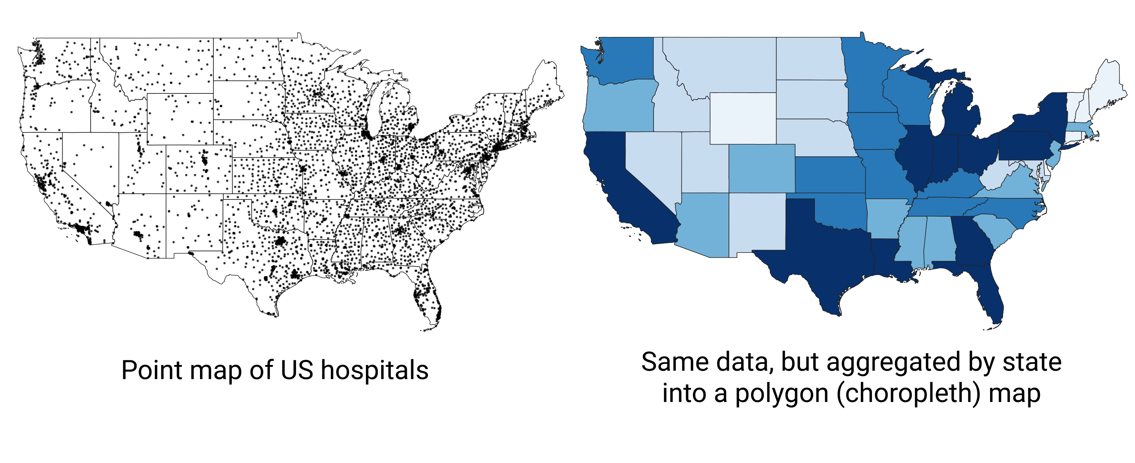

Figure 114: You can count addresses by state (or other area) to produce polygon, or choropleth, maps instead of point maps.

First, save the database to your local machine by going to *Export > Download > CSV* of Socrata interface. Figure 115 shows where you can find the Export button.



Figure 115: In Socrata, you can export the entire dataset as a CSV.

Next, open the file in your favorite spreadsheet tool. If you use Google Sheets, use *File > Import > Upload* to import CSV data. Make sure your address columns are present, and move on to creating a pivot table (in Google Sheets, go to *Data > Pivot table*, make sure the entire data range is selected, and click *Create*). In the pivot table, set **Rows** to *State*, because we want to get counts by state. Next, set pivot table’s **Values** to *State*—or really any other column that has no missing values—and choose *Summarize by: COUNTA*. Voila!



Figure 116: Use pivot tables in any spreadsheet software to count addresses per area (such as state, county, of zip code).

Your aggregated dataset is ready, so save it as a CSV. If you use Google Sheets, go to *File > Download > Comma-separated values (.csv, current sheet)*. You can now merge this dataset with your polygons manually using editing capabilities of [GeoJson.io](geojsonio.html), or merge it all in one go using powerful [Mapshaper](mapshaper.html).

We will introduce both tools in the next few sections. But before we do that, let’s talk about data normalization and why showing counts of hospitals per state doesn’t really tell a good story.

## Normalize Data to Create Meaningful Polygon Maps

Polygon (choropleth) maps are best when they represent relative, not absolute values. Consider two maps shown in Figure 117. They both are about Covid-19 cases in the US states (excluding Alaska and Hawaii) as of June 26, 2020. The map on the left shows total number of recorded cases per state, and the map on the right shows cases adjusted by the state’s population. Darker colors represent higher values. Do you notice any differences in spatial patterns?

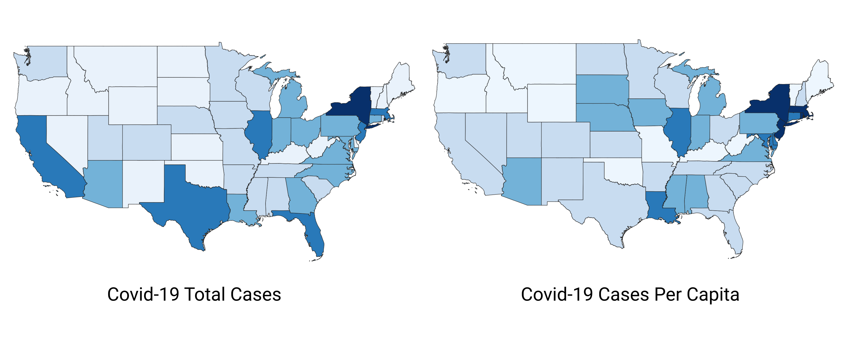

Figure 117: Choropleth (polygon) maps work best with normalized values.

Note: Both maps show Covid-19 data collected by the New York Times and published [on GitHub](https://github.com/nytimes/covid-19-data). In one map, we normalized (divided) values by population in each state, according to the 2018 US Census American Community Survey, the most recent data available on the day of writing. We didn’t add legends and other important cartographic elements so that you can better focus on interpreting spatial patterns. In both cases, we used Jenks natural breaks for classification.

What are the worst-hit states according to the map showing total Covid-19 counts? If you are familiar with the US geography, you can quickly tell that these are New York, New Jersey, Massachusetts, Florida, Illinois, Texas, and California. But five of these happen to be some of the most populous states in the US, so it makes sense that they will also have higher Covid-19 cases.

Now, how about the map on the right? You can see that New York and its neighbors, including New Jersey and Massachusetts, have by far the highest rates per capita (per person), which we saw in the first map. But you can also see that in fact California, Texas, and Florida were impacted to a lesser extent than the map on the left had suggested. So the map with per-capita values is a much better illustration to the story about New York being the epicenter of the Covid-19 crisis in the United States (at least in the spring of 2020).

#### Different ways to normalize data

You can normalize data in many ways, and there is not necessarily one acceptable way of doing it.

One of the most common ways of normalization is deriving “per capita”, or “per person” values. If values are small, such as rare disease cases or lottery winners, they can be presented as “per 1,000” or “per 100,000” people. Divide your quantity by population in that area to derive per capita values.

Choropleth (polygon) maps work well with percentages. The good news is, humans like percentages too. It is quite natural for us to understand that a 9% unemployment rate means that of 100 people who were willing to work, nine were unable to find a job. To derive a percentage for unemployment, divide the number of unemployed people by labor force size (adult population who are willing and able to work), and multiply by 100.

Unlike counts, most *measured* variables do not need normalization because they belong to a scale. For example, median age (the age of the “middle” person in a population, when sorted from youngest to oldest) can be directly compared among populations. We know that humans live anywhere between 0 and 120 years or so, and we wouldn’t expect median ages to be vastly different from one country to another (maybe twice, but not tenfold). Median incomes, if measured in the same currency, also belong to the same scale and can be compared directly.

#### How not to normalize values

Absolute values are very important for context. Saying that “20% of blond men living in in town X won the lottery” may sound like a catchy headline, but in reality the town has 450 residents, of those 200 are men, and of those only 5 have light hair color. One of those five (and here comes the 20%) was lucky to win the lottery, so technically the headline didn’t lie.

This is, of course, an extreme and comic example, but exaggerations in this spirit are not uncommon. If you want readers to trust you, make sure you are open about total counts when reporting normalized values (such as percentages or per capita values).

Absolute values are important for another reason: behind numbers there are often people, and smaller, normalized values may hide the scale of the problem. Saying that “the unemployment rate is only 5%” is valid, but the 5% of, say, Indian labor force (around 522 million) is about 26 million, which is pretty much the total population of Australia.

Exercise your best judgement when you normalize values. Make sure you don’t blow numbers out of proportion by normalizing values in smaller populations. But also don’t hide large counts behind smaller percentages for larger populations.

At this point, you should have enough geocoding and spreadsheet skills to aid you with map making. In the following section, we will talk about geographical data in general and will introduce different geospatial file formats to ensure you are ready to create, use, and share map data.

## Convert to GeoJSON format

Geospatial data comes in an overwhelming number of file formats. We will tell you about a few most common ones so that you have a general idea of what tools you can use to work with them. But before we do that, let’s talk about the basics of geospatial (map) data.

#### About geospatial data

The first thing to know about geospatial data is that it consists of two components, **location** and **attribute**. When you use Google Maps to search for a restaurant, you get a red marker on the screen that points to the latitude and longitude of the physical location of the restaurant in the real world. These latitude and longitude (two numbers) are your location component. The name of the restaurant, its human-friendly address, and guest reviews are the attributes, which bring value to your location data.

Second, geospatial data can be **raster** or **vector**, as illustrated in Figure 118. Raster data is a grid of cells (“pixels”) of a certain size (for example, 1 meter by 1 meter). For example, satellite images of the Earth that you see on Google Maps are raster geospatial data. Each pixel contains the color of Earth that satellite cameras were able to capture. People and algorithms can then use raster data (images) to create outlines of buildings, lakes, roads, and other objects. These outlines become vector data. For example, most of [OpenStreetMap](https://www.openstreetmap.org) was built by volunteers tracing outlines of objects from satellite images.

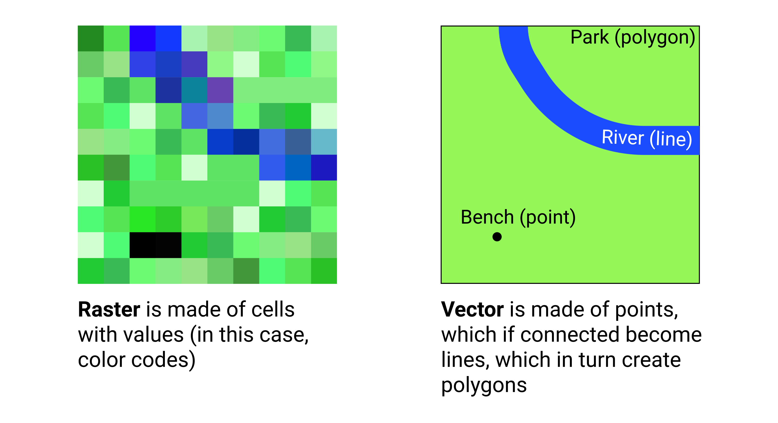

Figure 118: Geospatial data can be raster or vector.

In this book, we will focus on vector data, which is based on points, lines, and polygons. Vector data can be much more precise than raster data, because points’ coordinates can be expressed with precise decimals. In addition, vector data can contain as much extra *attribute* information about each object as desired, whereas raster data is generally limited to 1 value per cell, whether it is the Earth color, or temperature, or altitude. Moreover, vector map files are usually much smaller in size than raster ones.

Let’s take a look at some of the most common vector file formats.

#### GeoJSON

[GeoJSON](https://geojson.org) is a newer, popular open format for map data that comes in .geojson or .json files. It was first developed in 2008, and then standardized in 2016 by the Internet Engineering Task Force (IETF). The code snippet below represents a single point (feature) with latitude of 41.76 and longitude of -72.67 in GeoJSON format. That point has a *name* attribute (property) whose value is *Hartford*.

{  
 "type": "Feature",  
 "geometry": {  
 "type": "Point",  
 "coordinates": [-72.67, 41.76]  
 },  
 "properties": {  
 "name": "Hartford"  
 }  
}

The simplicity and readability of GeoJSON allows you to edit it even in the most simple text editor. We strongly recommend you use and share your map data in GeoJSON. Web-based maps, such as those built with Leaflet, Mapbox, Google Maps JS API, and Carto, as well as ArcGIS and QGIS all support GeoJSON.

Also, your GitHub repository will automatically display any GeoJSON files in a map view, like is shown in Figure 119.



Figure 119: GitHub can show previews of GeoJSON files stored in repositories.

In GeoJSON, coordinates are ordered in *longitude-latitude* format, the same as X-Y coordinates in mathematics. This is the opposite of Google Maps and some other web map tools, which order values as *latitude-longitude*. For example, *Hartford, Conn.* is located at (-72.67, 41.76) according to GeoJSON, but at (41.76, -72.67) in Google Maps. Neither notation is right or wrong, just make sure you know which one you are dealing with.

#### Shapefiles

The shapefile format was created in the 1990s by Esri, the company that develops ArcGIS software. Shapefiles typically appear as a folder of subfiles with suffixes such as .shp, .shx, and .dbf. The folder with shapefiles is often compressed in a .zip file.

Although government agencies commonly distribute map data in shapefile format, the standard tools for editing these files—ArcGIS and its free and open-source cousin, QGIS—are not as easy to learn as other tools in this book. For this reason, we recommend converting shapefiles into GeoJSON files if possible. [Mapshaper](mapshaper.html), discussed a bit later in the chapter, can perform such conversion.

#### GPS Exchange Format (GPX)

If you ever exported your Strava run or a bike ride from a GPS device, chances are you ended up with a .gpx file. GPX is an open standard and is based on XML markup language. Like GeoJSON, you can inspect a GPX file in any simple text editor to see its contents. Most likely, you will see a collection timestamps and latitude/longitude coordinates of the recording GPS device at that particular time. You should be able to convert GPX to GeoJSON with [GeoJson.io](geojsonio.html) utility discussed later in this chapter.

#### Keyhole Markup Language (or KML)

The KML format rose in popularity during the late 2000s. Google Earth, a free and user-friendly tool, allowed many people to view and edit geographic data. KML files were often used with maps powered by Google Fusion Tables, but that became history in late 2019. [GeoJson.io](geojsonio.html) should be able to convert your KML file into a GeoJSON.

Sometimes .kml files are distributed in a compressed .kmz format. See [Converting from KMZ to KML format](convert-kmz) section of this book to learn to convert.

#### MapInfo TAB

Similar to Esri’s shapefiles, MapInfo’s TAB format comes as a folder with .tab, .dat, .ind, and some other files. It is a proprietary format created and supported by MapInfo, Esri’s competitor, and is designed to work well with MapInfo Pro GIS software. Unfortunately, you will most likely need MapInfo Pro, QGIS, or ArcGIS to re-save these as GeoJSON or a Shapefile.

## GeoJson.io to Convert, Edit, and Create Map Data

[GeoJson.io](https://geojson.io) is a popular open-source web tool to convert, edit, and create GeoJSON files. The tool was originally developed by [Tom MacWright](https://macwright.org/about/) in 2013 and quickly became a go-to tool for geospatial practitioners.

In this tutorial, we will show you how to convert existing KML, GPX, TopoJSON, and even CSV files with lat/lon data into GeoJSON files. We will also look at editing attribute data and adding new features to GeoJSON files, and creating them from scratch by tracing satellite imagery.

#### Convert KML, GPX, and other formats into GeoJSON

Navigate to [GeoJson.io](https://geojson.io). You will see a map on the left, and a Table/JSON attribute view area on the right. At the start, it represents an empty feature collection (features are your points, lines, and polygons).

Drag and drop your geospatial data file into the map area on the left. Alternatively, you can also import a file from *Open > File* menu. If you don’t have a geospatial file, download [Hartford parks](data/hartford-parks.kml) in KML format. If GeoJson.io was able to recognize and import the file, you will see a green popup message in the upper-left corner saying how many features (in case of Hartford parks, polygons) were imported. Figure 120 shows us that 62 features were imported from the sample Hartford parks file. You can see that the polygons appeared on top of the Mapbox world layer.

Note: If GeoJson.io couldn’t import your file, you will see a red popup saying it “Could not detect file type”. You will need to use a different tool, such as Mapshaper or QGIS, to convert your file to GeoJSON.



Figure 120: GeoJson.io successfully imported Hartford parks KML file.

You can now save your file to GeoJSON. Go to *Save > GeoJSON* to download a converted GeoJSON file to your computer.

#### Create GeoJSON from a CSV file

GeoJson.io can transform a spreadsheet with *latitude* (or *lat*) and *longitude* (or *lon*) columns into a GeoJSON file of point features. Each row in the spreadsheet becomes its own point, and all columns other than *lat* and *lon* become *attributes* (or *properties*) of point features. An example of such spreadsheet is shown in Figure 121. You can [download it](data/hartford-and-suburbs.csv) for the exercise.



Figure 121: A spreadsheet with lat/lon columns can be transformed into a GeoJSON with point features.

1. Save your spreadsheet as a CSV file, and drag-and-drop it to the map area of GeoJson.io. You should see a green popup in the upper-left corner notifying you how many features were imported.

Note: If you had some data on the map already, GeoJson.io wouldn’t erase anything but instead would add point features to the existing map.

1. Click on a marker to see a popup with point properties. If you used the sample file with towns around Hartford, you will see *town*, *community_type*, and *wiki_link* features in addition to the tool’s default *marker-color*, *marker-size*, and *marker-symbol* fields.
2. The popup is interactive, and you can click and edit each property (including property names). You can also add a new property by clicking the *Add row* button. You can delete the marker by clicking *Delete feature* button.
3. Click *Save* to record all marker changes to the GeoJSON. This will close the popup window, and you will see updated markers in the JSON tab to the right of the map.
4. It may be quicker to view all data as a table instead of dealing with individual marker popups. In **Table** tab to the right of the map, you can add, rename, and remove columns from *all* features (markers) at once. Table cells are also modifiable, so you can edit your data there.
5. Once you are happy with your map data, go to *Save > GeoJSON* to download the result to your computer. You can also log into GeoJson.io with your GitHub account and save directly to your repository.

#### Create a GeoJSON from scratch using drawing tools

GeoJson.io lets you create geospatial files from scratch, using simple drawing tools to put markers (points), lines, and polygons to appropriate locations. These are useful when you have no original file to work with.

1. Open GeoJson.io and in the lower-left corner switch from Mapbox (vector tiles) to Satellite.
2. In the upper-right corner of the map, use the Search tool to find the area you’re interested in mapping. For this exercise, we will use tennis courts at Trinity College, Hartford, as shown in Figure 122.



Figure 122: Use drawing tools to create points, lines, and polygons in GeoJson.io.

1. In the toolbar, you have a choice of four drawing tools: a polyline (which is a series of points connected by lines, but not closed like a polygon), a polygon, a rectangle (which is just an instance of a polygon), and a marker (point). Let’s start with the latter.
2. Click on the *Draw a marker* button, and click anywhere on the map to place it. You will see a gray marker that is now part of your map. You can modify its properties, or delete it in the interactive pop-up.
3. Next, choose *Draw a polyline* and click on multiple locations in the map to see connected lines appearing. To finish and create a feature, click again on the final point. Polylines are generally used for roads and paths.
4. Drawing a polygon is similar to drawing a polyline, except that you need to complete the feature by making your final point at the same location as your initial point. Polygons are used to define object boundaries, from continents to buildings, cars, and anything that has significant dimensions.
5. Use *Edit layers* tool (the one above *Delete*) to move a marker to a better position, or adjust the shapes of your features.

Once you are done creating features and their physical boundaries, it is time to add meaningful attribution data. Use the interactive popups or the Table view to give objects names and other qualities. When finished, save the GeoJSON to your computer.

Drawing tools can be used to correct your existing GeoJSON files. For example, if you created a GeoJSON from a CSV file, you might decide to move some markers with *Edit layers* tool instead of modifying their latitude and longitude values. Or you might decide that your polygons (eg those representing Hartford parks) are too “simplified”, and make them more precise with the satellite imagery.

In the next section, we will introduce Mapshaper, another free online tool to convert and modify geospatial files.

## Mapshaper to Convert, Edit, and Join Data

Like [GeoJson.io](geojsonio.html), [Mapshaper](https://mapshaper.org) is a free, open-source editor that can convert geospatial files, edit attribute data, filter and dissolve features, simplify boundaries to make files smaller, and many more. Unlike GeoJson.io, Mapshaper doesn’t have drawing tools, so you won’t be able to create geospatial files from scratch.

Mapshaper is developed and maintained by Matthew Bloch [on GitHub](https://github.com/mbloch/mapshaper). It is written in JavaScript, so we recommend you use a recent version of Firefox or Chrome.

This free and easy-to-learn Mapshaper web tool has replaced *many* of our map preparation tasks that previously required expensive and hard-to-learn ArcGIS software, or its free but still-challenging-to-learn cousin, QGIS. Even advanced GIS users may discover Mapshaper to be a quick alternative for some common but time-consuming tasks.

#### Import, convert, and export map boundary files

You can use Mapshaper to convert between geospatial file formats. Unlike GeoJson.io, Mapshaper also supports Esri Shapefiles (which is a folder of individual files with the same name, but different extensions), so you can easily convert a Shapefile into a web-friendly GeoJSON.

1. Navigate to [Mapshaper.org](https://mapshaper.org). The start page is two large drag-and-drop zones which you can use to import your file. The smaller area at the bottom, *Quick import*, uses default import settings and is a good way to begin.
2. Drag and drop your geospatial file to the *Quick import* area, or use our sample Shapefile of [US state boundaries](data/us-states.zip). This is a .zip archive which contains a folder with all necessary files.

Note: If you want to import a folder, you need to either select all files inside that folder and drop them all together to the import area, or create a .zip archive.

1. Each imported file becomes a layer, and is accessible from the dropdown menu in the top-middle of the browser window. There, you can see how many features each layer has, toggle their visibility, or delete them.
2. To export, go to *Export* in the upper-right corner, and select a desired file format. The choice of export formats is shown in Figure 123. As of July 2020, these are Shapefile, GeoJSON, TopoJSON (similar to GeoJSON, but with topographical data), JSON records, CSV, or SVG (Scalable Vector Graphics, for web and print). If you export more than one layer at a time, Mapshaper will archive them first, and you will download an output.zip that contains all exported layers.



Figure 123: You can use Mapshaper to quickly convert between geospatial file formats.

Tip: Mapshaper doesn’t work with KML or KMZ files, but you can use GeoJson.io to convert these.

#### Edit data for specific polygons

You can edit attribute data of individual polygons (and also points and lines) in Mapshaper. Figure 124 shows you how.

1. Import the file whose polygon attributes you want to edit.
2. Under the cursor tool, select *edit attributes*.
3. Click on the polygon you want to edit. A pop-up will appear in the upper-left corner listing all attributes and values of the polygon.
4. Click on any value (underlined, in blue) and edit it.
5. When you are done, export your geospatial file by clicking *Export* and choosing the desired file format.



Figure 124: Use *edit attributes* tool (under Cursor tool) to edit attributes of polygons, lines, and points.

#### Simplify map boundaries to reduce file size

You may not need precise and detailed map boundaries for data visualization projects where zoomed-out geographies are shown. Detailed boundaries are heavy, and may slow down your web maps.

Consider two maps of the contiguous US states, also known as Lower-48, shown in Figure 125. The map on the left is more detailed and is about 230 kilobytes, but the map on the right is only 37 kilobytes, 6 times smaller!

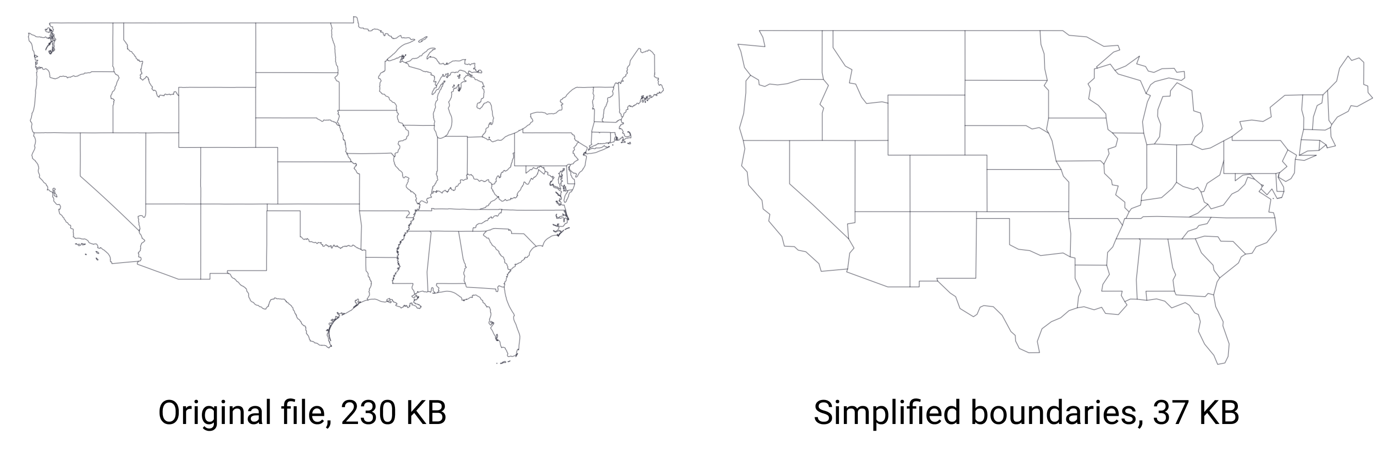

Figure 125: Consider simplifying geometries with Mapshaper to make your web maps faster.

1. Import your geo file to Mapshaper. You can use the [sample contiguous US states GeoJSON](data/lower-48.geojson).
2. Click the *Simplify* button in the upper-right corner. The Simplification menu will appear, where you can choose one of three methods. We recommend checking *prevent shape removal*, and leaving the default *Visvalingam / weighted area*. Click *Apply*.
3. You will see a slider with 100% appear on top (Figure 126), replacing the layer selection dropdown. Move the slider to the right and see the map simplify its shape as you go. Stop when you think the map looks appropriate (when the shapes are still recognizable).
4. Mapshaper may suggest to repair line intersections in the upper-left corner. Click *Repair*.
5. You can now export your file using the *Export* feature.

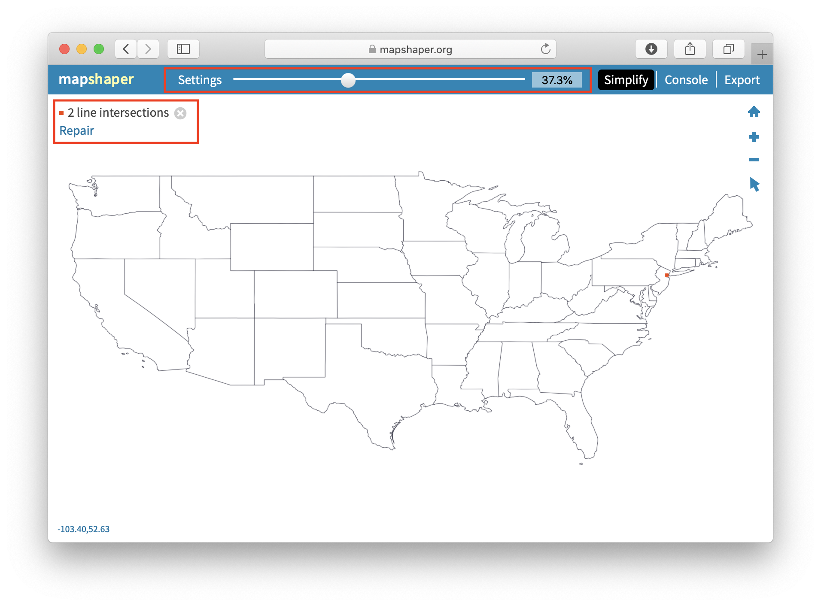

Figure 126: Use Simplify & Repair tools in Mapshaper.

Tip: You may find the US shape a bit unusual and vertically “shrunk”. In **Console**, type -proj EPSG:3857 to change projection to Web Mercator, which is more common.

#### Dissolve internal polygons to create an outline map

Mapshaper’s most powerful tools are available through **Console**, which allows you to type commands for common map editing tasks. One of such tasks is to create an outline map by removing the internal boundaries. For example, you can dissolve state boundaries of the US map in the previous exercise to get the outline of the country, like is shown in Figure 127.



Figure 127: Mapshaper lets you dissolve boundaries to create an outline shape.

Click the Console button, which opens a window to type in commands. Enter the command below, then press return (Enter).

-dissolve

You will see that internal boundaries became lighter color, and that’s Mapshaper’s way of saying they no longer exist. You can now export your outline shape.

#### Clip a map to match an outline layer

The state of Connecticut consists of 8 counties, which in turn are divided into towns. There are a total of 169 towns in Connecticut. Imagine you are given a [boundary file of all 169 towns](data/ct-towns.geojson), and [the outline of Hartford county](data/hartfordcounty-outline.geojson). You need to “cut” the original towns map to only include those towns that fall within Hartford county.

Mapshaper allows you to do just that using one simple -clip command.

1. Import two boundary files into Mapshaper. One is the larger one that is being clipped (if you use sample files, *ct-towns*), and one is the desired final shape (*hartfordcounty-outline*). The latter is what ArcGIS calls the “clip feature”.
2. Make sure your active layer is set to the map you are clipping (*ct-towns*).
3. In the **Console**, type -clip followed by the name of your clip layer, like that:

-clip hartfordcounty-outline

1. You should see your active layer got clipped. Sometimes you end up with tiny “slivers” of clipped areas that remain alongside the borders. If that is the case, use the -filter-slivers command to remove them, like that:

-clip hartfordcounty-outline -filter-slivers

1. Your Mapshaper state should look like pictured in Figure 128. You can now save the file on your computer using the *Export* button.



Figure 128: When clipping, make sure your active layer is the one being clipped (with many features), not the clipping feature iteslf.

#### Remove unwanted data fields

Sometimes map features, such as polygons, lines, and points, contain unwanted *attributes* (or fields, or columns) that you may want to remove. In **Console**, use -filter-fields editing command to remove unnecessary fields.

For example, remove all fields except *town*:

-filter-fields town

If you want to leave more than one field, separate them by a comma, but without spaces, like that:

-filter-fields town,state

Note: If you leave a space after comma, you will get a *Command expects a single value* error.

#### Join spreadsheet data with polygon map

Combining spreadsheet data with geographical boundaries is a common task for geospatial practitioners. Imagine you have a file with [Connecticut town boundaries](data/ct-towns.geojson), and you want to add [population data](data/ct-towns-popdensity.csv) to each of them in order to build a choropleth map.

Mapshaper provides a powerful -join command to join such files. Remember that you need some common keys in both datasets (such as *town name*, or *state*, or *country*) in order to join files. Otherwise Mapshaper has no way of knowing which numbers belong to which polygons.

1. Import both geospatial file and a CSV dataset into Mapshaper using Quick import box.
2. Make sure both files appear in the drop-down list of layers. Your CSV data will be shown as something that resembles a table. Use the *Cursor > inspect attributes* tool to make sure the data is imported correctly. If you use the sample CT files, note that the *ct-towns* layer has *name* attribute with the name of the town, and *ct-towns-popdensity* has town names in the *town* column.
3. Make your geospatial layer (*ct-towns*) is the one active.
4. Open **Console**, and use the -join command, like that:

-join ct-towns-popdensity keys=name,town

where ct-towns-popdensity is the CSV layer you are merging with, and keys are the attributes that contain values to join by. In case with our sample files, these would be town names which are stored in name attribute of the map file, and town column of the CSV file.

1. You will see a message in the console notifying you if join was performed successfully, or if Mapshaper encountered any errors.
2. Use the *Cursor > inspect attributes* tool to make sure you see CSV columns as fields of your polygons, like is shown in Figure 129.
3. You can now save the file to your computer by clicking the *Export* button.



Figure 129: Mapshaper lets you join spatial and CSV files using common keys (for example, town names).

Tip: To avoid confusion, it may be useful to re-name your CSV column that contains key values to match the key attribute name of your map. In our example, you would rename *town* column to *name* column in the CSV, and your command would end with keys=name,name.

Do you remember aggregating address-level point records of hospitals into [hospital counts per state](pivot-point-to-polygon.html)? Now is a good time to find that .CSV file and practice your merging skills.

#### Count points in polygons with Mapshaper

Mapshaper lets you count points in polygons, and record that number in polygon attributes using -join command.

1. Import two geospatial files, one containing polygon boundaries (for example, [US state boundaries](data/us-states.geojson)), and another containing points that you want to aggregate (for example, [hospitals in the US](data/hospitals-points.geojson)).
2. Make sure your polygons (not points) layer is active by selecting it from the dropdown menu.
3. In **Console**, perform -join using a count() function, like that:

-join hospitals-points calc='hospitals = count()' fields=

This command tells Mapshaper to count points inside *hospitals-points* layer and record them as *hospitals* attribute of the polygons. The fields= part tells Mapshaper to not copy any fields from the points, because we are performing many-to-one matching (many hospitals per state, in our case).

1. Use the *Cursor > inspect attributes* tool to make sure polygons obtained a new field with the recorded count of points, like is shown in Figure 130.
2. Save the new file using *Export* button and choosing the desired output format.



Figure 130: Mapshaper’s -join can count points in polygons.

#### More about joins

As you saw in counting points in polygons example, you do not need to specify *keys* if you want to perform join based on geographical locations between two geo files. If one of your files is a CSV, you need *keys*.

If you don’t have a CSV table that matches the columns in your boundary map data, you can easily create one. Upload the boundary map to Mapshaper, and export in CSV format. Open the downloaded file in any spreadsheet tool. To match data columns in the CSV spreadsheet, use the [VLOOKUP](vlookup.html) function.

In real life, you will rarely have perfect files with one-to-one matches, so you might want to have more information about which features didn’t get matched so that you can fix your data. Mapshaper helps you keep track of data that is not properly joined or matched. For example, if the polygon map contains 169 features (one for each town in Connecticut), but the CSV table contains only 168 rows of data, Mapshaper will join all of those with matching keys, and then display this message:

[join] Joined data from 168 source records to 168 target records  
[join] 1/169 target records received no data  
[join] 1/169 source records could not be joined

To get more details on which values were not joined, add unjoined unmatched -info flags to your join command, like this:

-join ct-towns-popdensity keys=name,town unjoined unmatched -info

The unjoined flag saves a copy of each unjoined record from the source table into another layer named *unjoined*. The unmatched flag saves a copy of each unmatched record from the target table to a new layer named *unmatched*. And the -info flag outputs some additional information about the joining procedure to the console.

#### Merge selected polygons with join and dissolve commands

In Mapshaper, you can merge selected polygons into larger “clusters” using -join and -dissolve commands.

Imagine that you are employed by the CT Department of Public Health, and your task is to divide 169 towns into 20 so-called Health Districts and produce a new geospatial file. By the way, health districts [are a real thing in Connecticut](https://portal.ct.gov/DPH/Local-Health-Admin/LHA/Local-Health-Administration---Site-Map).

You should begin by creating a *crosswalk* of towns and their health districts. It can be as simple as a two-column CSV list of a town and its district. Because your boss didn’t give you a list of towns in a spreadsheet format, but instead a GeoJSON file with town boundaries, let’s extract a list of towns from it.

1. Import [ct-towns.geojson](data/ct-towns.geojson) to Mapshaper using Quick import box.
2. You can use the *Cursor > inspect attributes* tool to see that each polygon has a *name* attribute with the name of the town.
3. Save attribute data as a CSV file using *Export* button. Open the file in any spreadsheet tool. You will see that your data is a one-column file with a *name& column that lists 169 towns.
4. Create a second column titled *merged* and copy-paste values from the first, *name* column. At this point your spreadsheet contains two columns with the same values.
5. Pick a few towns, for example *West Hartford* and *Bloomfield*, and assign “Bloomfield-West Hartford” to their *merged* column, like is shown in Figure 131. You may stop right here and move to the next step, or keep assigning district names to a few other neighboring towns.



Figure 131: Create a two-column crosswalk of towns and which districts they should be merged to.

1. Save this new file as *ct-towns-merged.csv*, and drag-and-drop it to Mapshaper on top of your *ct-towns* layer. Click *Import*.
2. This new CSV layer will be added as *ct-towns-merged* and will appear as a series of table cells. From the dropdown menu, select *ct-towns* to get back to your map.
3. Now you are ready to merge certain towns into districts according to your uploaded CSV file. Open **Console**, and type:

-join ct-towns-merged keys=name,name

to join the CSV layer with the boundaries layer that you see on the screen, followed by

-dissolve merged

to dissolve polygons of towns according to the *merged* column of the CSV file.

In our example, only Bloomfield and West Hartford are dissolved into a combined “Bloomfield-West Hartford” regional health district (with the shared boundary between towns becoming grayed out), and all of the other polygons remain the same. Figure 132 shows the final result.



Figure 132: Merge polygons based on a predefined crosswalk.

You can inspect attribute data of polygons using *Cursor > inspect attributes* tool, and save the resulting file using the *Export* button.

#### Learn more advanced MapShaper methods

There are many more commands within Mapshaper that are worth exploring if you are serious about GIS, such as changing projections, filtering features using JavaScript expressions, assigning colors to polygons based on values, and many more. Explore the [Wiki](https://github.com/mbloch/mapshaper/wiki/Command-Reference) of Mapshaper project on GitHub for more commands and examples.

TODO: Add Mapwarper section here

## Convert a Compressed KMZ file to KML format

Sometimes KML files are distributed in compressed KMZ format. The easiest way to convert is to use free Google Earth Pro.

1. Download and install [Google Earth Pro](https://www.google.com/earth/versions/) for desktop.
2. Double-click on any .kmz file to open it in Google Earth Pro. Alternatively, open Google Earth Pro first, and go to *File > Open* and choose your KMZ file.
3. Right-click (or control-click) on the KMZ layer under Places menu, and select *Save Place As…*, like is shown in Figure 133.

 4. In the dropdown menu of *Save file…* window, choose KML format, like is shown in Figure 134.



Figure 134: Save as KML, not KMZ.

Alternatively, you can use any zip-utility to extract a KML file from KMZ. KMZ is simply a ‘zipped’ version of a KML file!

# Detect Bias in Data Stories

While we like to believe data visualizations simply “tell the truth,” when you dig further into this topic, you realize that there are multiple ways to represent reality. In this chapter, you will learn how visualizations display the biases of the people and the software that create them. Although we cannot stop bias, we can teach people to look for and detect it, and be aware of our own.

Sections in this chapter:

* [How to Lie with Charts](how-to-lie-with-charts.html), inspired by Darrell Huff (1954)
* [How to Lie with Maps](how-to-lie-with-maps.html), inspired by Mark Monmonier (1996)

Enroll in our free online course *TO DO add link*, which introduces these topics in the brief video below, and offers more exercises and opportunities to interact with instructors and other learners.

#### Learn more

* Darrell Huff, How to Lie with Statistics (W. W. Norton & Company, 1954), <http://books.google.com/books?isbn=0393070875>
* Mark S. Monmonier, How to Lie with Maps, 2nd ed. (University of Chicago Press, 1996), <http://books.google.com/books?isbn=0226534219>
* Nathan Yau, “How to Spot Visualization Lies,” FlowingData, February 9, 2017, <http://flowingdata.com/2017/02/09/how-to-spot-visualization-lies/>

## How to Lie with Charts

One of the best ways to learn how to detect bias in data visualization is to intentionally manipulate a chart, and tell two (or more) opposing stories with the same data. You’ll learn what to watch out for when viewing other people’s charts, and think more carefully about the ethical issues when you design your own.

This exercise was inspired by a classic book published more than fifty years ago: Darrell Huff, *How to Lie with Statistics* (W. W. Norton & Company, 1954), <http://books.google.com/books?isbn=0393070875>

Right-click this link and Save to download this sample data in CSV format to your computer: [us-gross-domestic-product-per-capita](data/us-gross-domestic-product-per-capita.csv). This historical data on economic productivity comes from the World Bank, World Development Indicators, <http://data.worldbank.org/data-catalog/world-development-indicators>

Upload the CSV file to your Google Drive (with Settings to Convert to Google format) to create a Google Sheet.

Select the data cells and Insert > Chart > Line chart, similar to the default version shown below:

In your Google Sheet chart, double-click the vertical y-axis to edit the Minimum and Maximum values.



Screenshot: Edit the Min and Max values of the Y-axis

Make the line look “flatter” (slower economic growth) by lowering the minimum to $36,000, and increasing the maximum to $100,000, as shown below:

Make the line look like a “sharper increase” (faster economic growth) by increasing the minimum to $38,000, and lowering maximum to $52,000, as shown below:

** TO DO – add conclusion **

## How to Lie with Maps

One of the best ways to learn how to detect bias in data visualization is to intentionally manipulate a map, and tell two (or more) opposing stories with the same data. You’ll learn what to watch out for when viewing other people’s maps, and think more carefully about the ethical issues when you design your own.

This exercise was inspired by Mark S. Monmonier, *How to Lie with Maps, 2nd ed.* (University of Chicago Press, 1996), <http://books.google.com/books?isbn=0226534219>

First, scroll through this data on Median Household Income for Hartford-area towns, 2011-15, from American Community Survey 5-year estimates. Or right-click to [open this Google Sheet in a new tab](https://docs.google.com/spreadsheets/d/13bFHsXJtADIkUCGgjpO76RjrV0OAu62hzK-J3bXEVsk/edit#gid=556312122).

Next, explore two different polygon maps of the same data. Use the drop-down menu to compare “Extreme Differences” versus “Uniform Equality”

Why are these two maps portray the same data so differently? To see the answer, look at the data ranges. . ..

** TO DO **

Create your own version…

TODO: Add section on how interactive maps such as Google Maps change borders and data depending on the internet address of the user

# Tell Your Data Story

TODO: Write this chapter: Tell the story about your data, including its most meaningful insights and limitations Write compelling titles, labels, and sentences to accompany your visualization. Call attention to the most meaningful insights in your chart, and explain any data limitations.

This chapter draws inspiration from Cole Nussbaumer Knaflic, *Storytelling with Data: A Data Visualization Guide for Business Professionals* (Wiley, 2015), <http://www.storytellingwithdata.com/book/>

* Beginning, Middle, and End
* Draw Attention to Meaning
* Integrate Story with Your Data
* Write Clearly about What You Visualize
* Credit Data Sources and Collaborators

Credit sources and collaborators on dataviz products and readme files

Under US law, you cannot copyright data, such as the raw information in the rows and columns of a spreadsheet. But you can copy, but representations of data can be protected by copyright. … explain… In the spirit of openness, we encourage you to share your data visualizations under a Creative Commons license… explain… in fact, this book is copyrighted, and the source text is publicly available under a Creative Commons TODO: TYPE license…

# Appendix

# Fix Common Mistakes

Creating your data visualizations through code templates hosted on GitHub has multiple advantages over drag-and-drop tools. Coding gives you more power to customize their appearance and interactive features, and to control where your data and products reside online. But there’s also a trade-off. Code can “break” and leave you staring at a blank screen. Sometimes problems happens through no fault of your own, such as when a “code dependency” to an online background map or code library is unexpectedly interrupted. But more often it seems that problems arise because we make simple mistakes that break our own code. Whatever the cause, one big drawback of working with code is that you’re also responsible for fixing it.

We designed this section as a guide to help new coders diagnose and solve common errors when working with code templates on GitHub. We understand the feeling you experience when a simple typo—such as a misplaced semicolon (;)—makes your data visualization disappear from the screen. Finding the source of the problem can be very frustrating. But breaking your code—and figuring out how to fix it—also can be a great way to learn, because trial-and-error on a computer often provides immediate feedback that supports the learning process and develops our thinking.

TODO: Start here; Reorganize the logic of subsections below, perhaps in this way

* Problems with Mac computers
* Problems with data tables
* Problems with iframes (since this chapter appears before code templates)
* Problems with GitHub forking and hosting
* Problems with code templates

#### Problems with Mac computers: cannot see filename extension

Several tools in this book will not work properly if your computer does not display the filename extensions, meaning the abbreviated file format that appears after the period, such as data.csv or map.geojson. The Mac computer operating system hides these by default, so you need to turn them on by going to Finder > Preferences > Advanced, and check the box to *Show all filename extensions*, as shown in Figure 135.



Figure 135: On a Mac, go to Finder > Preferences > Advanced and check the box to *Show all filename extensions*.

#### Problems with data tables

Avoid typing blank spaces after column headers—or any spreadsheet entries—since some data visualization tools will not match them with headers lacking a blank character.



#### Problems with iframes

##### My iframe does not appear in my web page

* Go back to the [Embed tutorials in this book](embed.html) to double-check the directions
* Items listed in your iframe (such as the URL, width, or height) should be enclosed inside straight quotation marks (single or double)
  + BROKEN iframe (missing quotation marks for width and height)
* <iframe src="https://handsondataviz.github.io/leaflet-map-simple" width=90% height=350></iframe>
  + FIXED iframe (with correct quotation marks)
* <iframe src="https://handsondataviz.github.io/leaflet-map-simple" width="90%" height="350"></iframe>
* Use only https (the extra ‘s’ means ‘secure’), not http. Some web browsers will block content if it mixes http and https resources, and some code templates in this book require https.



Screenshot: Replace http with https

* Use only straight quotes, not curly quotes. Avoid pasting text from a word-processor into GitHub, which can accidentally carry over curly quotes. Typing directly into the GitHub editor will create straight quotes.



Screenshot: Curly quotes versus straight quotes

TODO: Test one way to fix GitHub errors by going into the commits and going back to a previous version of the code. Is this possible in the web version?

#### Safely Delete your GitHub Repo and Start Over

If you need to delete your GitHub repo and start over, here’s a simple way to safely save your work:

* Go to the top-level of your GitHub repository, similar to https://github.com/USERNAME/REPOSITORY
* Click the green “Clone or Download” button, and select Download Zip to receive a compressed folder of your repo contents on your computer.
* In your GitHub repo, click on Settings (upper-right area) and scroll down to Delete This Repository.
* To prevent accidental deletions, GitHub requires you to type in the REPOSITORY name.
* Now you can start over in one of these ways:
  + If you wish to [Create a Simple Web Page with GitHub Pages](github-pages.html), follow that tutorial again.
  + OR
  + Fork another copy of the original GitHub repository to your account. After you create your copy, if you wish to add selected files that you previously downloaded to your computer, follow directions to [Upload Code with GitHub](create-repo) in the second half of this tutorial in this book

#### Problems with Creating a Simple Web Page with GitHub Pages

If you followed the [Create a Simple Web Page with GitHub Pages tutorial](github-pages.html), it should have created two web links (or URLs):

* your code repository, in this format: https://github.com/USERNAME/REPOSITORY
* your published web page, in this format: https://USERNAME.github.io/REPOSITORY

Be sure to insert your GitHub username, and your GitHub repository name, in the general formats above.

These URLs are NOT case-sensitive, which means that https://github.com/USERNAME and https://gitub.com/username point to the same location.

##### My simple GitHub web page does not appear

* Make sure that you are pointing to the correct URL for your published web page, in the format shown above.
* Be patient. During busy periods on GitHub, it may take up to 1 minute for new content to appear in your browser.
* **MOVE UP** If your map does *not* appear right away, wait up to 30 seconds for GitHub Pages to finish processing your edits. Then do a “hard refresh” to [bypass any saved content in your browser cache](https://en.wikipedia.org/wiki/Wikipedia:Bypass_your_cache) and re-download the entire web page from the server, using one of these key combinations:
  + Ctrl + F5 (most browsers for Windows or Linux)
  + Command + Shift + R (Chrome or Firefox for Mac)
  + Shift + Reload button toolbar (Safari for Mac)
  + Ctrl + Shift + Backspace (on Chromebook)
* Test the link to your published web page in a different browser. If you normally use Chrome, try Firefox.
* On rare occasions, the GitHub service or GitHub Pages feature may be down. Check <https://status.github.com>.

##### My simple GitHub web page does not display my iframe

* If you followed the [Create a Simple Web Page with GitHub Pages tutorial](github-pages) and inserted an iframe in the README.md file, it will appear in your published web page, under these conditions:
  + Ideally, your README.md should be the ONLY file in this GitHub repository
  + Any other files in your repo (such as index.html, default.html, or index.md) will block the iframe HTML code in your README.md from being published on the web. If you accidentally selected a GitHub Pages Theme, you need to delete any extra files it created: click each file, select trash can to delete it, and commit changes.



Screenshot: Extra files in GitHub repo will block iframe in your README

#### Problems with Leaflet Maps with Google Sheets template

##### My map does not appear

1. Confirm that you have completed all of the key steps in the [Leaflet Maps with Google Sheets](leaflet-with-google-sheets) tutorial in this book, especially these:

* Sign in to Google and File > Make a Copy of the Google Sheet to your Google Drive.
* File > Publish your Google Sheet (Jack often forgets this key step!)
* Copy your Google Sheet web address from top of your browser (usually ends with ...XYZ/edit#gid=0) and paste into your google-doc-url.js file in your GitHub repo. Do NOT copy the *Published* web address (which usually ends with ...XYZ/pubhtml)
* When you paste your Google Sheet web address into google-doc-url.js, be careful not to erase single-quote marks or semicolon
* Go to your live map link, which should follow this format: https://USERNAME.github.io/REPOSITORY, refresh the browser, and wait at least 30 seconds.

1. Check your Google Sheet for errors:

* Do NOT rename column headers (in row 1) of any sheet, because the Leaflet Map code looks for these exact words.



Screenshot: User accidentally renamed column headers in the Points tab

* Do NOT rename row labels (in column A) of any sheet, due to the same reason above.



Screenshot: Do not rename or delete

* In your Points tab, DO NOT leave any blank rows

1. Confirm on GitHub Status (<https://status.github.com/>) that all systems are operational.
2. If you cannot find the problem, go to the top of this page to Safely Delete Your GitHub Repo and Start Over. Also, make a new copy of the Google Sheet template, give it a new name, and copy data from your old sheet using File > Paste Special > Values Only.

#### Problems with Chart.js code templates

##### Chart displays old data

If you upload new data to your Chart.js code template on GitHub Pages, and it does not appear in your browser after refreshing and waiting up to one minute, then GitHub Pages is probably not the cause of the problem. Instead, some browsers continue to show “old” Chart.js in the web cache. The simplest solution is to File > Quit your browser and re-open the link to your Chart.js

TODO: Our Chart.js templates appear blank (just text, no chart) when viewed in the local browser. But Leaflet maps appear mostly or partially complete. Why is this, and how should we inform readers about this? Discuss with Ilya

#### Solve Problems with Browser Developer Tools

Peek inside any website and view the web code under the hood with the browser developer tools.

In Chrome for Mac, go to View > Developer > Developer Tools



In Firefox for Mac, go to Tools > Web Developer > Inspector



# Find Connecticut Data

Since this book was created in Hartford, Connecticut, we include state and municipal open data repositories and boundary files.

**Connecticut Open Data** (<http://data.ct.gov>), the official portal for state government agencies, is hosted on the Socrata platform, which offers built-in data visualization tools and APIs. See also how to create a [filtered point map with Socrata](filtered-point-map-socrata) in this book.

See also separate repositories for individual state agencies:

* Office of the State Comptroller (<http://www.osc.ct.gov/openCT.html>)
* CT State Department of Education (<http://www.sde.ct.gov/sde/cwp/view.asp?a=2758&q=334520>)
* Office of Policy and Management (<http://ct.gov/opm/cwp/view.asp?a=3006&Q=383258&opmNav_GID=1386>)
* link to all CT state government agencies (<http://portal.ct.gov/Department-and-Agencies/>)

**Connecticut State Data Center** (<http://ctsdc.uconn.edu/>), part of the U.S. Census Data Center Network, is the lead agency for US Census data and other socioeconomic data for Connecticut, and is based at the University of Connecticut Libraries. The site also features data visualizations created on the Tableau platform and provides population projections for the state of Connecticut.

**MAGIC: The Map and Geographic Information Center** (<http://magic.lib.uconn.edu>), based at the University of Connecticut Libraries, specializes in providing geographic, aerial photography, and map images for the state, past and present. The site also features interactive maps.

**DataHaven** (<http://ctdatahaven.org/>), a non-profit organization, collects and interprets information about Connecticut neighborhoods, such as its Community Wellbeing Survey. Data resources feature neighborhood profiles for densely-populated areas (New Haven and Hartford-West Hartford), and town profiles for other areas across the state.

**Connecticut Data Collaborative** (<http://ctdata.org>) is a public-private partnership that advocates for open data access to drive planning, policy, budgeting and decision making in Connecticut at the state, regional and local levels. We democratize public data through custom data exploration tools and a dynamic town profile tool, hosted on the open-source CKAN platform. Users can find state and federal data on topics such as public health, education, crime, municipal data, and racial profiling data.

**Hartford Data** (<http://data.hartford.gov>), the official portal of the City of Hartford municipal government, is hosted on the Socrata platform, which features built-in visualizations and APIs. See also how to create a [filtered point map with Socrata](filtered-point-map-socrata) in this book. Also, the Hartford Data site links to the City’s ArcGIS Online geographic data (<http://gisdata.hartford.gov/>) and the City’s financial data (<http://checkbook.hartford.gov/>) and budget (<http://budget.hartford.gov/>).

In addition to the official repositories above, Connecticut news organizations that create data visualizations often include links to download data files.

**Connecticut Mirror / Trend CT** (<http://ctmirror.org/>) and (<http://trendct.org/>) are publications of the Connecticut News Project, an independent, nonpartisan, nonprofit organization that focuses on state policy issues. Most of their data visualizations are built with open-source code, with publicly accessible data files. See also their GitHub repository (<https://github.com/trendct>).

**Hartford Courant Data Desk** (<http://www.courant.com/data-desk>) produces digital visualizations for the *Hartford Courant*, the largest daily newspaper in Connecticut, owned by Tribune Publishing. Many of these data visualizations are published on the Tableau platform, which allows readers to download the underlying data.

### Census areas in the Hartford region

The [U.S. Census Bureau](https://census.gov) collects and shares population, housing, and economic data on its open repositories.

* The Decennial Census is a full count of the population every ten years, most recently in 2010 and the upcoming one in 2020. Because decennial data are counts and not estimates, they represent “true” values and hence come without margins of errors.
* The American Community Survey (ACS) (<https://www.census.gov/programs-surveys/acs/>) is annual sample count, which produces:
  + 1-year estimates for areas with populations of 65,000+
  + 5-year estimates for all census areas
  + ACS used to release 3-year estimates for geographies with population of 20,000+, but discontinued after the 2011-2013 release.

Because ACS produces estimates and not “true” counts, data comes with margins of errors. Generally, margins of errors are higher for smaller geographies (eg census blocks) and smaller values (eg the number of Asian females aged 60+ who live in Union, CT). Hence, one needs to be critical when using ACS or other survey data.

### Data.census.gov

Data.census.gov (<https://data.census.gov>) is the main platform to access US Census data. It provides an easy search across census and survey tables. There is an interface to view tables for various years and geographies, and a download button to save data as CSV or PDF. It replaced American FactFinder (<https://factfinder.census.gov>) in July 2019.

### Social Explorer

Social Explorer (<https://www.socialexplorer.com/>) is a popular tool to view and download census and related demographic data, past and present. The platform allows users to create data maps that may be exported as static images or presentation slides. Social Explorer requires subscription, but many academic institutions provide access.

TODO: create tutorial on how to cleanly download census data from Social Explorer and Census.gov to join with geography, especially census tract numbers

Census areas are geographic divisions in this *general format*:

* State
* County
* County subdivisions (equivalent to Connecticut towns and cities)
* Census tracts (designated areas, roughly 2,500 to 8,000 people)
* Block groups (sub-unit of tract, roughly 600 to 3,000 people)
* Census blocks (sub-unit of block group, but not always a city block)

ADD individual data from Census Manuscript available 70+ years later – link to national archives

The interactive map below illustrates hierarchical relations among geographical census entities for the Hartford region, from state to census block level.

Learn more: Explore the standard hierarchy of US Census geographic entities and definitions (<https://www2.census.gov/geo/pdfs/reference/geodiagram.pdf>)

See also in this book: [Geocode addresses with the US Census Geocoder](geocode.html)

### National Center for Education Statistics

National Center for Education Statistics (NCES) (<https://nces.ed.gov/>) is the primary federal agency for collecting and reporting education data.

* Elementary/Secondary Information System (ELSi) (<https://nces.ed.gov/ccd/elsi>) - create custom tables and charts from the Common Core of Data (CCD) and Private School Survey.

#### Boundaries

* Converted from shapefile WGS84 to GeoJSON format
* To download a GeoJSON file, right-click the link and Save to your computer
* If you accidentally open the GeoJSON code in your browser, select File > Save Web Page to download it
* To view or edit, drag files into <http://geojson.io> or <http://mapshaper.org>
* Learn more in the [Transform Your Map Data](transform.html) chapter of this book

|  |  |  |  |
| --- | --- | --- | --- |
| Geography | Year-Source-Size | Right-click + Save to download GeoJSON |  |
| CT outline | [2010 Census UConn MAGIC WGS84 1:100,000](http://magic.lib.uconn.edu/connecticut_data.html#boundaries) | [ct-outline.geojson](data/ct-outline.geojson) |  |
| CT counties | [2010 Census UConn MAGIC WGS84 1:100,000](http://magic.lib.uconn.edu/connecticut_data.html#boundaries) | [ct-counties.geojson](data/ct-counties.geojson) |  |
| CT towns | [2010 Census UConn MAGIC WGS84 simplified to 224k](http://magic.lib.uconn.edu/connecticut_data.html#boundaries) | [ct-towns.geojson](data/ct-towns.geojson) |  |
| CT census tracts | [2010 Census UConn MAGIC WGS84 1:100,000](http://magic.lib.uconn.edu/connecticut_data.html#boundaries) | [ct-tracts-2010.geojson](data/ct-tracts-2010.geojson) |  |
| Hartford County outline | [2010 Census UConn MAGIC WGS84 1:100,000](http://magic.lib.uconn.edu/connecticut_data.html#boundaries) | [hartfordcounty-outline.geojson](data/hartfordcounty-outline.geojson) |  |
| Hartford County towns | [2010 Census UConn MAGIC WGS84 1:100,000](http://magic.lib.uconn.edu/connecticut_data.html#boundaries) | [hartfordcounty-towns.geojson](data/hartfordcounty-towns.geojson) |  |
| Hartford County tracts | [2010 Census UConn MAGIC WGS84 1:100,000](http://magic.lib.uconn.edu/connecticut_data.html#boundaries) | [hartfordcounty-tracts-2010.geojson](data/hartfordcounty-tracts-2010.geojson) |  |
| Hartford outline | [2010 Census UConn MAGIC WGS84 1:100,000](http://magic.lib.uconn.edu/connecticut_data.html#boundaries) | [hartford-outline.geojson](data/hartford-outline.geojson) |  |
| Hartford census tracts | [2010 Census UConn MAGIC WGS84 1:100,000](http://magic.lib.uconn.edu/connecticut_data.html#boundaries) | [hartford-tracts-2010.geojson](data/hartford-tracts-2010.geojson) |  |
| Hartford neighborhoods | [2015 Hartford Open Data 1:50,000](http://gisdata.hartford.gov/datasets/d3deb11bfd9242ce9c927187c512da9e_5) | [hartford-neighborhoods.geojson](data/hartford-neighborhoods.geojson) |  |

TODO: - add Capitol Region Council of Governments (CRCOG) <http://www.crcog.org/> - add school districts (and clarify elementary-secondary) - add Capitol Region Education Council (CREC) <http://www.crec.org/> - add school attendance areas from federal site - describe Freedom of Information Act (FOIA) data requests in Connecticut

# Peer Review Samples

ONLY FOR WEB EDITION: The next pages include partial-credit and full-credit samples for peer review in the Data Visualization for All edX course.

## Section 2 Chart 1 Peer Review Sample

Students in the Data Visualization for All course come from several different countries, including Australia, Bangladesh, and Belgium.



#### Evaluate

1. Story: Did the author clearly tell a meaningful story about the data, with text and visuals?
2. Chart Type: Did the author choose a chart type that best matches their data story?
3. Embed: Did the author embed an interactive chart into the web page?
4. Good Design: Did the author follow principles of good chart design?

## Section 2 Chart 1 Peer Review Sample with Notes

Students in the Data Visualization for All course come from several different countries, including Australia, Bangladesh, and Belgium.



#### Evaluate

1. Story: Did the author clearly tell a meaningful story about the data, with text and visuals?

* No, this simple statement that students come from “several different countries” is not a very meaningful story.

1. Chart Type: Did the author choose a chart type that best matches their data story?

* No. Although a vertical column chart is a good start, a horizontal bar chart would be a better match for these long labels.

1. Embed: Did the author embed an interactive chart into the web page?

* No, when you try to float your cursor over the chart, it is a static image, not an interactive visualization.

1. Good Design: Did the author follow principles of good chart design?

* No, the chart ignores several design principles, such as: - Failure to sort data into a meaningful order - Failure to declutter the chart by removing the unnecessary legend

## Section 2 Chart 2 Peer Review Sample

Nations with the highest percentage of female students enrolled in Data Visualization for All are the Ukraine (51 percent) and Turkey (47 percent), based on preliminary data for those with high enrollment levels (25 or more students).

View the preliminary data for 21 Feb 2017 from <http://handsondataviz.org>

#### Evaluate

1. Story: Did the author clearly tell a meaningful story about the data, with text and visuals?
2. Chart Type: Did the author choose a chart type that best matches their data story?
3. Embed: Did the author embed an interactive chart into the web page?
4. Good Design: Did the author follow principles of good chart design?

## Section 2 Chart 2 Peer Review Sample with Notes

Nations with the highest percentage of female students enrolled in Data Visualization for All are the Ukraine (51 percent) and Turkey (47 percent), based on preliminary data for those with high enrollment levels (25 or more students).

View the preliminary data for 21 Feb 2017 from <http://handsondataviz.org>

#### Evaluate

1. Story: Did the author clearly tell a meaningful story about the data, with text and visuals?

* Yes, this insight on gender differences in student enrollments across nations is a meaningful story.

1. Chart Type: Did the author choose a chart type that best matches their data story?

* Yes, this stacked horizontal bar chart is a good match for showing part-to-whole relationships (gender by percentage) between different nations.

1. Embed: Did the author embed an interactive chart into the web page?

* Yes, when you float your cursor over it, the interactive chart tooltip shows data labels and values.

1. Good Design: Did the author follow principles of good chart design?

* Yes, the chart demonstrates good design principles, such as:
  + Sorting data into a meaningful order
  + Using color contrast (blue vs grays) to highlight percentages of female students

## Section 3 Peer Review Sample 1

#### My Leaflet map

#### My Highcharts scatter chart

#### Evaluate

1. Leaflet map and title: Did the author embed an interactive Leaflet map with a new title?
2. Leaflet map layers: Did the author add controls that toggle on/off different map layers?
3. Leaflet point markers: Did the author upload a new set of markers, with pop-ups that show titles for each point?
4. Highcharts scatter chart: Did the author embed an interactive Highcharts scatter chart with a new title and axis labels?
5. Highcharts data tooltips: Did the author upload a new set of data, with tooltips that show labels and details for each point?
6. Additional comments for the author. What works well? What could be improved?

## Section 3 Peer Review Sample 1 with Notes

#### My Leaflet map

#### My Highcharts scatter chart

#### Evaluate

1. Leaflet map and title: Did the author embed an interactive Leaflet map with a new title?

* No, the map title is the same as the original template, and is not new.

1. Leaflet map layers: Did the author add controls that toggle on/off different map layers?

* No, the map does not contain layer controls.

1. Leaflet point markers: Did the author upload a new set of markers, with pop-ups that show titles for each point?

* No, the map only contains one point, and the author did not upload a new set of points.

1. Highcharts scatter chart: Did the author embed an interactive Highcharts scatter chart with a new title and axis labels?

* No, the chart title and axis labels are the same as the original template, and are not new.

1. Highcharts data tooltips: Did the author upload a new set of data, with tooltips that show labels and details for each point?

* No, the author did not upload a new set of data points.

1. Additional comments for the author. What works well? What could be improved?

## Section 3 Peer Review Sample 2

#### My Leaflet map

#### My Highcharts scatter chart

#### Evaluate

1. Leaflet map and title: Did the author embed an interactive Leaflet map with a new title?
2. Leaflet map layers: Did the author add controls that toggle on/off different map layers?
3. Leaflet point markers: Did the author upload a new set of markers, with pop-ups that show titles for each point?
4. Highcharts scatter chart: Did the author embed an interactive Highcharts scatter chart with a new title and axis labels?
5. Highcharts data tooltips: Did the author upload a new set of data, with tooltips that show labels and details for each point?
6. Additional comments for the author. What works well? What could be improved?

## Section 3 Peer Review Sample 2 with Notes

#### My Leaflet map

#### My Highcharts scatter chart

#### Evaluate

1. Leaflet map and title: Did the author embed an interactive Leaflet map with a new title?

* Yes, the title in this map has changed from the original template

1. Leaflet map layers: Did the author add controls that toggle on/off different map layers?

* Yes, this map contains map layer controls.

1. Leaflet point markers: Did the author upload a new set of markers, with pop-ups that show titles for each point?

* Yes, this map contains new points that were added to the original template.

1. Highcharts scatter chart: Did the author embed an interactive Highcharts scatter chart with a new title and axis labels?

* Yes, this chart contains a new title and axis labels.

1. Highcharts data tooltips: Did the author upload a new set of data, with tooltips that show labels and details for each point?

* Yes, this chart contains a new set of data points that were uploaded to the original.

1. Additional comments for the author. What works well? What could be improved?

# Publishing with Bookdown

This open-access book is built with free-to-use, open-source tools—primarily [Bookdown](https://bookdown.org), [GitHub](http://github.com), and [Zotero](http://zotero.org)—and this chapter explains how, so that readers may do it themselves and share their knowledge to improve the process. In addition to our notes below, see also Yihui Xie’s more comprehensive [Bookdown guide](https://bookdown.org/yihui/bookdown/).[1]

Our broad goal is an efficient workflow to compose one document in the easy-to-write [Markdown format](https://en.wikipedia.org/wiki/Markdown) that Bookdown generates into multiple book products: an HTML web edition to read online, a PDF print edition for traditional book publishing, a Microsoft Word edition for editors who request it for copyediting, and option for other formats as desired.

Since Bookdown is an [R code package](https://www.r-project.org/), we composed the book manuscript in R-flavored Markdown, with one file (.Rmd) for each chapter. We use Bookdown to build these files in its GitBook style as a set of static HTML pages, which we upload to our GitHub repository. Readers can view the open-access web edition of the book at our custom domain: <https://HandsOnDataViz>. Also, we use Bookdown to build additional book outputs (PDF, MS Word, Markdown) and upload these to the docs folder of our GitHub repository, so that our O’Reilly Media editor may download and comment on the manuscript as we revise. Finally, we also have the option to use [Pandoc](https://pandoc.org) alone to convert the full-book Markdown file (.md) into an AsciiDoc file (.asciidoc) for easier importing into the [O’Reilly Atlas platform](https://docs.atlas.oreilly.com/writing_in_asciidoc.html). See some caveats and workarounds below.

### File Organization and Headers

We organized the [GitHub repository for this book](http://github.com/handsondataviz/book) as a set of .Rmd files, one for each chapter. As co-authors, we are careful to work on different chapters of the book, and to regularly push our commits to the repo. Only one of us regularly builds the book with Bookdown to avoid code merge conflicts.

Bookdown assigns a default ID to each header, which can be used for cross-references. The default ID for # Topic is {#topic}, and the default ID for ## Section Name is {#section-name}, where spaces are replaced by dashes. But we do *not* rely on default IDs because they might change due to editing or contain duplicates across the book.

Instead, we *manually assign a unique ID* to each first- and second-level header in the following way. Note that the {-} symbol, used alone or in combination *with a space* and a unique ID, prevents auto-numbering in the second- thru fourth-level headers:

# Top-level chapter title {#unique-name}  
## Second-level section title {- #unique-name}  
### Third-level subhead {-}  
#### Fourth-level subhead {-}

Also, we match the unique ID keyword to the file name for top-level chapters this way: 01-keyword.Rmd to keep our work organized. Unique names should contain only *alphanumeric* characters (a-z, A-Z, 0-9) or dashes (-).

A special header in this book is the unnumbered header beginning with (APPENDIX), which indicates that all chapters appearing afterwards are appendices. According to [Bookdown](https://bookdown.org/yihui/bookdown/markdown-extensions-by-bookdown.html), the numbering style will appear correctly in HTML and LaTeX/PDF output, but not in Word or ebooks.

# Chapter One  
  
# Chapter Two  
  
# (APPENDIX) Appendix {-}  
  
# Appendix A  
  
# Appendix B

In the Bookdown index.Rmd for the HTML book output and the PDF output, the toc_depth: 2 setting displays chapter and section headers down to the second level in the Table of Contents.

The split_by: section setting divides the HTML pages at the second-level header, which creates shorter web pages with reduced scrolling for readers. For each web page, the unique ID becomes the file name, and is stored in the docs subfolder.

The number_sections setting is true for the HTML and PDF editions, and given the toc_depth: 2, this means that they will display two-level chapter-section numbering (1.1, 1.2, etc.) in the Table of Contents. Note that number_sections must be true to display Figure and Table numbers in x.x format, which is desired for this book. See relevant settings in this excerpt from index.Rmd:

output:  
 bookdown::gitbook:  
 ...  
 toc_depth: 2  
 split_by: section  
 number_sections: true  
 split_bib: true  
 ...  
bookdown::pdf_book:  
 toc_depth: 2  
 number_sections: true

Note that chapter and section numbering do *not* appear automatically in the MS Word output unless you supply a reference.docx file, as described below:

* <https://bookdown.org/yihui/rmarkdown/word-document.html>
* <https://stackoverflow.com/questions/52924766/numbering-and-referring-sections-in-bookdown>
* <https://stackoverflow.com/questions/50609212/caption-styles-for-word-document2-in-bookdown>

In the _bookdown.yml settings, all book outputs are built into the docs subfolder of our GitHub repo, as shown in this excerpt:

output_dir: "docs"  
book_filename: "HandsOnDataViz"  
language:  
 label:  
 fig: "Figure "  
chapter_name: "Chapter "

In our GitHub repo, we set GitHub Pages to publish to the web using master/docs, which means that visitors can browse the source files at the root level, and view the HTML web pages hosted in the docs subfolder. We use the GitHub Pages custom domain setting so that the HTML edition is available at <https://HandsOnDataViz.org>.

The docs subfolder also may contain the following items, which are *not* generated by Bookdown and need to be manually created:

* CNAME file for the custom domain, generated by GitHub Pages.
* .nojekyll invisible empty file to ensure speedy processing of HTML files by GitHub Pages.
* 404.html custom file to redirects any mistaken web addresses under the domain back to the index.html page.

One more option is to copy the Google Analytics code for the web book, paste it into an HTML file in the book repo, and include this reference in the index.Rmd code:

output:  
 bookdown::gitbook:  
 ...  
 includes:  
 in_header: google-analytics.html

## Style Guide for *Hands-On Data Visualization*

View the underlying source code to understand how this page was composed at: <https://github.com/HandsOnDataViz/book/blob/master/17-bookdown.Rmd>

This book is composed in R-flavored Markdown (.Rmd), and each paragraph begins on a separate line. O’Reilly style guide prefers *italics* rather than bold. Use single back tics to display a monospaced code word.

O’Reilly guidelines recommend making your writing as conversational as possible. Imagine you’re speaking to someone one on one, not giving a formal lecture to a large group. Refer to the reader as “you” and to yourself as “I” for a single-author book, and refer to yourselves as “we” for a co-authored book. Use active voice, not passive voice.

More from O’Reilly about chapter structure: Each chapter should begin with a paragraph or two that summarizes what the chapter is about and why that information is important to the overall topic of your book. Subsequent sections should walk readers through the information you’re presenting. Keep readers oriented by including signposts like “As you learned in Chapter 3” and “I’ll discuss this topic in more detail later in this chapter.”

More from O’Reilly about transitions: End section X by saying something like, “Now that you understand X, you’re ready to dig into topic Y,” and start section Y by explaining how it relates to topic X. Daisy-chaining helps readers understand how concepts are connected and why you’re covering them in this order. Finally, at the end of each chapter, summarize what you discussed in that chapter, and mention what the following chapter is going to cover.

O’Reilly encourages the use of tips, notes, and warnings, and assigns each of them an animal icon in their books (lemur, crow, and scorpion, respectively). In this book manuscript, simply start each with a paragraph beginning with the keyword, followed by a colon, to simplify find-and-replace at a later date:

* Tip: A couple of sentences that convey a helpful bit of information, a quick way to do things better.
* Note: A couple of sentences of supplemental information. It describes something you want readers to keep in mind as they work, so you use a note to set it apart and make sure they see it.
* Warning: Similar to a note or tip, but specifically focused on a way to help readers avoid making a mistake or getting into trouble.

Insert an embedded link to [O’Reilly](https://www.oreilly.com/). This appears as a colored clickable link in HTML and Word editions, and a non-colored but clickable link in the PDF edition. According to O’Reilly Atlas documentation, the AsciiDoc version should automatically unfurl for the printed edition.

Also, embed the link directly in the sentence, such as [download this sample PDF](https://handsondataviz.org/data/ct-dph-covid-2020-05-31.pdf), and avoid linking words such as “here” or “this web page.”

When instructions refer to software menu items, use italics. Example: Select *File > Make a Copy* to save your own version to your Google Drive.

For lists, always insert a blank line *before* the items, unless they appear directly after hashtag header.

* unordered
* list

1. ordered
2. list

Dashes:

* Use a hyphen (1 dash) for hyphenated words, such as two-thirds or dog-friendly hotel.
* Use an en-dash (2 dashes) for ranges, such as the May–September magazine issue.
* Use an em-dash (3 dashes) to insert an additional thought—like this—in a sentence.

Insert TODO to note items to finish or review with co-author or editor.

At the end of each chapter, insert **Summary** using bold type, rather than a hashtag header, to avoid creating several unnecessary web pages named “Summary” in the HTML edition. Although this does not match the O’Reilly style guide, it can easily be fixed in book production.

Insert three back tics to insert a code block. Check character line length limits in [O’Reilly style guide](http://oreillymedia.github.io/production-resources/styleguide/#line-length):

<link rel="stylesheet" href="https://unpkg.com/leaflet@1.6.0/dist/leaflet.css" />  
<script src="https://unpkg.com/leaflet@1.6.0/dist/leaflet.js"></script>

### Conditional Formatting

Conditional formatting offers the option to display text or images in some editions, but not other editions. Options:

1. Insert a HTML code comment <!-- Comment --> in the .Rmd file to hide a few lines of text. This appears as commented-out text in the HTML and .md formats, is not displayed in the HTML browser, and does not appear in any way in the PDF, MS Word or AsciiDoc formats.

Demo:

1. R package function is_[html/latex]_output allows conditional output for different book products, such as text that should appear in the HTML edition but not the PDF edition, or vice versa.

Demos:

This line appears in the PDF and Word versions, and is commented-out in the HTML and Markdown and AsciiDoc versions.

This line appears in the HTML, Word, Markdown, and AsciiDoc versions, and is commented-out in the PDF version.

TODO: Create conditional formatting that displays *only* in the HTML edition, and allows the inclusion of R code-chunks to conditionally display images. See links for more complex conditional formatting:

* <https://stackoverflow.com/questions/56808355/how-to-conditionally-process-sections-in-rmarkdown>
* <https://bookdown.org/yihui/rmarkdown-cookbook/latex-html.html>
* <https://blog.earo.me/2019/10/26/reduce-frictions-rmd/>
* <https://stackoverflow.com/questions/53861244/html-specific-section-in-bookdown>
* <https://stackoverflow.com/questions/41084020/add-a-html-block-above-each-chapter-header>
* <https://stackoverflow.com/questions/45360998/code-folding-in-bookdown>

1. Option to customize the style.css code for the HTML book.
2. Option to add headers, footers, preambles to the HTML or LaTeX versions.
3. Build different versions of the HTML and LaTeX (PDF) books using different chapters by listing them in order in the _bookdown.yml file:

rmd_files:  
 html: ["index.Rmd", "abstract.Rmd", "intro.Rmd"]  
 latex: ["abstract.Rmd", "intro.Rmd"]

### Cross-references

In order to cross-reference in Bookdown, assign a unique name or R code-chunk label to each chapter, section, figure, and table. Unique names and labels should contain only *alphanumeric* characters (a-z, A-Z, 0-9) or dashes (-).

To cross-reference any *chapter or section*, and allow readers to jump there, use a HTML link with the unique name, such as index.html or style-guide.html. Demos:

* See [Introduction](index.html)
* See [“Style Guide” in Chapter x](style-guide.html).

Contrary to the [Bookdown manual](https://bookdown.org/yihui/bookdown/cross-references.html), *avoid* using Bookdown unique ID links to cross-reference chapters or sections, because these create extraneous and imprecise URLs, such as this bad example.

To cross-reference figures and tables, and display their auto-number and allow readers to jump there, write a call-out with a Bookdown reference to a code-chunk label, such as See Figure <a href="#fig:sample-map">138</a> or See Table <a href="#tab:left-table">1</a>. Demos:

* See Figure 136.
* See Table 1.

Cross-reference interactivity varies by output:

* In HTML, all cross-refs are clickable.
* In PDF, all cross-refs are clickable (except chapter-level HTML links).
* In Word, no cross-refs are clickable (unless this varies with reference.docx).
* TBA with Markdown (.md) and AsciiDoc.

When writing cross-references in the text, the [O’Reilly Style Guide](http://oreillymedia.github.io/production-resources/styleguide/#considering_electronic_formats) prefers live cross references (e.g., “see Figure 2-1”), but if not feasible, use “preceding” or “following” because physical placement of elements may vary across print and digital formats. *Avoid* using “above” or “below.”

## Images

View the underlying source code to understand how this page was composed at: <https://github.com/HandsOnDataViz/book/blob/master/17-bookdown.Rmd>

Create high-resolution color screenshots and other static images in .png or .jpg format, with tight cropping on a high-resolution Retina monitor, typically at 144 ppi. Save items into the images subfolder by chapter. Make sure that color images include high contrast and/or shading, because they will be converted to grayscale by the publisher for the print book. Write file names in lowercase with dashes (not spaces) and begin with keyword of relevant section to keep related images grouped together. Despite being in separate folders, avoid duplicate image file names across the book. Avoid numbering images since they may not match the final sequence.

If a screenshot requires additional artwork or text for the HTML edition, make a copy of the original and add -ann to note that this version is annotated, save into the same folder with the same root file name, and use in the code-chunk image pathnames. The publisher will use the original image and add their own artwork for their editions.

If an image is larger than approximately 300px on either side, one more option is to reduce the image size in the PDF version. Use Photoshop (*not* Preview) to reduce the image size, and save a copy with the same file name with the .pdf extension into the folder.

In some cases (such as images inside Markdown tables, or static screenshots to accompany iframes), it may make sense to save a full-size version, with -original in the file name, for the publisher to use when creating the print book.

Overall, sometimes the folder will contain only one version of a simple image, but in other cases it may contain up to 3-4 versions of an image:

images/05-chart/design-setup.png  
images/05-chart/design-setup-ann.png  
images/05-chart/design-setup-ann.pdf  
images/05-chart/design-setup-original.png

If creating images to appear as the same size in sequence, add a code-comment with the image width, height, and resolution as a reminder to make others match up, like this:

<!-- Images below are 200x200 at 300 resolution -->

In this book, use *Markdown formatting only for images that appear inside tables* or *do not require captions or figure numbering*, and leave the caption field blank, like this example:

|  |  |
| --- | --- |
| Co-Authors | About Us |
|  | About [Jack Dougherty](http://jackdougherty.org) |
|  | About [Ilya Ilyankou](https://github.com/ilyankou) |

Although Markdown formatting offers a simple syntax that easily converts into other formats with Bookdown/Pandoc, there is no auto-numbering in the HTML edition, while auto-numbering appears in the PDF edition, and numbered figures are required by the publisher. Furthermore, Markdown formatting does not allow conditional output.

### Images using R code-chunks

For these reasons, this book *primarily uses R code-chunk formatting for images*. The syntax is more complex but supports auto-numbering in HTML and PDF, and conditional output for interactive and static images. Note that R code-chunk images do *not* easily convert with Pandoc from Markdown to AsciiDoc, but “Figure x Caption” appears as a placeholder.

Auto-numbering appears in Figure x.x format in HTML and PDF, but Figure x format in MS Word. Note that Word formatting can be changed with reference.docx.

Note that images in PDF output will “float” by design and may appear before or after the desired page, so always add a cross-reference call-out.

Write R code-chunk labels that follow the image file name, and avoid duplicate labels across the book:

ref:design-setup  
  
images/05-chart/design-setup.png

Do not insert spaces inside the ref:chunk-label for the caption, but add a blank line to separate it from the code-chunk. After the code-chunk, add *another* blank line to avoid “undefined reference” Bookdown errors.

For each figure, manually add a cross-reference call-out and insert fig.pos='h' to place the image “here” on the page in the PDF output, to *attempt* to avoid PDF floating. Ignore the Bookdown LaTeX warning message “h float specifier changed to ht.” See more at <https://bookdown.org/yihui/bookdown/figures.html> and <https://bookdown.org/yihui/rmarkdown-cookbook/figure-placement.html>

This Bookdown index.Rmd file includes two global R code-chunk settings immediately after the first header. One setting displays each code-chunk image without a code echo. The other setting automatically inserts the PDF version of an PNG/JPG image, whenever it exists, in the PDF output, which allows us to manually reduce the image sizes for the PDF book. Read more about these options in this Bookdown chapter: <https://bookdown.org/yihui/bookdown/figures.html>.

{r setup, include=FALSE}  
knitr::opts_chunk$set(echo = FALSE)  
options(knitr.graphics.auto_pdf = TRUE)

### Demo: R code-chunk for small static image for HTML and PDF editions

Small is defined as each side less than 300px, as shown in Figure 136.



Figure 136: Caption here. Markdown embedded links are acceptable.

### R code-chunk for larger static image using out.width and PDF img

For larger images, where one side is greater than 300px, set the out.width to a pixel number for ideal display in the HTML edition. Also, if needed, copy the image, use Photoshop to create a smaller image size, and save with same file name and a .pdf extension for auto-substitution in the PDF output …as shown in Figure 137.



Figure 137: Using out.width=200 and smaller PDF image size.

R code-chunks allow more complex conditional formatting, where an interactive map or animated GIF or YouTube video clip appears in the web version, and a static image with an embedded link appears in the PDF and MS Word outputs. To change the height of the default 400px iframe, add the new height to include_url as shown in the examples. However, to change the width of the default 675px iframe to less than 100 percent, add a line in a custom-scripts.html file.

### Demo: R code-chunk for iframe in HTML and static image in PDF

…as shown in Figure 138.



Figure 138: Caption here, and add embedded link to explore the [full-screen interactive map](https://handsondataviz.github.io/leaflet-maps-with-google-sheets/).

### Demo: R code-chunk for animated GIF in HTML and static image in PDF

When appropriate, create animated GIF files using Camtasia, and add fade-to-black to mark the end-point in the looped version. TODO: ADD this here …as shown in Figure 139.



Figure 139: Caption here, with embedded link to the [animated GIF](https://handsondataviz.org/images/17-bookdown/sheets-option-drag.gif).

### Demo: R code-chunk for Youtube video in HTML and static image in PDF

Be sure to use the *embed* link from the YouTube *share* button.

…as shown in the video 140.



Figure 140: Caption here, with embedded link to the [YouTube video](https://youtu.be/-nGdrzMuUnI).

### Demo: R code-chunk for YouTube video in HTML, with NO static image in PDF

This option may be relevant when you wish to display a video only in the HMTL edition, with no screenshot of it in the PDF edition. Note that this will alter figure-numbering between the HTML and PDF editions.

## Tables

View the underlying source code to understand how this page was composed at: <https://github.com/HandsOnDataViz/book/blob/master/17-bookdown.Rmd>

Create tables in Markdown format, since it produces good output for HTML, PDF, Word, and Markdown. Use a tool such as [Tables Generator](https://www.tablesgenerator.com/markdown_tables) to import significant table data in CSV format, format the column alignment as desired, and press Generate button to create table in Markdown format. For significant table data, save the CSV version in a GitHub repo for potential later use.

TODO: Check if any un-numbered Markdown tables in the chapter affect table auto-numbering.

Add the Markdown table code shown below to auto-number (Table x) in HTML, PDF, Word.

…as shown in Table 1.

Table 1: Left-justify content, remember blank Line

|  |  |  |
| --- | --- | --- |
| Much Much Longer Header | Short Header | Short Header |
| Left-justify text content with left-colons | Less | Here |
| Use more hyphens to grant more space to some columns | Less | Here |

Table 2: Right-justify content, remember blank line

|  |  |  |
| --- | --- | --- |
| Header1 | Header2 | Header3 |
| 123 | 456 | 789 |
| Right-justify | numerical content | with right-colons |
| Use equal hyphens | to make equal space | for all columns |

Workaround for Markdown-to-AsciiDoc: Currently, our attempt to use Pandoc to directly convert a Bookdown-generated Markdown file to AsciiDoc fails because Bookdown creates the .md file with tables in .html format, not Markdown. Our workaround is to paste the individual Markdown-formatted tables directly from the .Rmd into the large .md file prior to converting with Pandoc to AsciiDoc.

## Notes and Bibliography

This book displays endnotes for each chapter in the HTML book, and footnotes at the bottom of pages for the PDF and MS Word books, followed by an alphabetized bibliography of all references cited on the last page. The notes and bibliography also appear in the full-book Markdown file.

To create notes, insert citation keys in the text, such as @huffHowLieStatistics1954, which are generated by [Zotero bibliographic database](http://zotero.org) with the [Better BibTex extension](https://retorque.re/zotero-better-bibtex/), and export these in the *Better BibLaTeX* format into the dataviz.bib in the book repo. The repo also contains .csl file to generate the notes and bibliography in a specific Chicago-style format, downloaded from the [Zotero Styles Repository](https://www.zotero.org/styles). These instructions are referenced in the index.Rmd file for both the HTML and PDF formats, as shown in these excerpts:

bibliography: dataviz.bib  
citation-style: chicago-fullnote-bibliography.csl  
...  
output:  
 bookdown::gitbook:  
 ...  
 pandoc_args: [ "--csl", "chicago-fullnote-bibliography.csl" ]  
  
 bookdown::pdf_book:  
 ...  
 citation_package: none  
 pandoc_args: [ "--csl", "chicago-fullnote-bibliography.csl" ]

Here’s a text-only note, with no Zotero citation.[2]

To create a note with citations only, separate Zotero/BibTeX citation keys with semi-colons:[3]

Since notes also may include text and punctuation in Markdown syntax, always insert a caret symbol prior to the brackets to demarcate a note:[4]

Note that the chicago-fullnote-bibliography.csl format automatically shortens the note after it its first reference.

### Manual Pandoc Conversion to AsciiDoc

The O’Reilly Atlas platform can [import AsciiDoc documents](https://docs.atlas.oreilly.com/writing_in_asciidoc.html). While Bookdown does not directly generated this format, one workaround is use the Bookdown-generated large Markdown file, and manually convert it with Pandoc to AsciiDoc format.

* Download [Pandoc](https://pandoc.org)
* Set Bookdown to build the book as one large Markdown file (docs folder, suffix .md)
* Use command line to navigate to subfolder with pwd and cd.
* Convert with: pandoc handsondataviz.md --from markdown --to asciidoc --standalone --output handsondataviz.asciidoc

See workaround notes in the Tables section and other sections above.

Huff, Darrell. *How to Lie with Statistics*. W. W. Norton & Company, 1954–2010. <http://books.google.com/books?isbn=0393070875>.

Monmonier, Mark S. *How to Lie with Maps*. 2nd ed. University of Chicago Press, 1996. <http://books.google.com/books?isbn=0226534219>.

Xie, Yihui. *Bookdown: Authoring Books and Technical Documents with R Markdown*, 2018. <https://bookdown.org/yihui/bookdown/>.

1. Yihui Xie, *Bookdown: Authoring Books and Technical Documents with R Markdown*, 2018, <https://bookdown.org/yihui/bookdown/>
2. This is a note, with no bibliographic reference.
3. Darrell Huff, *How to Lie with Statistics* (W. W. Norton & Company, 1954–2010), <http://books.google.com/books?isbn=0393070875>; Mark S. Monmonier, *How to Lie with Maps*, 2nd ed. (University of Chicago Press, 1996), <http://books.google.com/books?isbn=0226534219>
4. Compare how “lying” is justified by Huff, *How to Lie with Statistics*, pp. 10-11 and Monmonier, *How to Lie with Maps*, pp. 11-12.